Computer Organization and Assembly Language
Lecture 1
What is Computer Organization
Computer Organization is the study of how the different parts of a computer are connected and how they work together.
It explains the inside structure of a computer and how it works, including the CPU (brain of the computer), memory (for storing data and instructions), input/output devices (like keyboard, mouse, screen, printer), and the way all these parts are linked with each other.
Continue…
Computer Organization means learning how a computer works “behind the scenes.”
It shows how the different hardware parts are arranged and how they work together to do tasks.
Key Points:
- Functional units: The main parts of a computer (CPU, memory, input/output devices).
- Interconnections: The way these parts are linked so they can share information.
- Control signals: Special signals that guide and control the actions of each part.
- Data flow: The movement of data from one part of the computer to another.

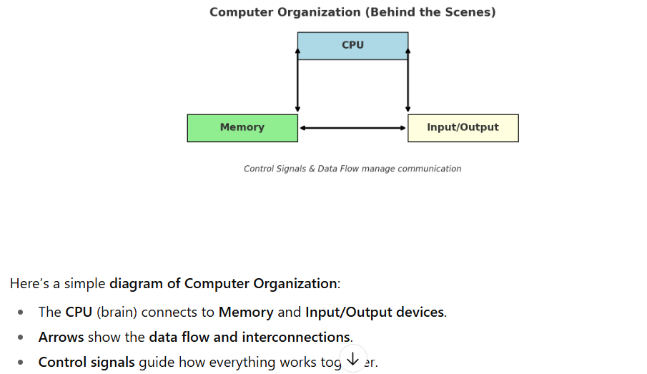
Components of Computer
1. CPU (Central Processing Unit)
- The brain of the computer.
- It does all the thinking, calculations, and decision-making.
- Example: Solving math problems, running apps, controlling data flow.
2. Memory
- The storage place inside the computer.
- Keeps data and instructions temporarily or permanently.
- Example: RAM (temporary memory) and Hard Drive/SSD (long-term storage).
3. Input Devices
- Devices that send information into the computer.
- Example: Keyboard, mouse, microphone, scanner.
4. Output Devices
- Devices that show results from the computer.
- Example: Monitor (screen), printer, speakers, projector.
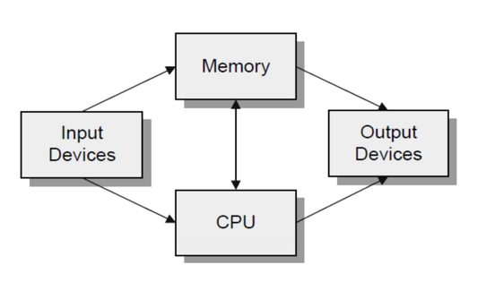
Central Processing Unit (CPU)
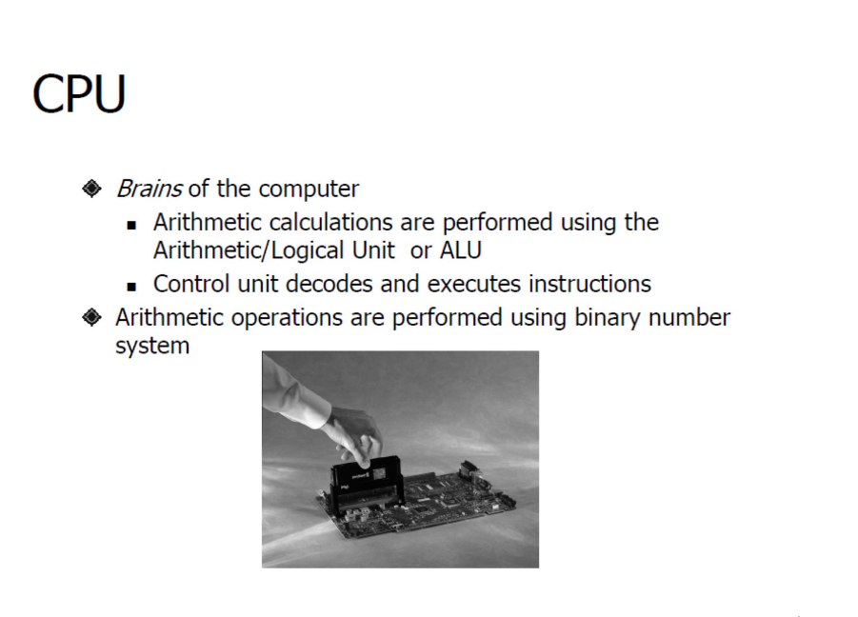
Control Unit
The control unit is the part of the CPU that directs all the operations. It uses a three-step process called the fetch/execute cycle to run a program's instructions.
- Fetch the instruction: The CPU gets the next instruction from memory. A special register, the program counter (PC), keeps track of which instruction to get next by holding its memory address.
- Increment the PC: The CPU updates the program counter to point to the next instruction in the sequence.
- Execute the fetched instruction: The CPU performs the action specified by the instruction.
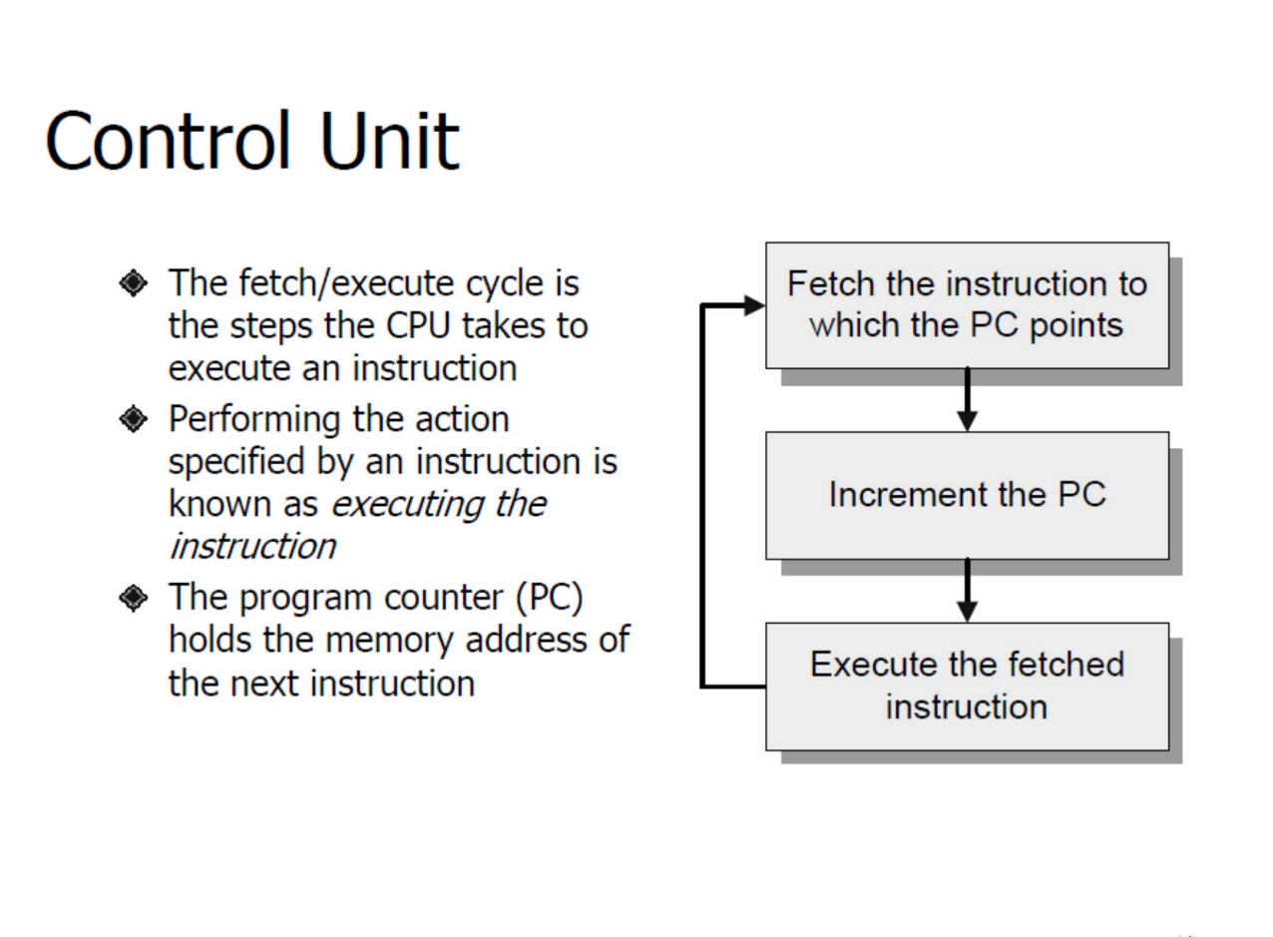
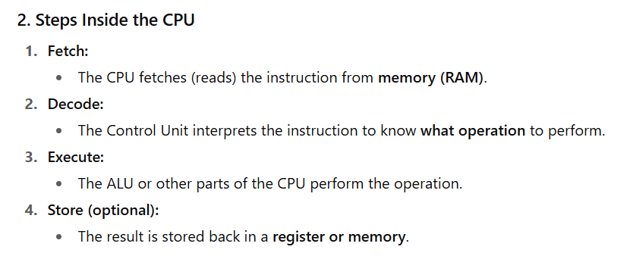

Program Counter
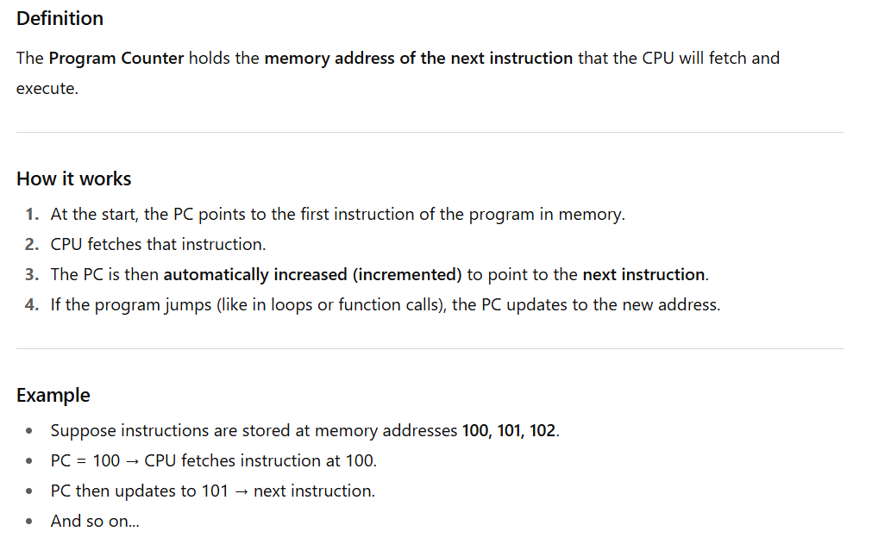
Input and output Devices
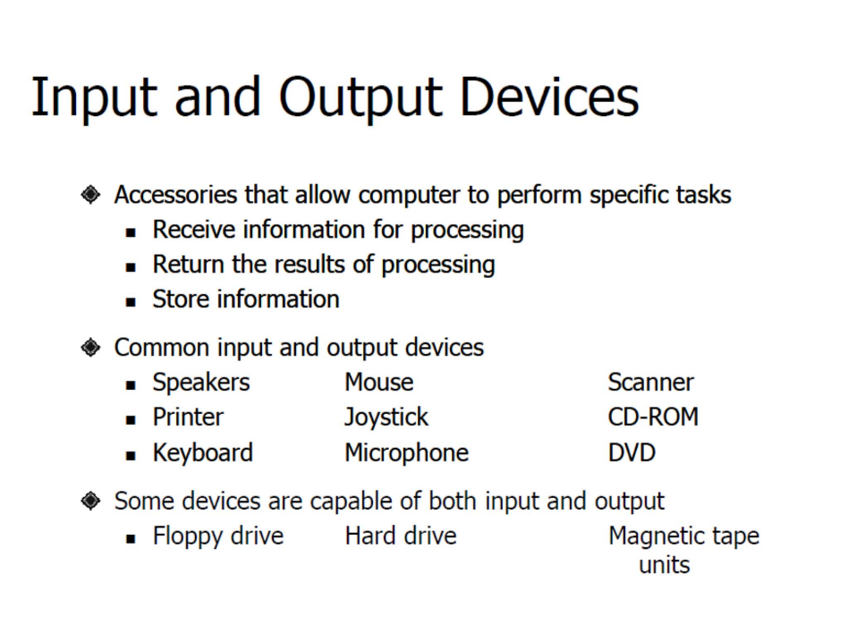

Monitor
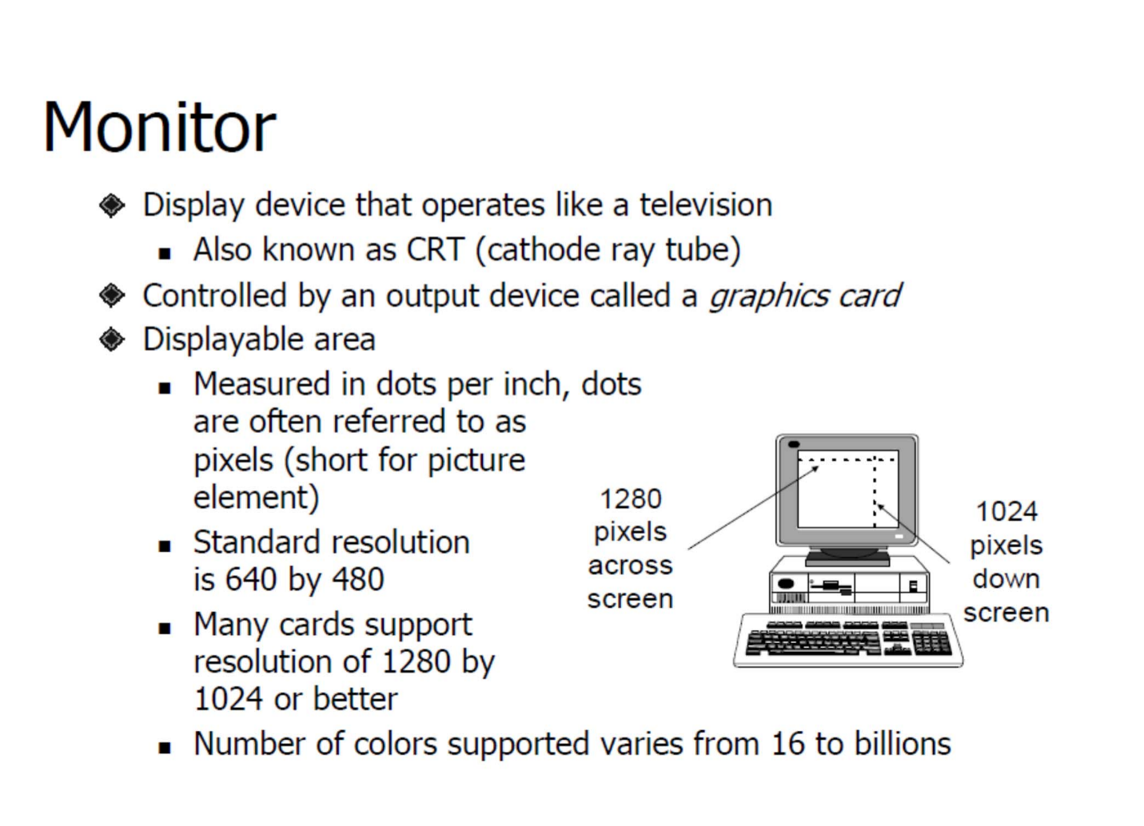
Software and its types
Software is a set of instructions, programs, or data that tells a computer how to perform specific tasks. Unlike hardware, which is the physical part of a computer (like the CPU, monitor, or keyboard), software is intangible—it exists as code and programs.
There are two main types of software:
- System Software: Helps run the computer and its hardware. Example: Operating Systems like Windows, macOS, or Linux.
- Application Software: Helps users perform specific tasks. Example: Microsoft Word, web browsers, or games.
Operating System
An Operating System (OS) is a special type of system software that acts as a bridge between the computer hardware and the user. It manages the computer’s resources and makes it easier for users and other software to interact with the hardware.
Services
- Process Management
- Memory Management
- File System Management
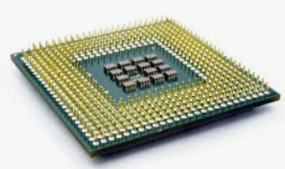
Microprocessor
A microprocessor is a small electronic chip that acts as the brain of a computer or device. It performs calculations, executes instructions, and controls other parts of the system.
- It is the CPU on a single chip.
- Found in computers, laptops, and even some smart devices.
Example: Intel i3, i5, i7, AMD Ryzen, etc.

Components
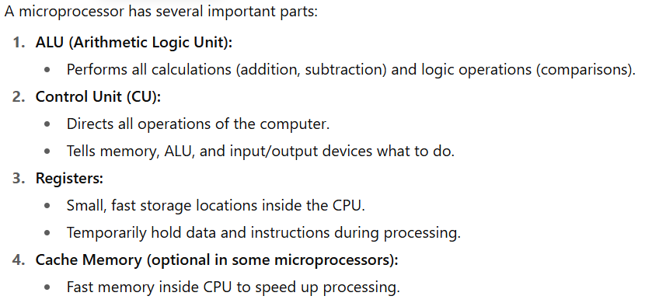
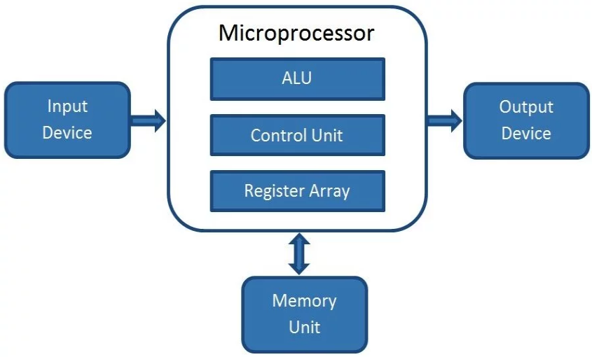
Microcontroller
A microcontroller is like a microprocessor + extra components on a single chip.
- It has a CPU, memory (RAM & ROM), and input/output ports all in one chip.
- Used in embedded systems for controlling devices.
Example: Arduino, PIC, and STM32.
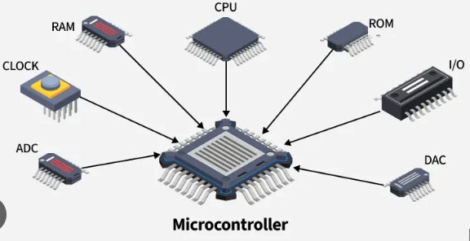
Difference between twos
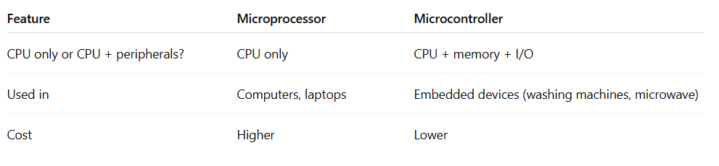
Embedded System
An embedded system is a special-purpose computer built to do a specific task.
- It usually uses a microcontroller.
- It is not general-purpose like a PC.
Examples:
- Washing machines
- Microwave ovens
- Digital cameras
- Smart watches
Direct Memory Access
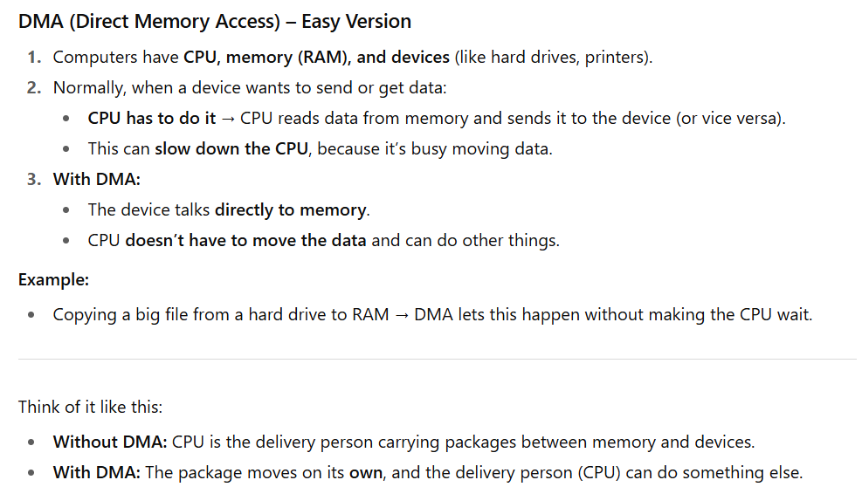
Drivers
A driver is a special software program that allows the operating system to communicate with hardware devices.
- Without drivers, the OS cannot understand or control hardware like printers, keyboards, or graphics cards.
- Think of it as a translator between the OS and the hardware.
Example:
- Printer driver lets your computer send documents to the printer.
- Graphics driver lets your OS use the GPU for display and gaming.

Word Length
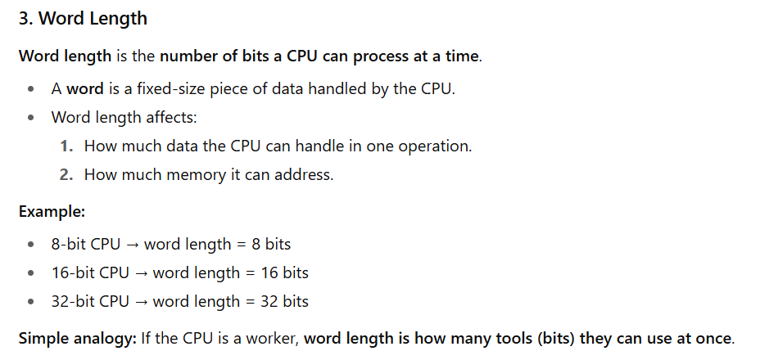
What are Buses?
In a computer system, a bus is like a group of roads made of wires that carry data, addresses, and signals between the CPU, memory, and input/output devices. Instead of each part having its own path, they all share this common “road” to communicate.
Types
1. Data Bus (Two-Way)
The data bus carries the actual information between the CPU, memory, and other devices.
- Direction: It is two-way (bidirectional) because data can move to the CPU (when reading) and from the CPU (when writing).
- Example: Like a delivery van that can both bring goods from a warehouse and send goods back.

2. Address Bus (One-Way)
The address bus is used to tell the computer where data should go or come from. It carries the memory addresses of instructions or data.
- Direction: It is one-way (unidirectional) because only the CPU decides and sends addresses, but memory or devices don’t send addresses back.
- Example: Like writing a delivery address on a parcel – only the sender (CPU) sets it.
3. Control Bus (Both Ways, Depending on Signal)
The control bus carries signals to coordinate and control activities (like read, write, or clock signals).
- Direction: It can be one-way or two-way, depending on the signal. Some signals are sent by the CPU to control devices, while some signals (like interrupts) come from devices to the CPU.
- Example: Like traffic lights and horns – sometimes the police (CPU) give orders, sometimes cars (devices) give signals back.

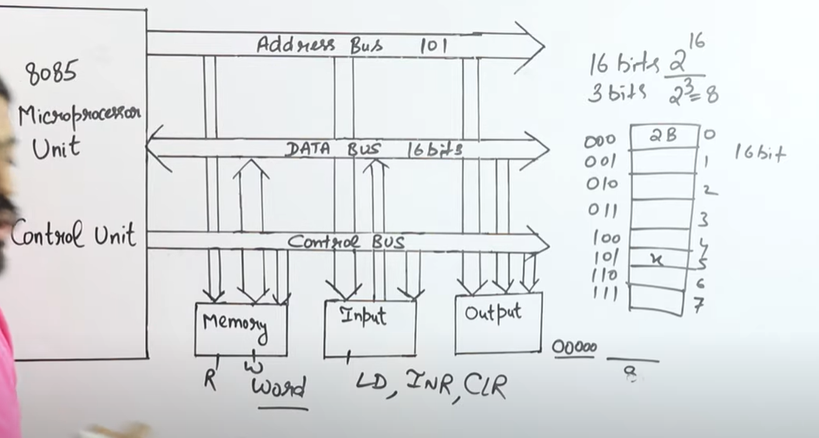
MAR, MDR and Instruction Register
1. MAR (Memory Address Register)
- Meaning: It holds the address of the memory location that the CPU wants to access (read or write).
- Role: Think of MAR as the "pointer" telling the CPU where in memory to look.
- Size: Its size depends on the size of the address bus (e.g., if the CPU has 16-bit addresses, MAR is 16 bits).
2. MDR (Memory Data Register)
- Meaning: It holds the data that is either:
  - Read from memory (to be used by CPU), or
  - Written into memory (sent from CPU).
- Role: Think of MDR as a "buffer" that temporarily stores data being transferred.
- Size: Its size matches the word size of the computer (e.g., 32-bit CPU → MDR is 32 bits).
3. Register (IR)
- The Instruction Register (IR) is a special-purpose register inside the CPU.
- It holds the current instruction that the CPU has just fetched from memory and is about to decode and execute.
- Once the instruction is in the IR, the Control Unit (CU) reads it, breaks it into the opcode (what to do) and the operands (data or addresses), and then generates control signals to carry out the task.
- The IR is updated in every fetch cycle, meaning with each new instruction, it replaces the old one
Instruction Execution Cycle
The Instruction Execution Cycle is the process that a computer follows to execute every instruction in a program. It happens in four main steps:
1. Fetch
In the fetch step, the CPU gets the instruction from the computer’s memory. The Program Counter (PC) holds the address of the next instruction. The CPU sends this address to memory, retrieves the instruction, and stores it in the Instruction Register (IR). The PC is then updated to point to the next instruction.
2. Decode
Once the instruction is fetched, the CPU needs to understand it. This is done in the decode step. The Control Unit (CU) interprets the instruction and determines what operation is required (like add, subtract, load, or store) and which registers or memory locations are involved.
3. Execute
In the execute step, the CPU performs the operation specified by the instruction. For example, if it’s an addition instruction, the ALU (Arithmetic Logic Unit) adds the numbers from the specified registers. If it’s a memory instruction, the CPU reads from or writes to memory.
4. Store / Write Back
Finally, the result of the instruction is stored in the appropriate place. If it’s a calculation, the result is saved in a register. If it’s a memory instruction, the data is written back to memory. After this step, the CPU moves on to the next instruction, and the cycle repeat

Lecture 1
Part 2
The microprocessor-based personal computer system
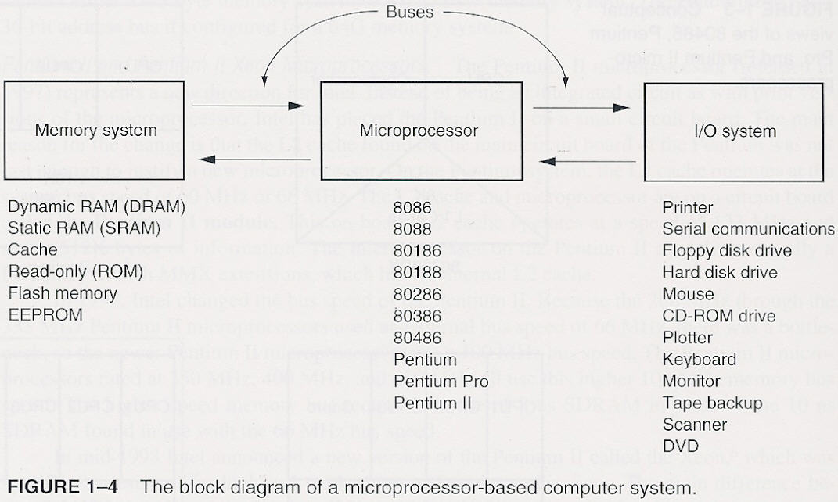
Interpretation of figure
The provided diagram shown the architecture of a microprocessor-based computer system. The microprocessor acts as the central processing unit, or "brain," of the system. It is connected to the memory system, which stores data and instructions, and the I/O (Input/Output) system, which handles communication with external devices like keyboards and monitors. These components are interconnected by buses that allow for the flow of information.
The flow of instructions is from memory to the microprocessor, not from I/O devices. The microprocessor fetches instructions from memory, processes them, and then uses the I/O system to interact with the user and external devices as needed.
The memory map of the PC
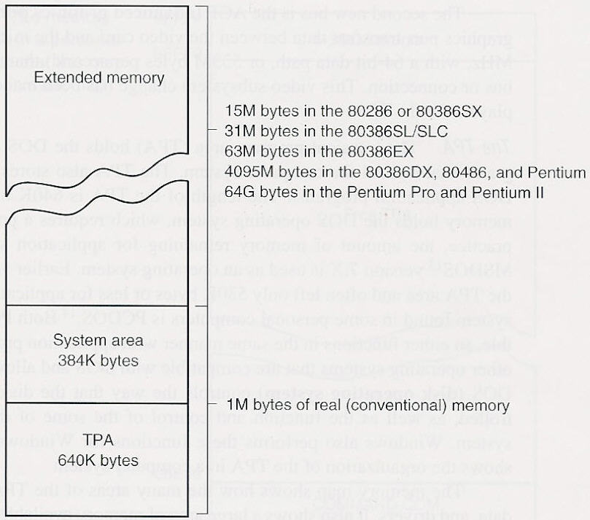
PC Memory Map
Computers divide their memory into different parts. This diagram shows how memory is arranged in older PCs and how much memory different processors can handle.
1. Conventional Memory (1 MB)
- The first 1 Megabyte (MB) of memory is called real or conventional memory.
- This is what the very first IBM PCs used.
It is further divided into two parts:
a) TPA (Transient Program Area) – 640 KB
- Size: 640 Kilobytes (KB)
- Used to load programs and DOS (operating system).
- This was the main usable memory for early programs.
b) System Area – 384 KB
- Size: 384 KB
- Reserved for system use: BIOS, video memory, device drivers, etc.
- Not available for normal programs.
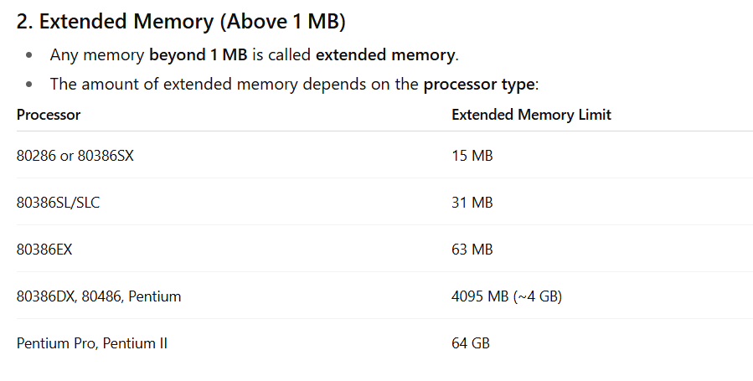
What are Buses?
In a computer system, a bus is like a group of roads made of wires that carry data, addresses, and signals between the CPU, memory, and input/output devices. Instead of each part having its own path, they all share this common “road” to communicate.
Types
1. Data Bus (Two-Way)
The data bus carries the actual information between the CPU, memory, and other devices.
- Direction: It is two-way (bidirectional) because data can move to the CPU (when reading) and from the CPU (when writing).
- Example: Like a delivery van that can both bring goods from a warehouse and send goods back.
2. Address Bus (One-Way)
Thia bus is used to tell the computer where data should go or come from. It carries the memory addresses of instructions or data.
- Direction: It is one-way (unidirectional) because only the CPU decides and sends addresses, but memory or devices don’t send addresses back.
- Example: Like writing a delivery address on a parcel – only the sender (CPU) sets it.
3. Control Bus (Both Ways, Depending on Signal)
This bus carries signals to coordinate and control activities (like read, write, or clock signals).
- Direction: It can be one-way or two-way, depending on the signal. Some signals are sent by the CPU to control devices, while some signals (like interrupts) come from devices to the CPU.
- Example: Like traffic lights and horns – sometimes the police (CPU) give orders, sometimes cars (devices) give signals back.


I/O Space
- I/O space is like a special address book for your computer.
- Each device (like keyboard, printer, hard disk) has its own unique address so the computer knows where to send or receive data.
- These addresses are written in hexadecimal (like 03F8 or 01F0).
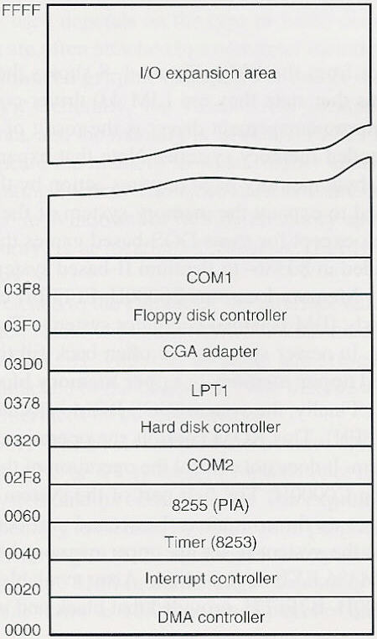
Why It Matters
- The CPU uses these addresses to talk to devices.
- It’s like sending a letter to a specific house—you need the correct address.
- This system allows up to 64K (65,536) different devices to be connected.
Microprocessor
A microprocessor is a small electronic chip that acts as the brain of a computer or device. It performs calculations, executes instructions, and controls other parts of the system.
- It is the CPU on a single chip.
- Found in computers, laptops, and even some smart devices.
Example: Intel i3, i5, i7, AMD Ryzen, etc.
Role of Buses
The microprocessor connects memory and I/O devices through buses (a set of wires).
- Buses help the CPU select memory or I/O devices,
- Transfer data between them,
- And control how everything works together.
Memory and I/O
- The memory stores instructions and data.
- The I/O devices allow the computer to interact with the outside world (like keyboard, monitor, mouse, etc.).
- The microprocessor follows the instructions stored in memory and then executes them step by step.
Main Tasks of a Microprocessor
The microprocessor mainly does three things:
- Data Transfer → Moves data between itself, memory, and I/O devices.
- Arithmetic and Logic → Performs simple calculations (add, subtract) and logic operations (AND, OR compare).
- Program Flow Control → Makes decisions and controls the order of instructions (like “if this happens, go there”).
Stored Program Concept (Von Neumann Idea)
The stored program concept means that both instructions and data are kept in the same memory. The CPU fetches instructions one by one, executes them, and moves to the next.
This concept makes computers and microprocessors very powerful, because they can handle many tasks just by changing the stored program.
Simple arithmetic and logic operations
Data
The data used by the microprocessor can come from either:
- The memory system (RAM, ROM), or
- The internal registers inside the CPU.
The microprocessor works on this data to perform calculations or operations.
Data Width
Data width means how many bits the processor can handle or transfer at once.
- Byte → 8 bits
- Word → Usually 16 bits (2 bytes)
- Double Word → 32 bits (4 bytes)
Larger data width = processor can work with bigger chunks of data = faster performance.
Numeric Coprocessor (µ)
Starting from the Intel 80486 processor, CPUs included a numeric coprocessor.
- This coprocessor helps in doing complex mathematical calculations, especially floating-point arithmetic (decimals, fractions, scientific calculations).
- Before this, floating-point math was slow and done in software. With the coprocessor, it became much faster.
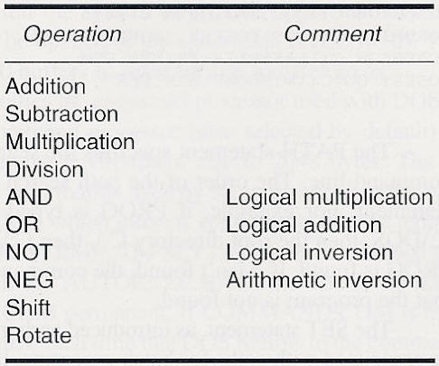
Decisions
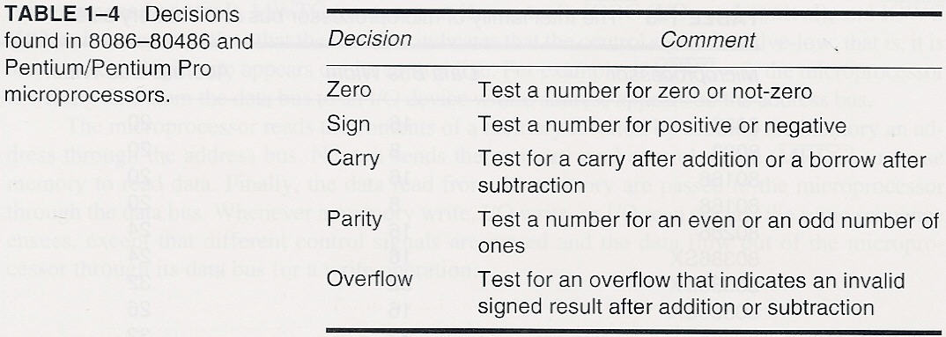
It lists the decision flags (status flags) used in 8086–80486 and Pentium/Pentium Pro microprocessors. These flags are part of the CPU’s status register and are set or cleared after arithmetic or logical operations. They help the processor make decisions in conditional instructions like JZ, JC, JS, etc.
Here’s what the table explains:
- Zero Flag (ZF):
Checks if the result of an operation is zero or not.
Example: 5 - 5 = 0, so ZF = 1.
- Sign Flag (SF):
Checks if the result is positive or negative (based on the most significant bit).
Example: -3 result would set SF = 1.
- Carry Flag (CF):
Detects a carry after addition or a borrow after subtraction.
Example: 255 + 1 in 8-bit causes CF = 1.
- Parity Flag (PF):
Checks whether the number of 1-bits in the result is even or odd.
Example: 1010 (two 1s, even) → PF = 1.
- Overflow Flag (OF):
Indicates if the signed result is too large (or too small) to fit in the destination operand.
Example: 127 + 1 in 8-bit signed causes OF = 1.
In short, this table is about processor decision-making flags used for conditional execution in assembly language
Bus Width in Intel Family of Microprocessors
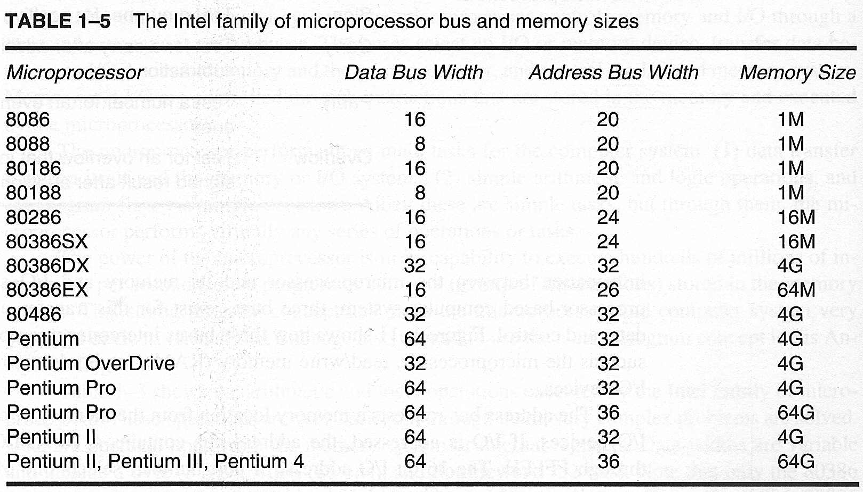
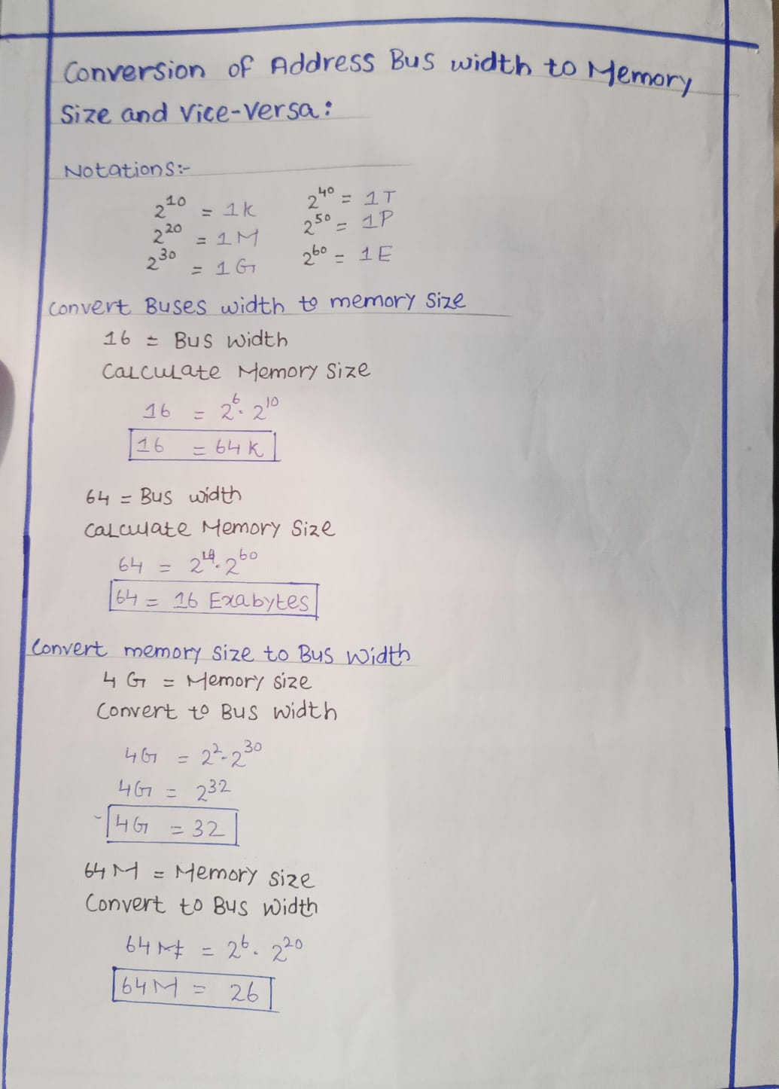
Number systems
Digit
- Decimal (base 10): 0 – 9
- Binary (base 2): 0 – 1
- Octal (base 8): 0 – 7
- Hexadecimal (base 16): 0 – 9, A – F
Positional Notation
- Radix (number base): The base of the number system (e.g., 10 for decimal, 2 for binary).
- Radix point: Like the decimal point (separates integer part and fractional part).
- Weight of position: Each digit has a value depending on its place (power of base).
  - Weight: 10¹ (tens position), 10⁰ (units), 10⁻¹
Example in decimal (base 10):
- 132=1×100+3×10+2×1
Or in power form:
- 132=1×10²+3×10¹+2×1⁰
Continue …
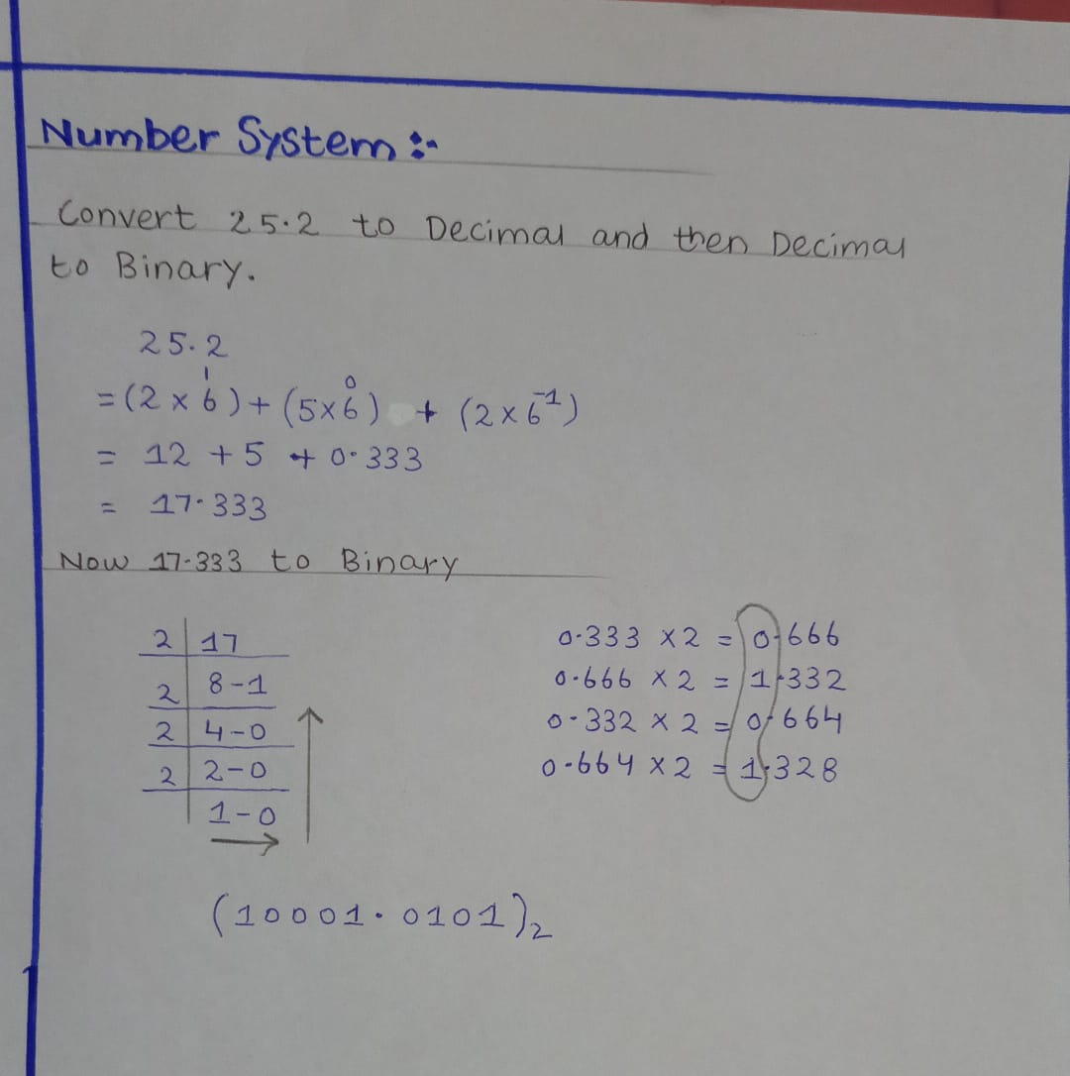
Data Representation
Lecture 2
Binary Numbers
Digits are 1 and 0
A computer only understands two digits:
- 1 → means ON / True
- 0 → means OFF / False
Everything in the computer (numbers, text, images, videos) is stored using just 1s and 0s.
1 = True, 0 = False
In logic:
- 1 = Yes, True, On
- 0 = No, False, Off
Example:
- Switch On = 1
- Switch Off = 0
MSB – Most Significant Bit
- The leftmost bit in a binary number.
- It has the highest value place.
- Example: In 1011, MSB = 1 (value 8 in decimal).
- Sometimes MSB is also used to show sign (positive or negative).
LSB – Least Significant Bit
- The rightmost bit in a binary number.
- It has the lowest value place.
- Example: In 1011, LSB = 1 (value 1 in decimal).
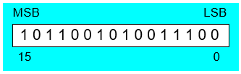
Continue …
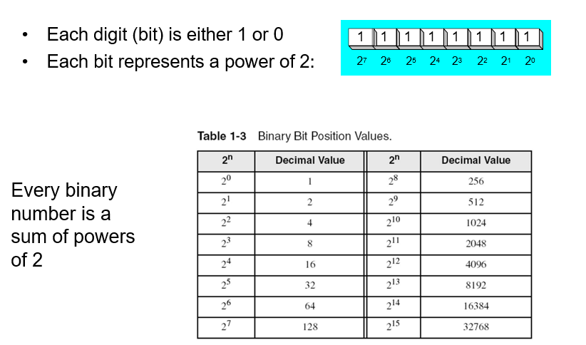

Translating Binary to Decimal
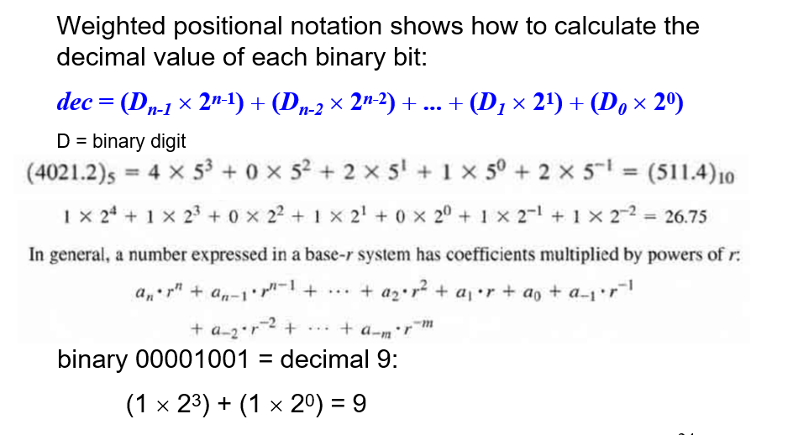
Translating Unsigned Decimal to Binary
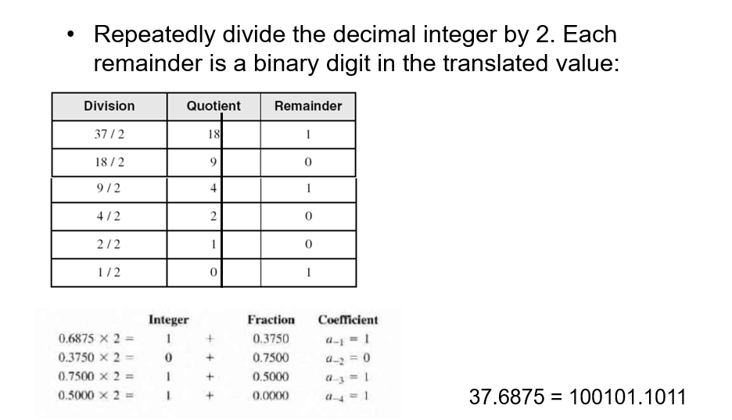

Exercise
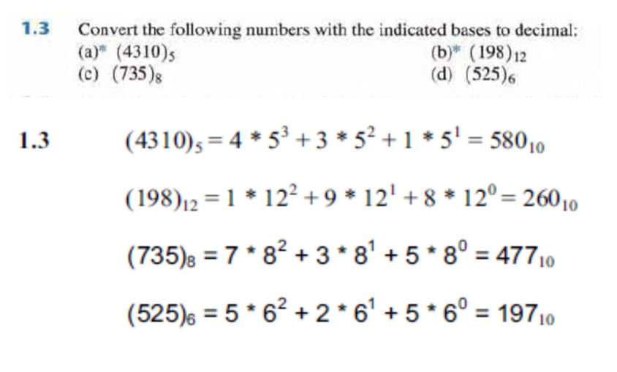
Converting Hexadecimal to Decimal
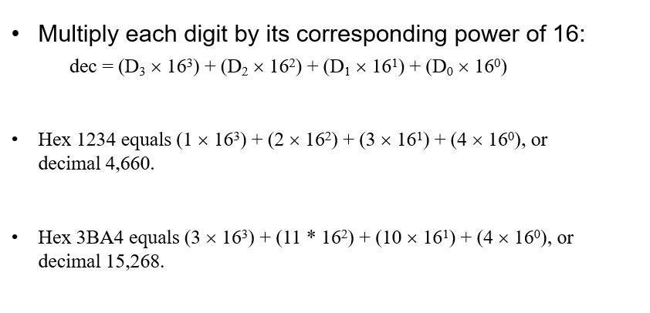

Binary Addition
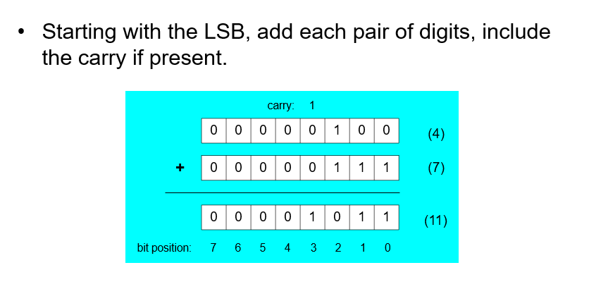Converting Decimal to Hexadecimal
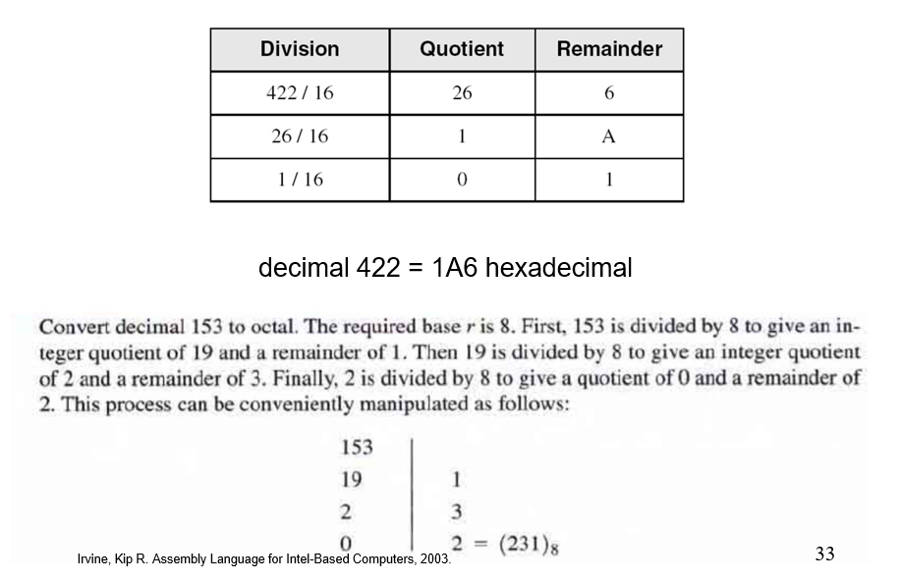

Convert Decimal Fraction to Octal Fraction
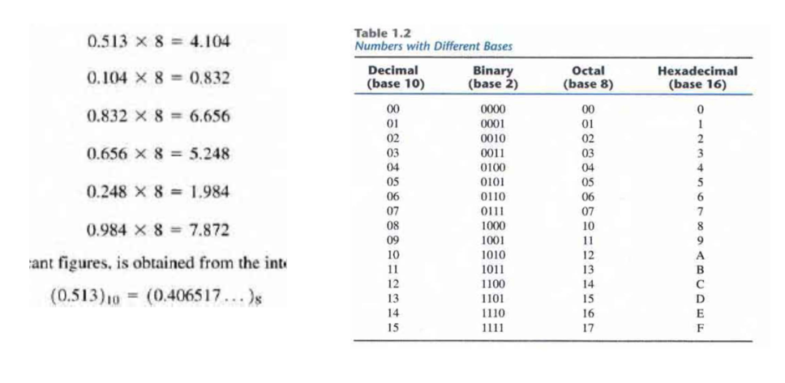Hexadecimal Integers
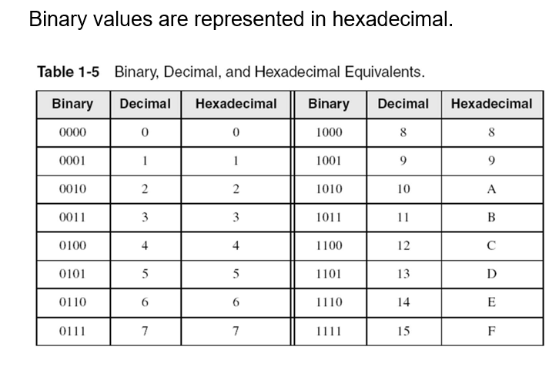

Powers of 16
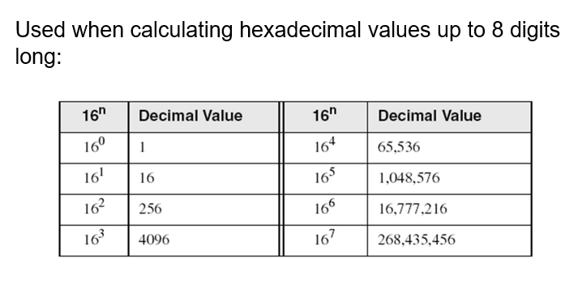
Translating Binary to Hexadecimal
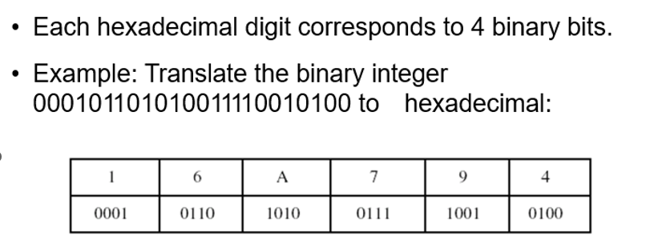

Hexadecimal Addition
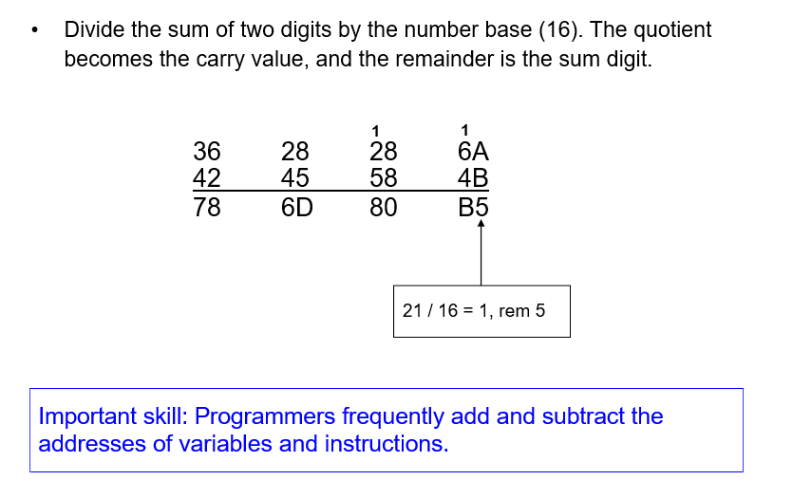
Integer Storage Sizes
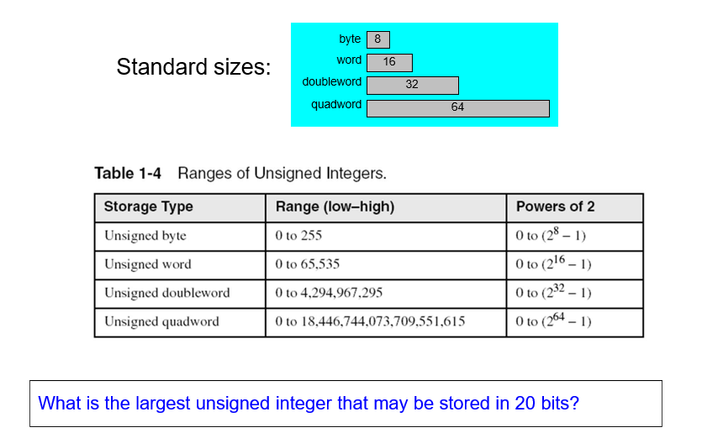
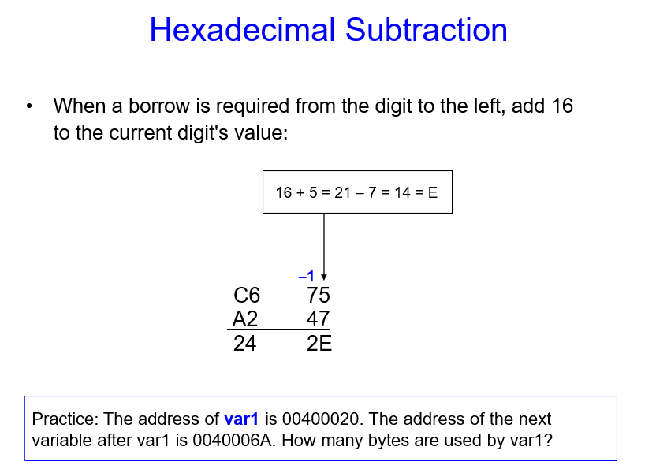
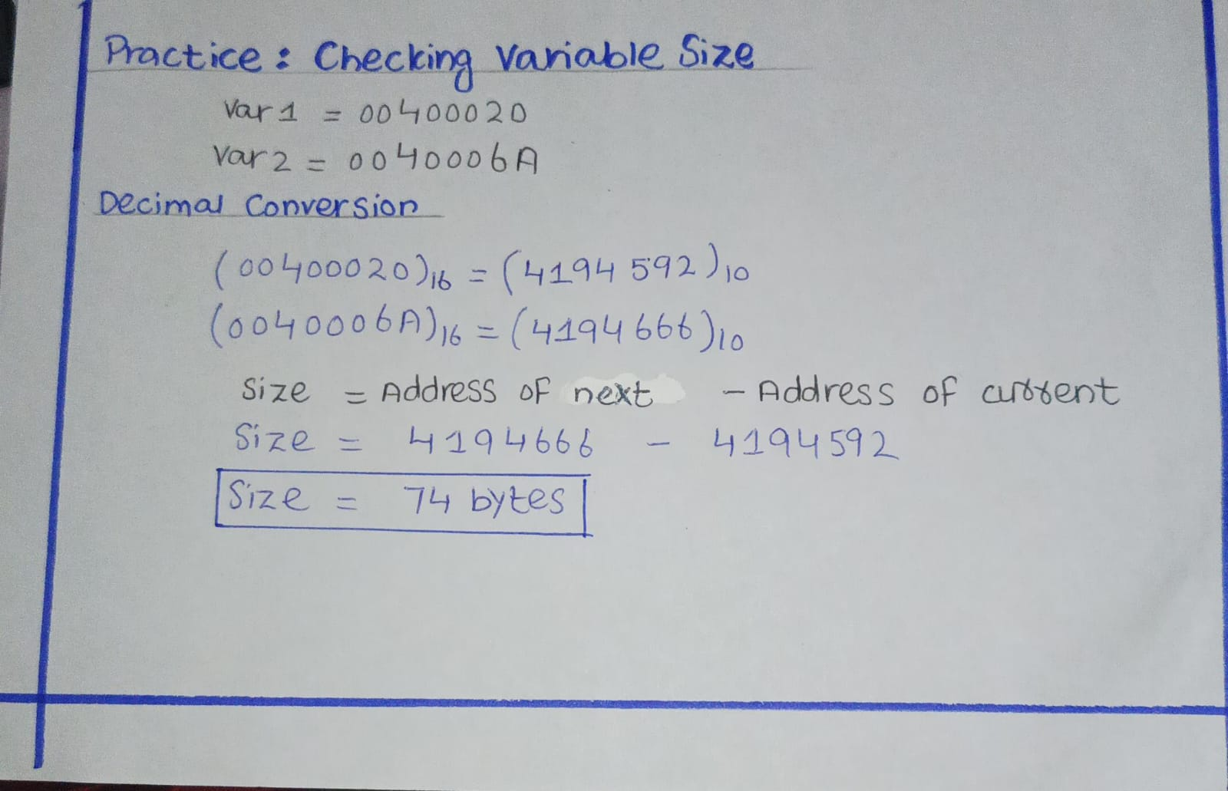
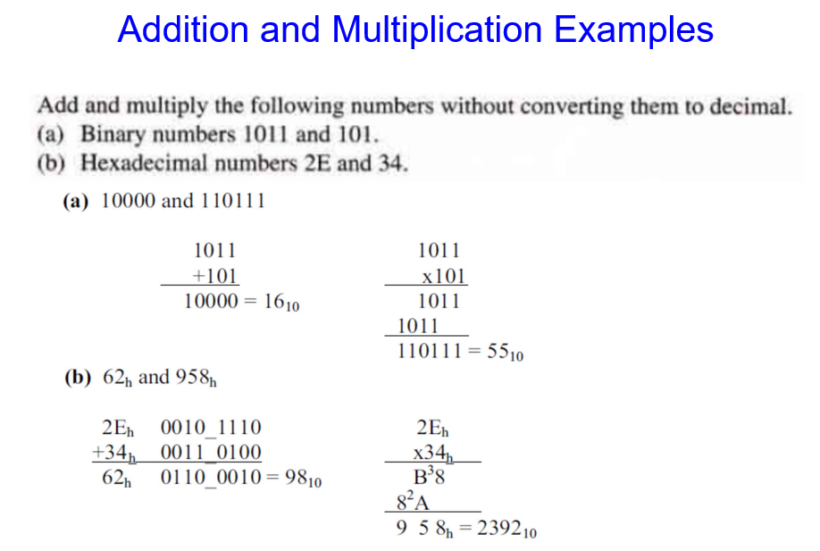


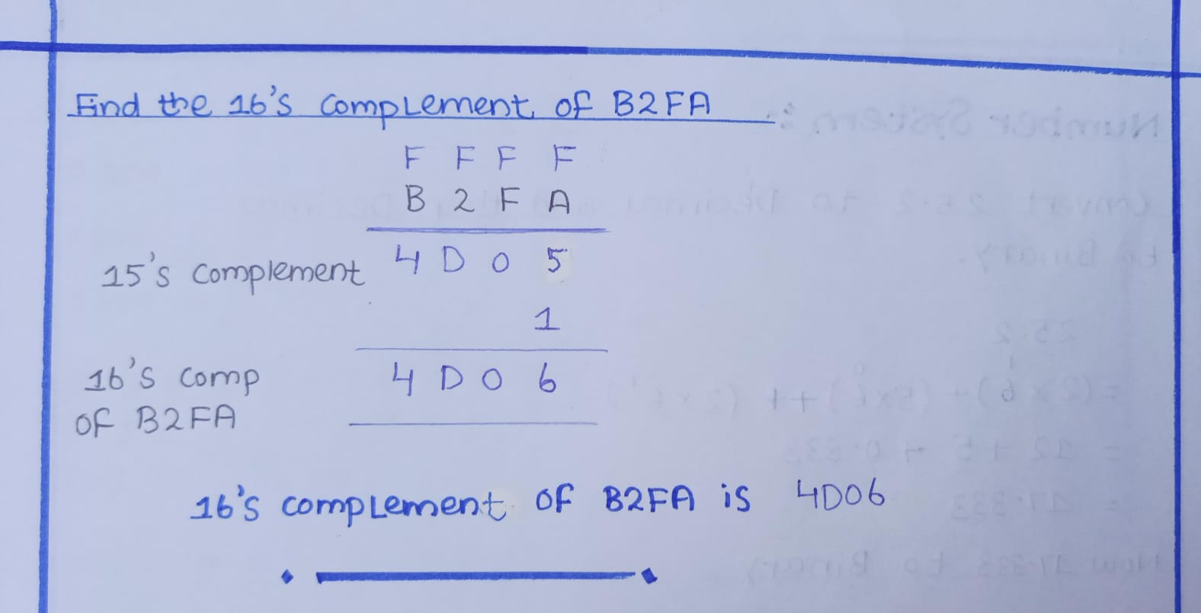
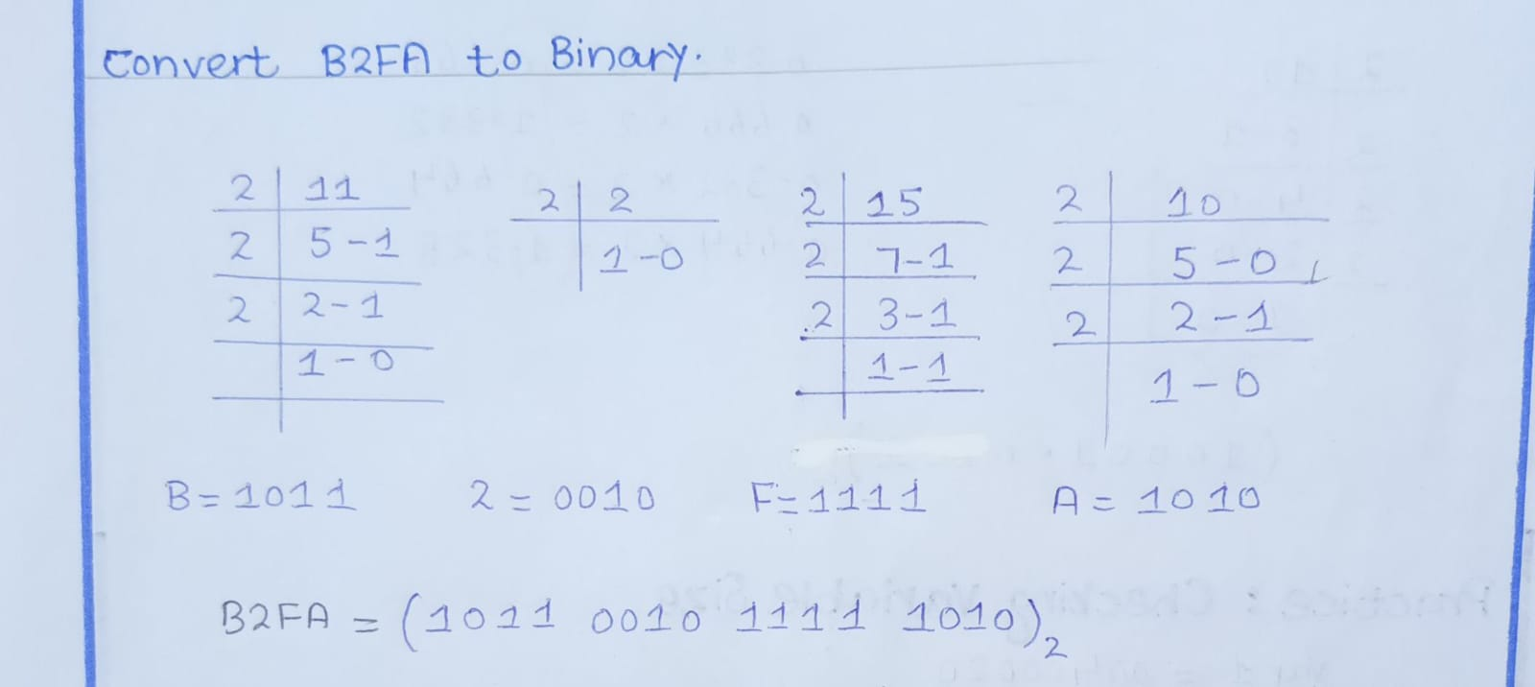

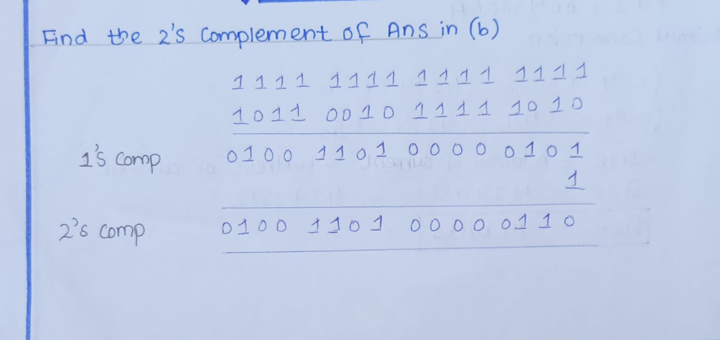
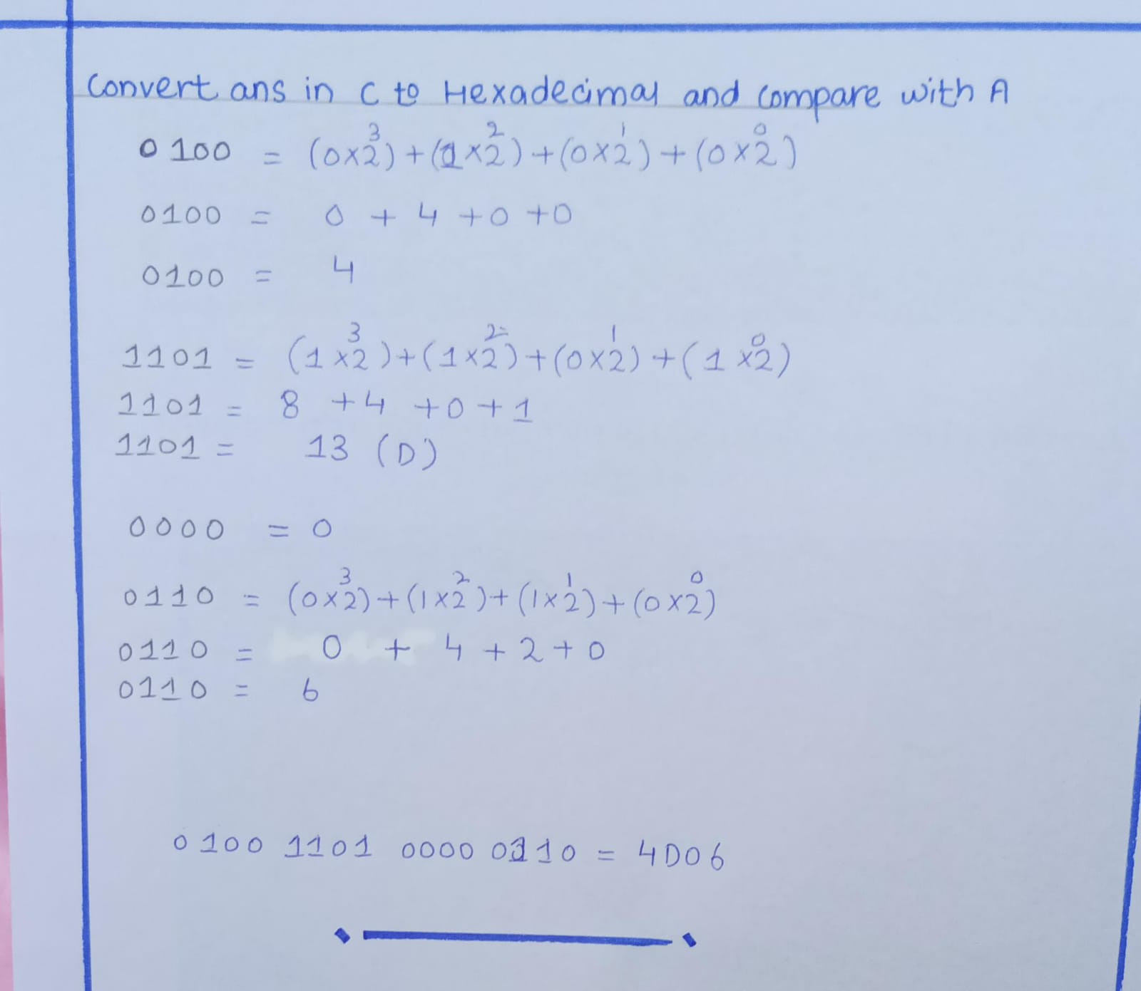
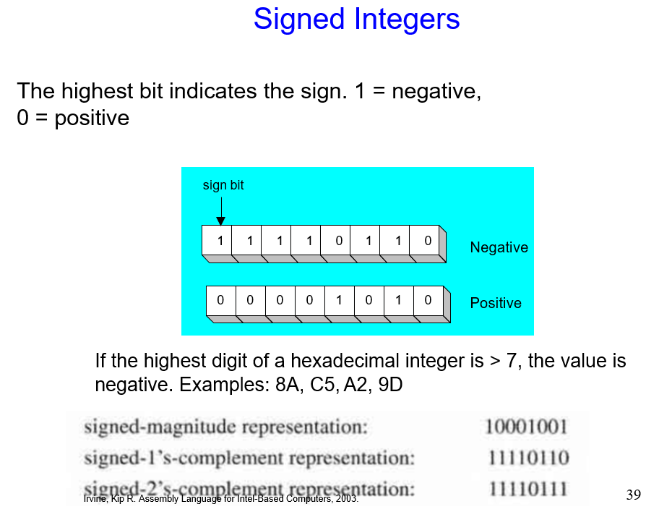
What is the largest unsigned integer that may be stored in 20 bits?
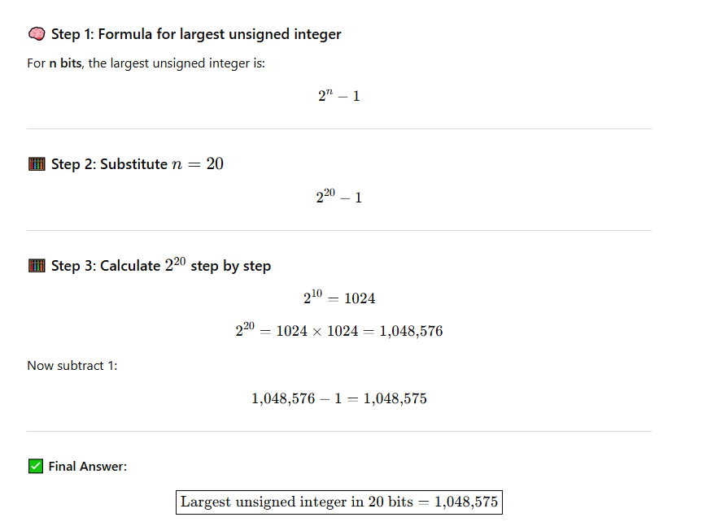

Practice: What is the largest positive value that may be stored in 20 bits?
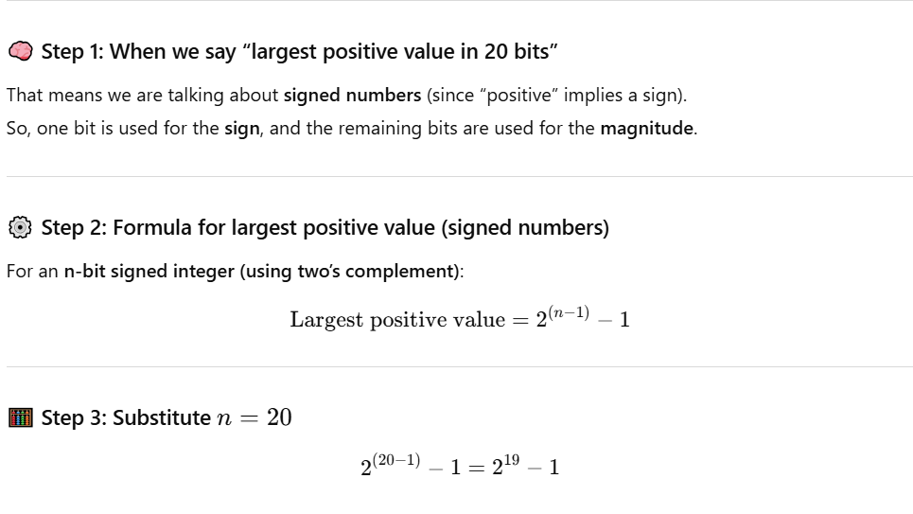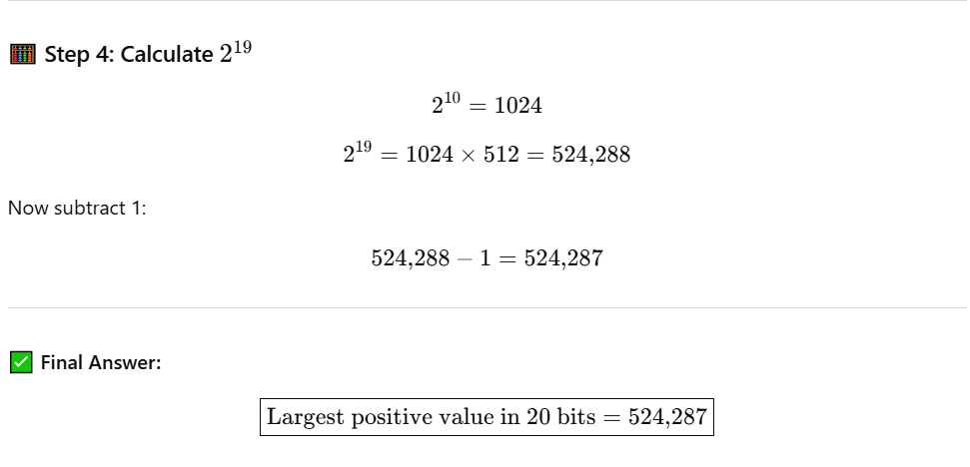

Lecture 4
Data Representation 2
Complements: 1s, 2s, 9s and 10s etc.
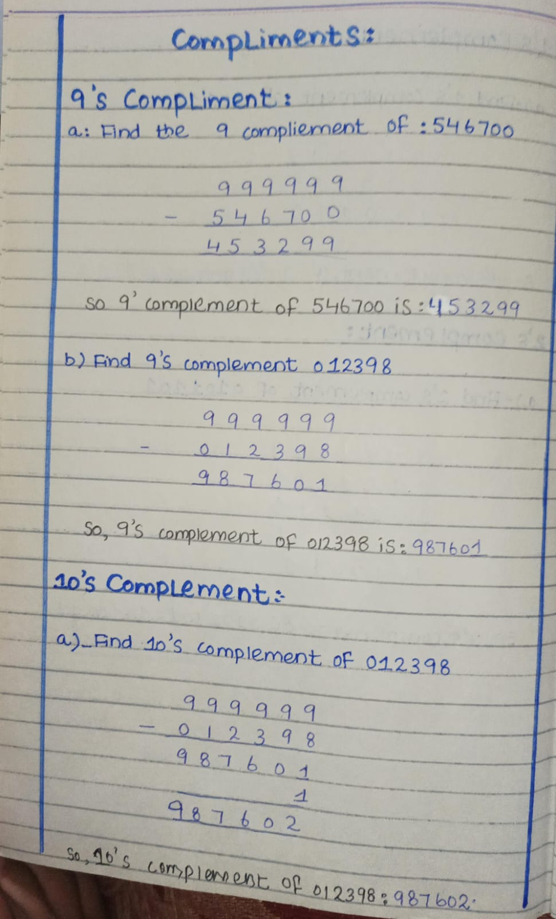
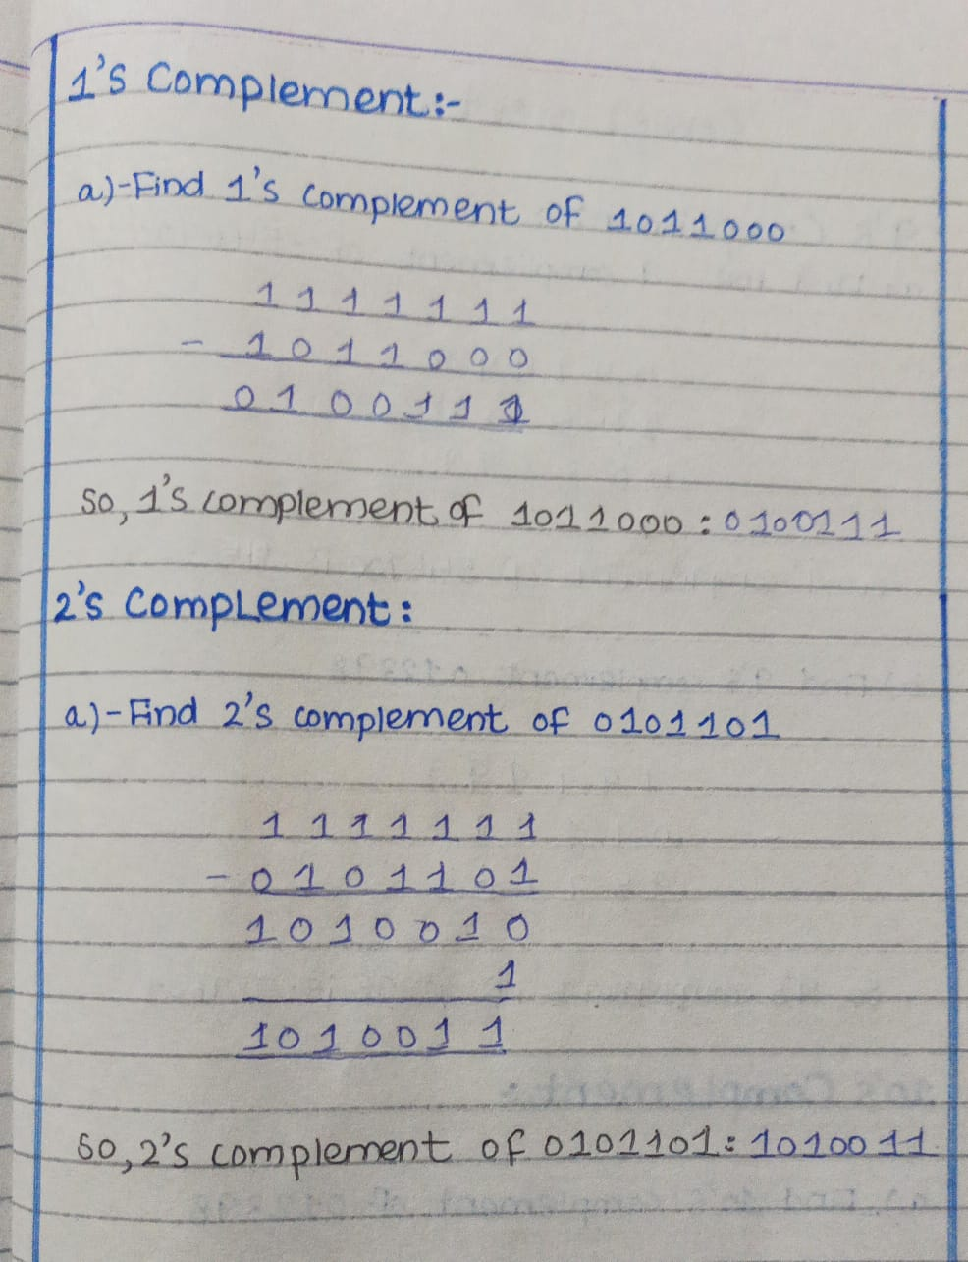

Subtraction Using Complements
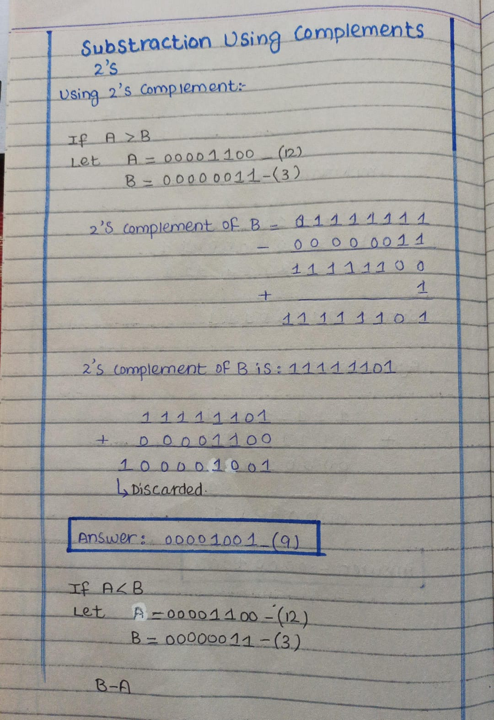
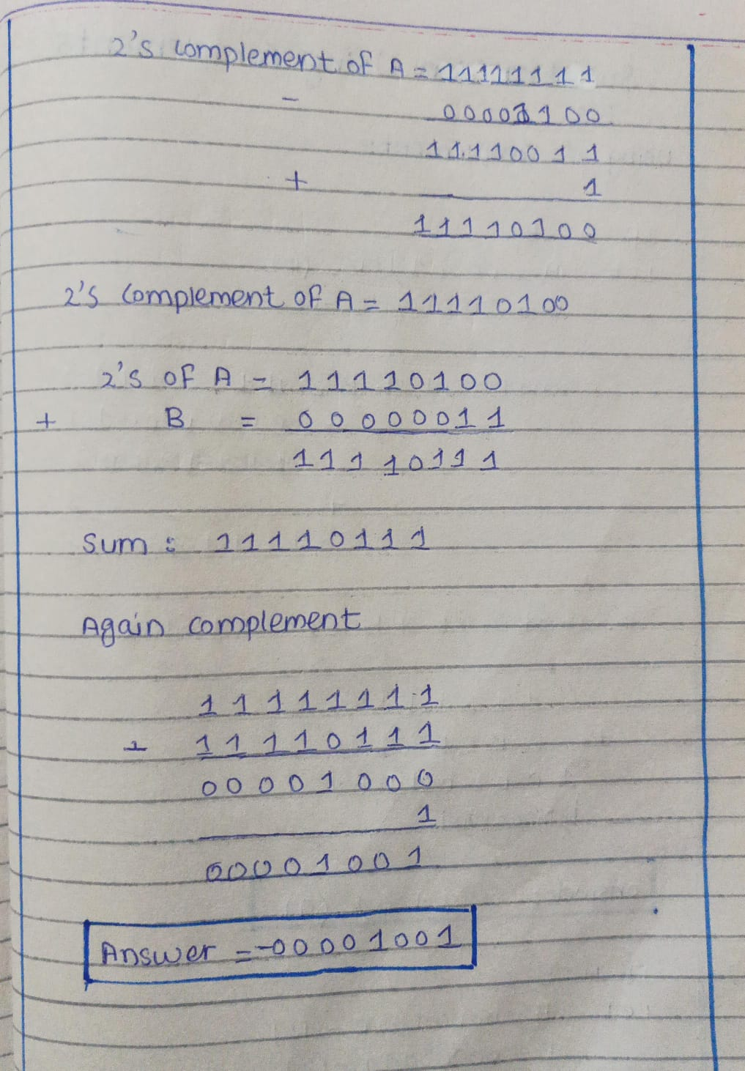
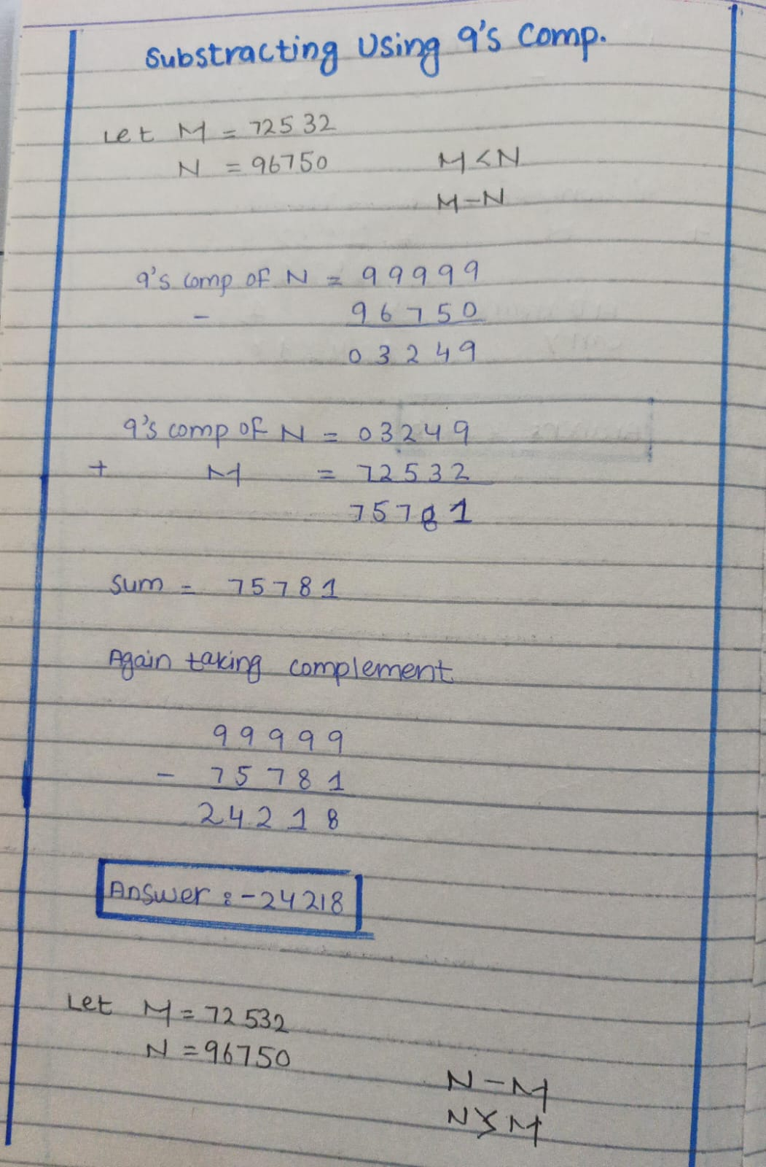
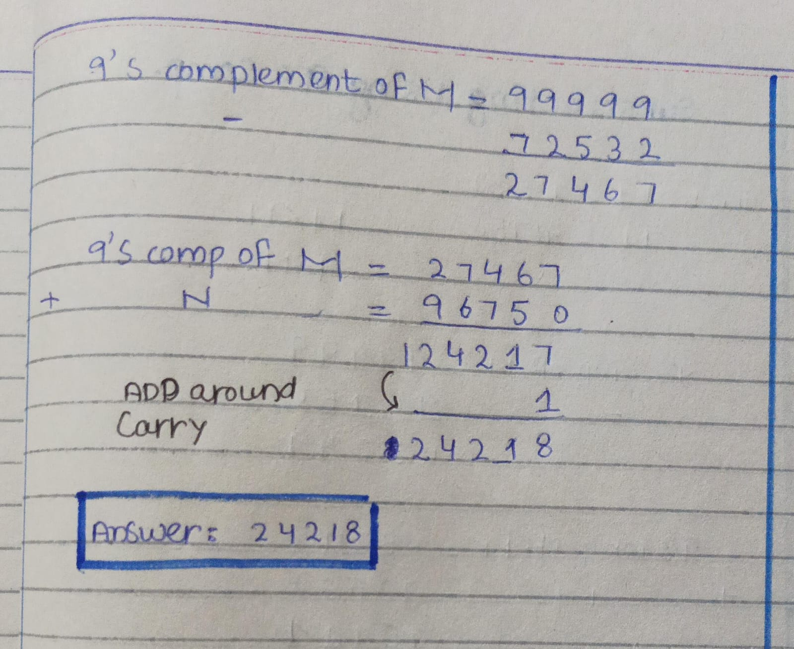
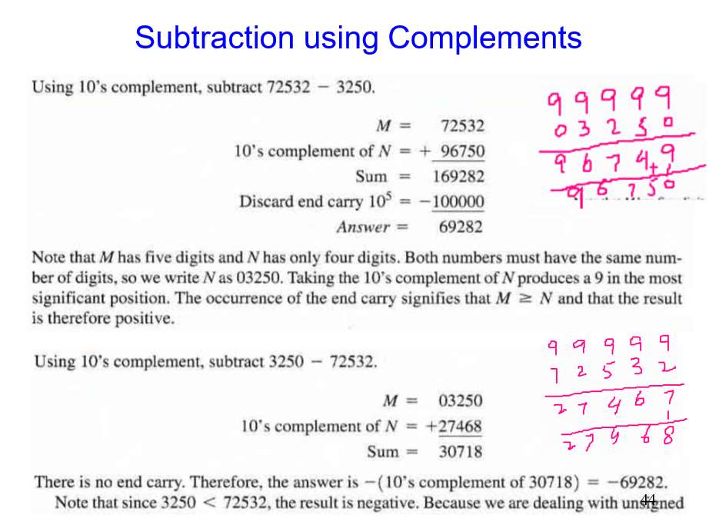
BCD Addition
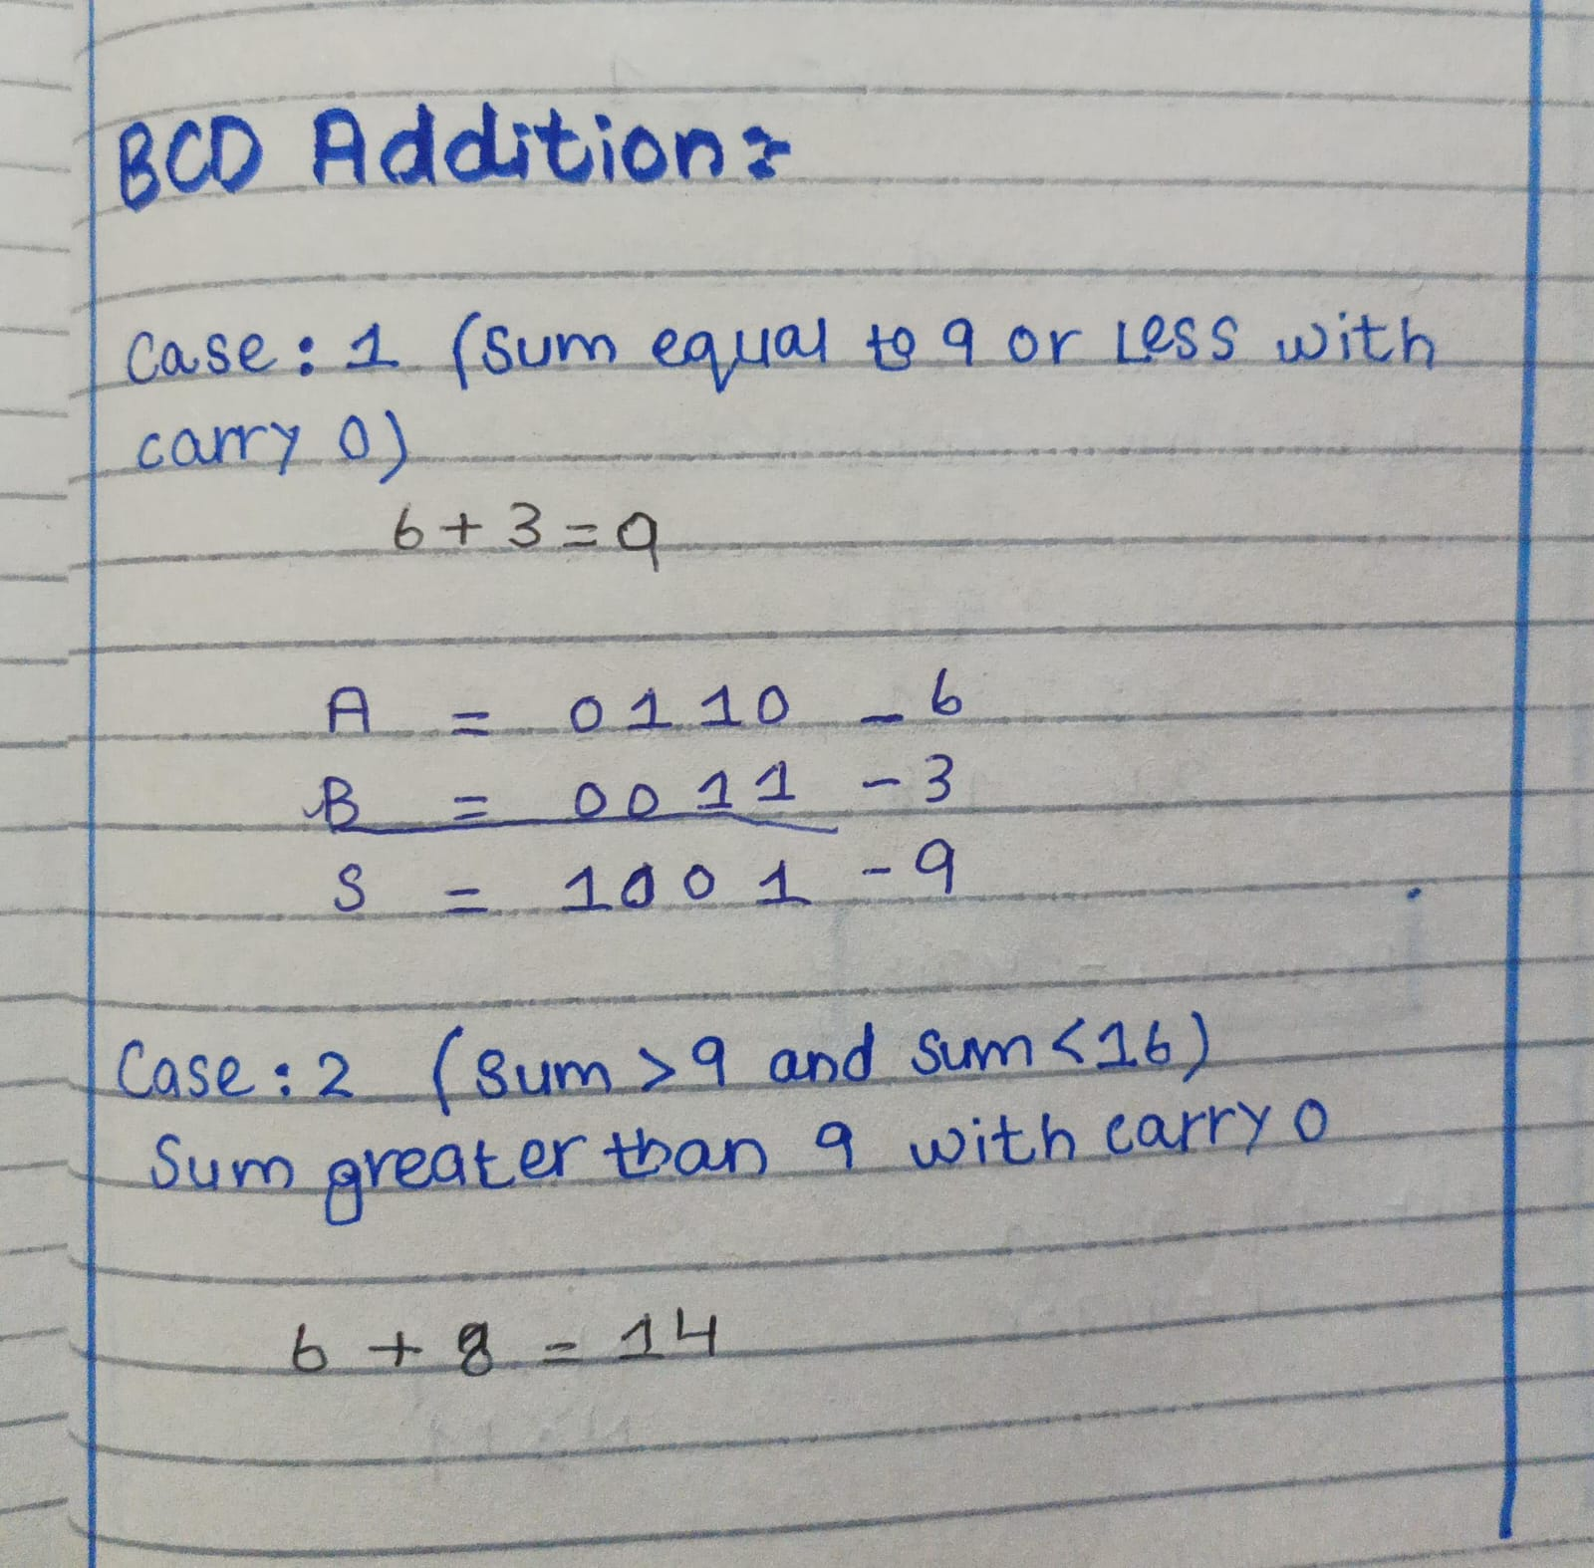

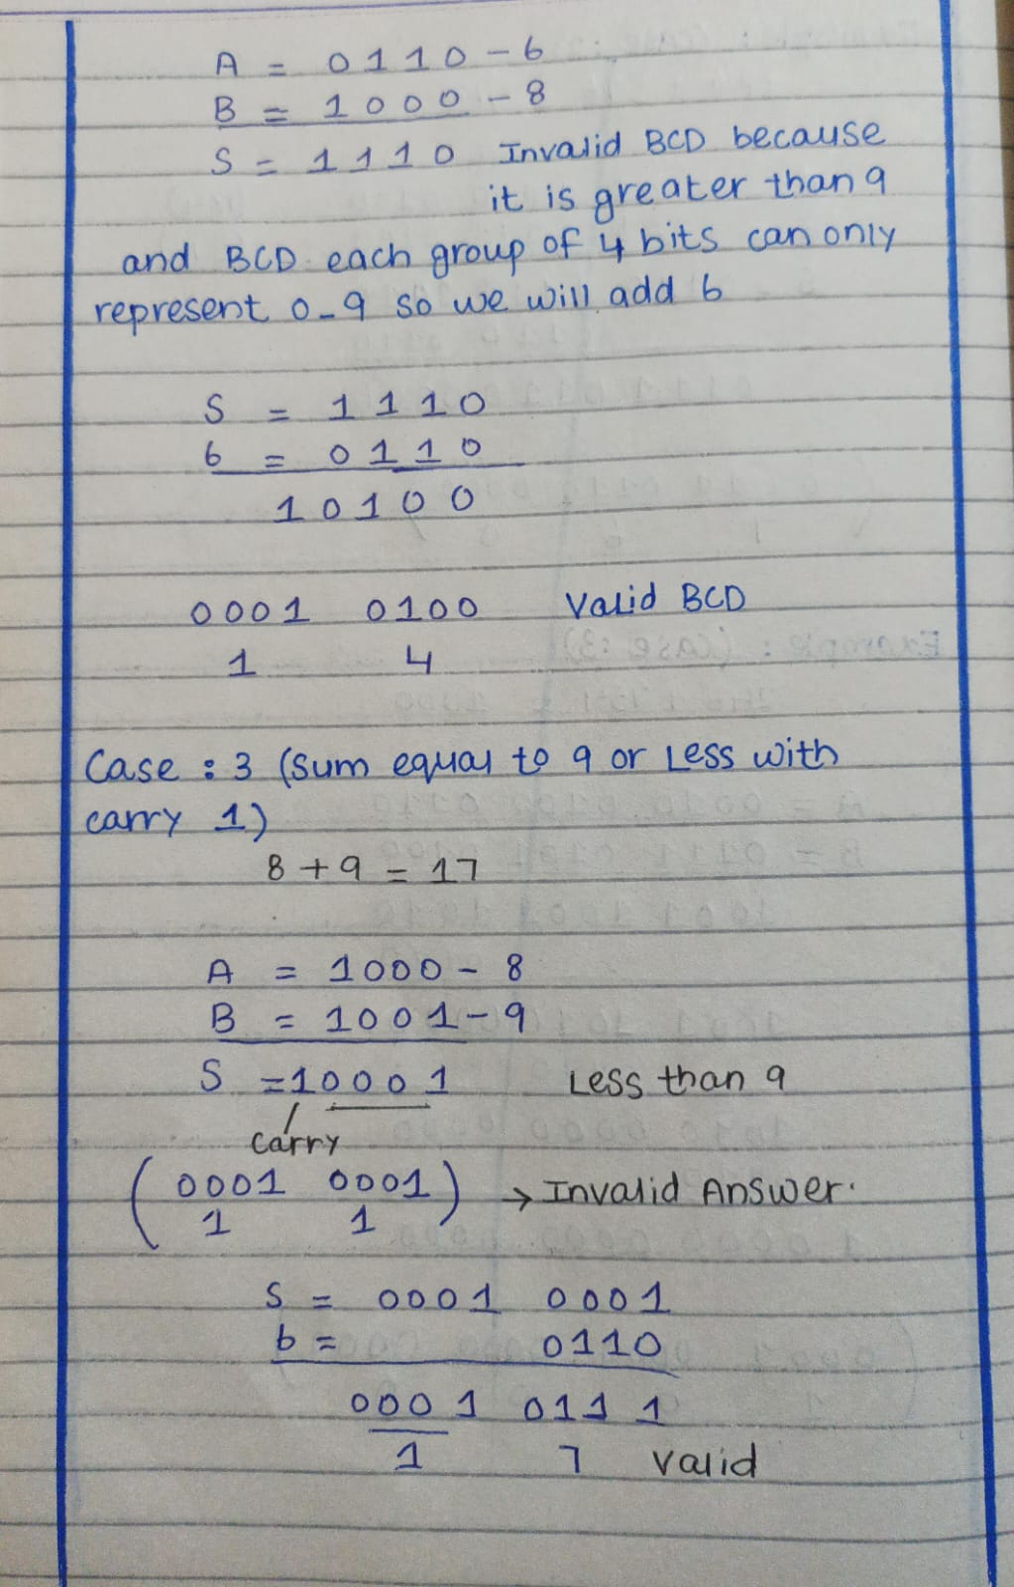
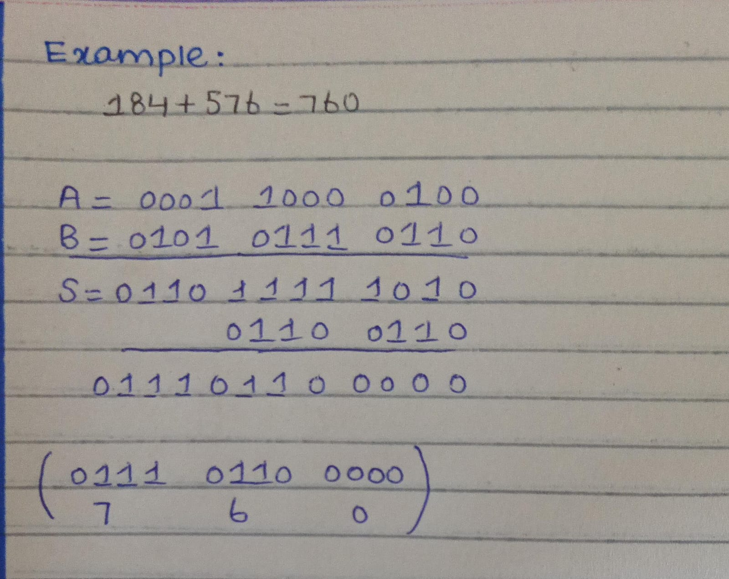
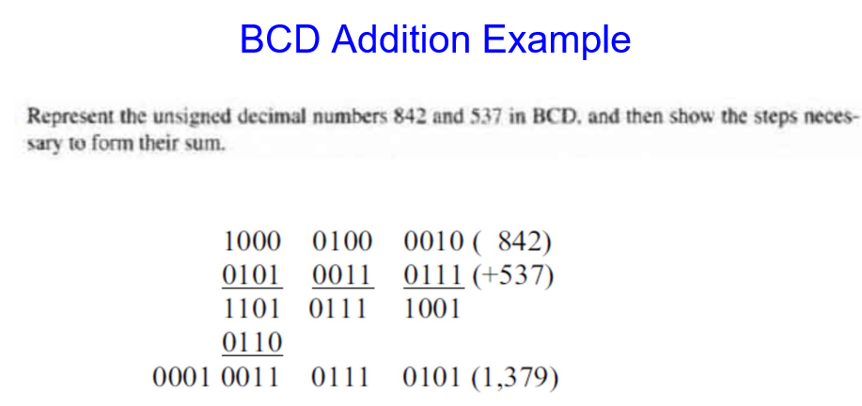

Character Storage
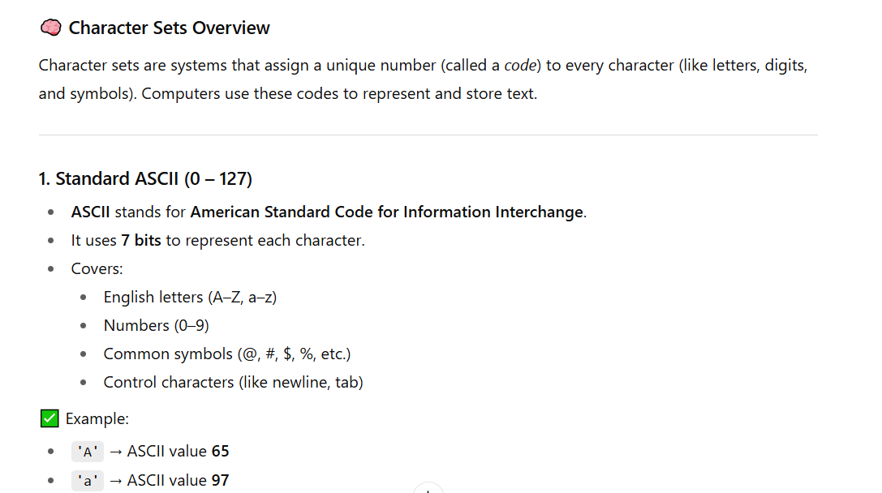
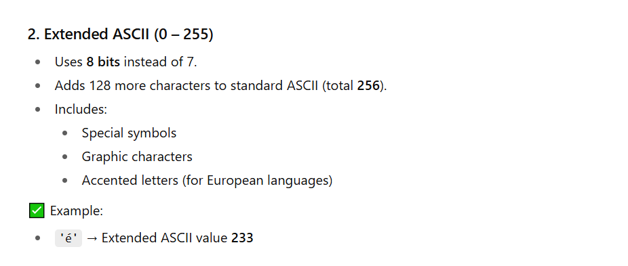
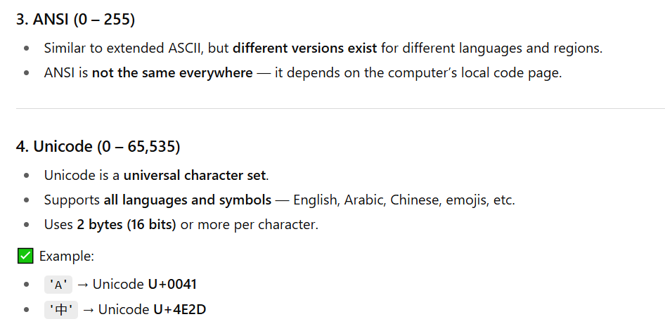
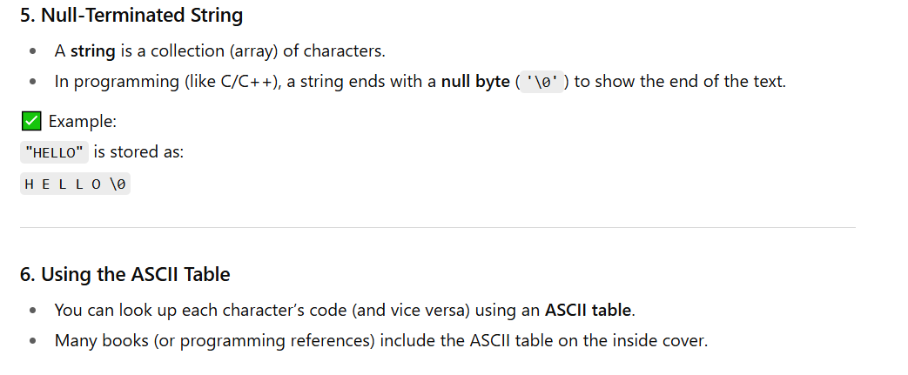
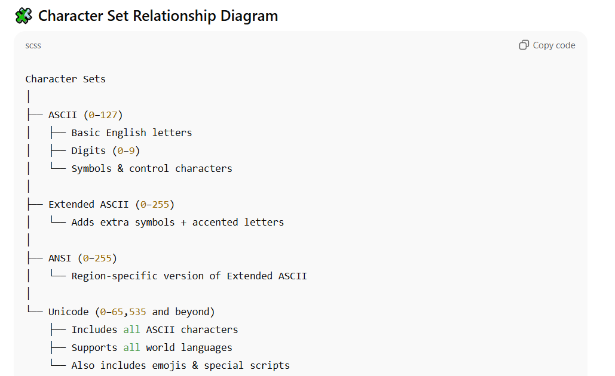

Numeric Data Representation
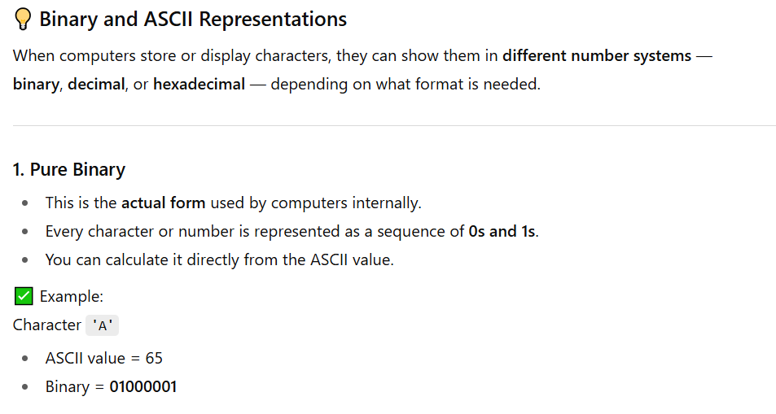
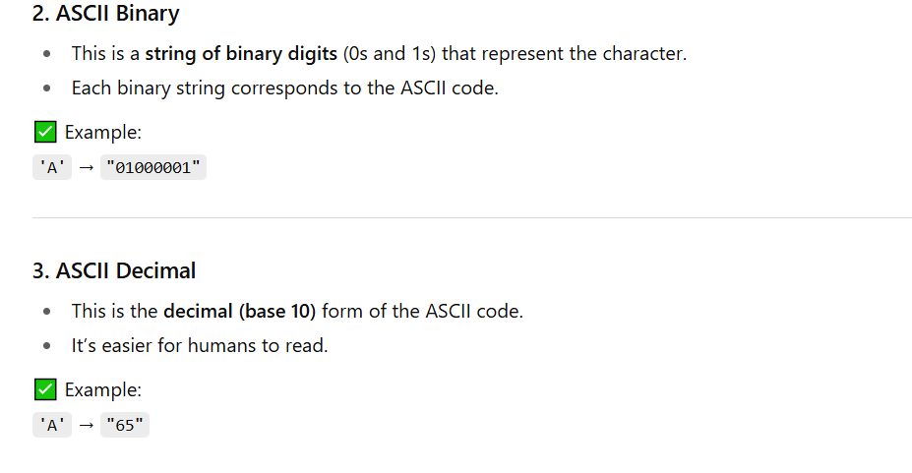
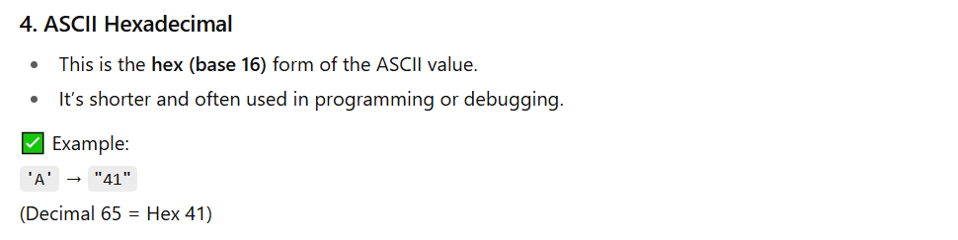

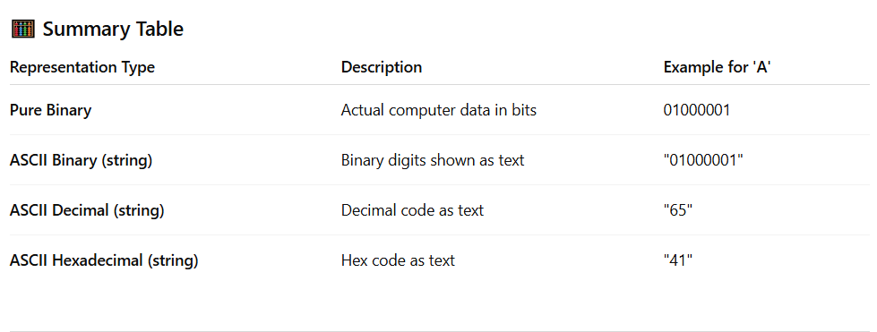
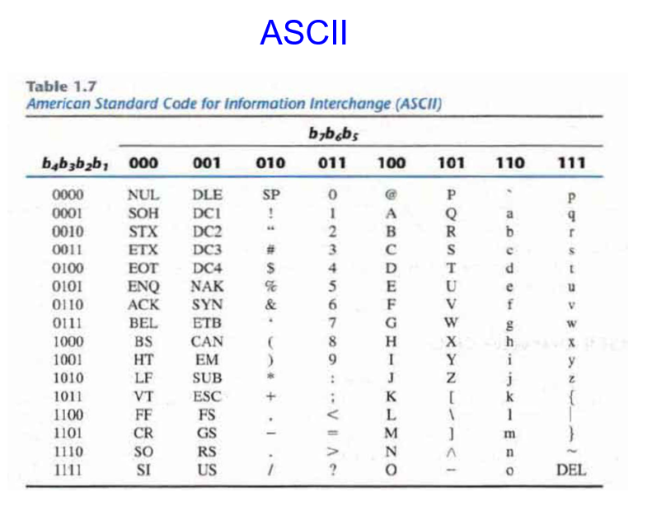

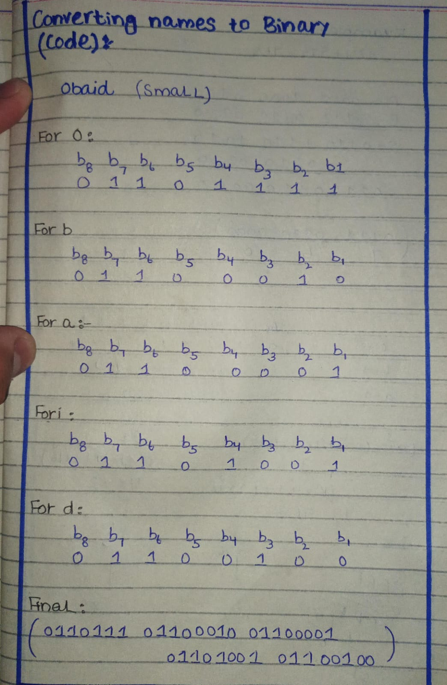
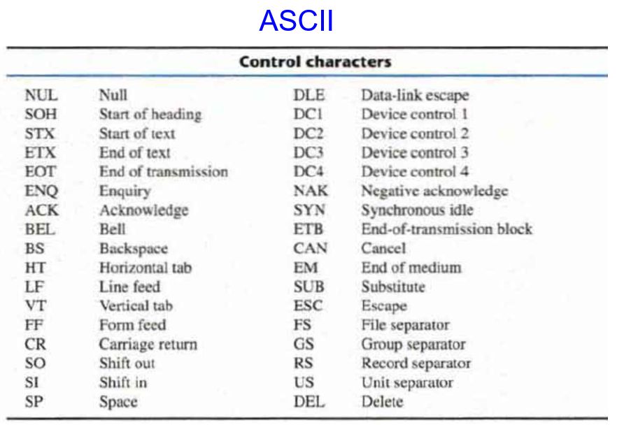
Question 03
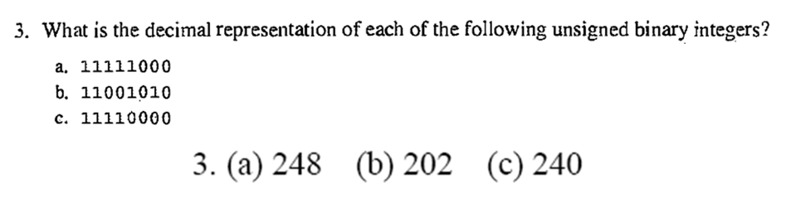
Solution
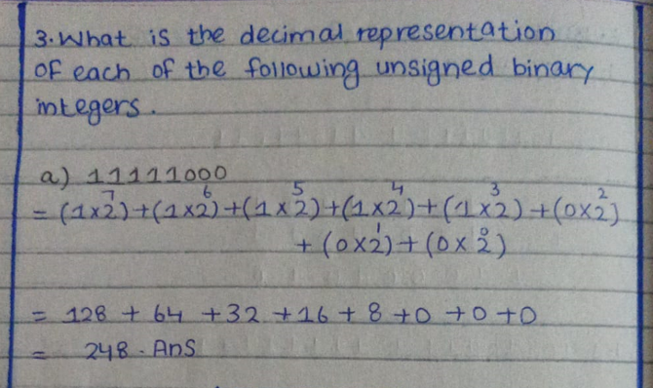
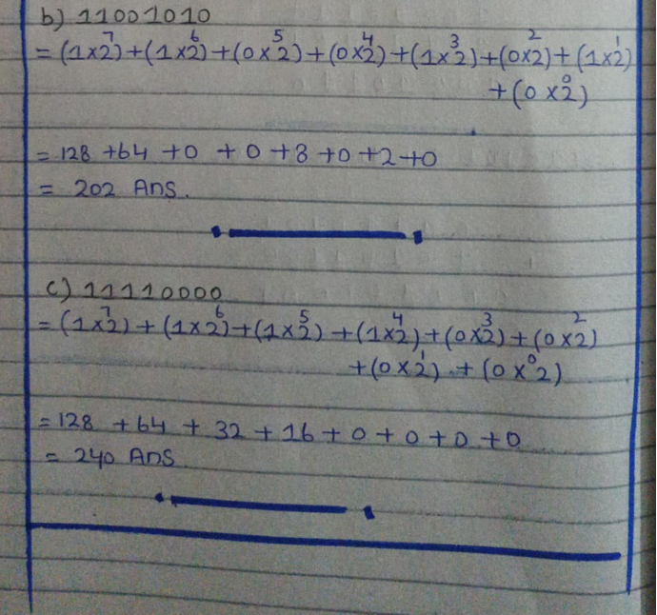
Question 06
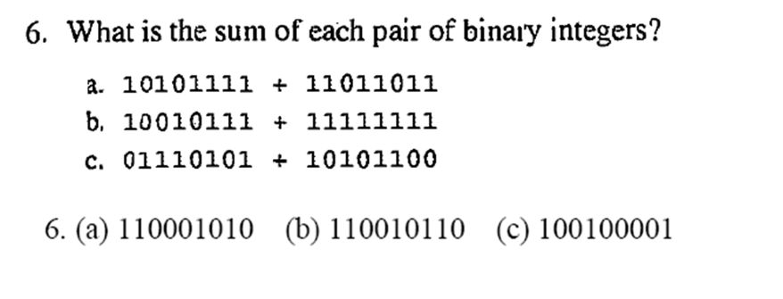
Solution
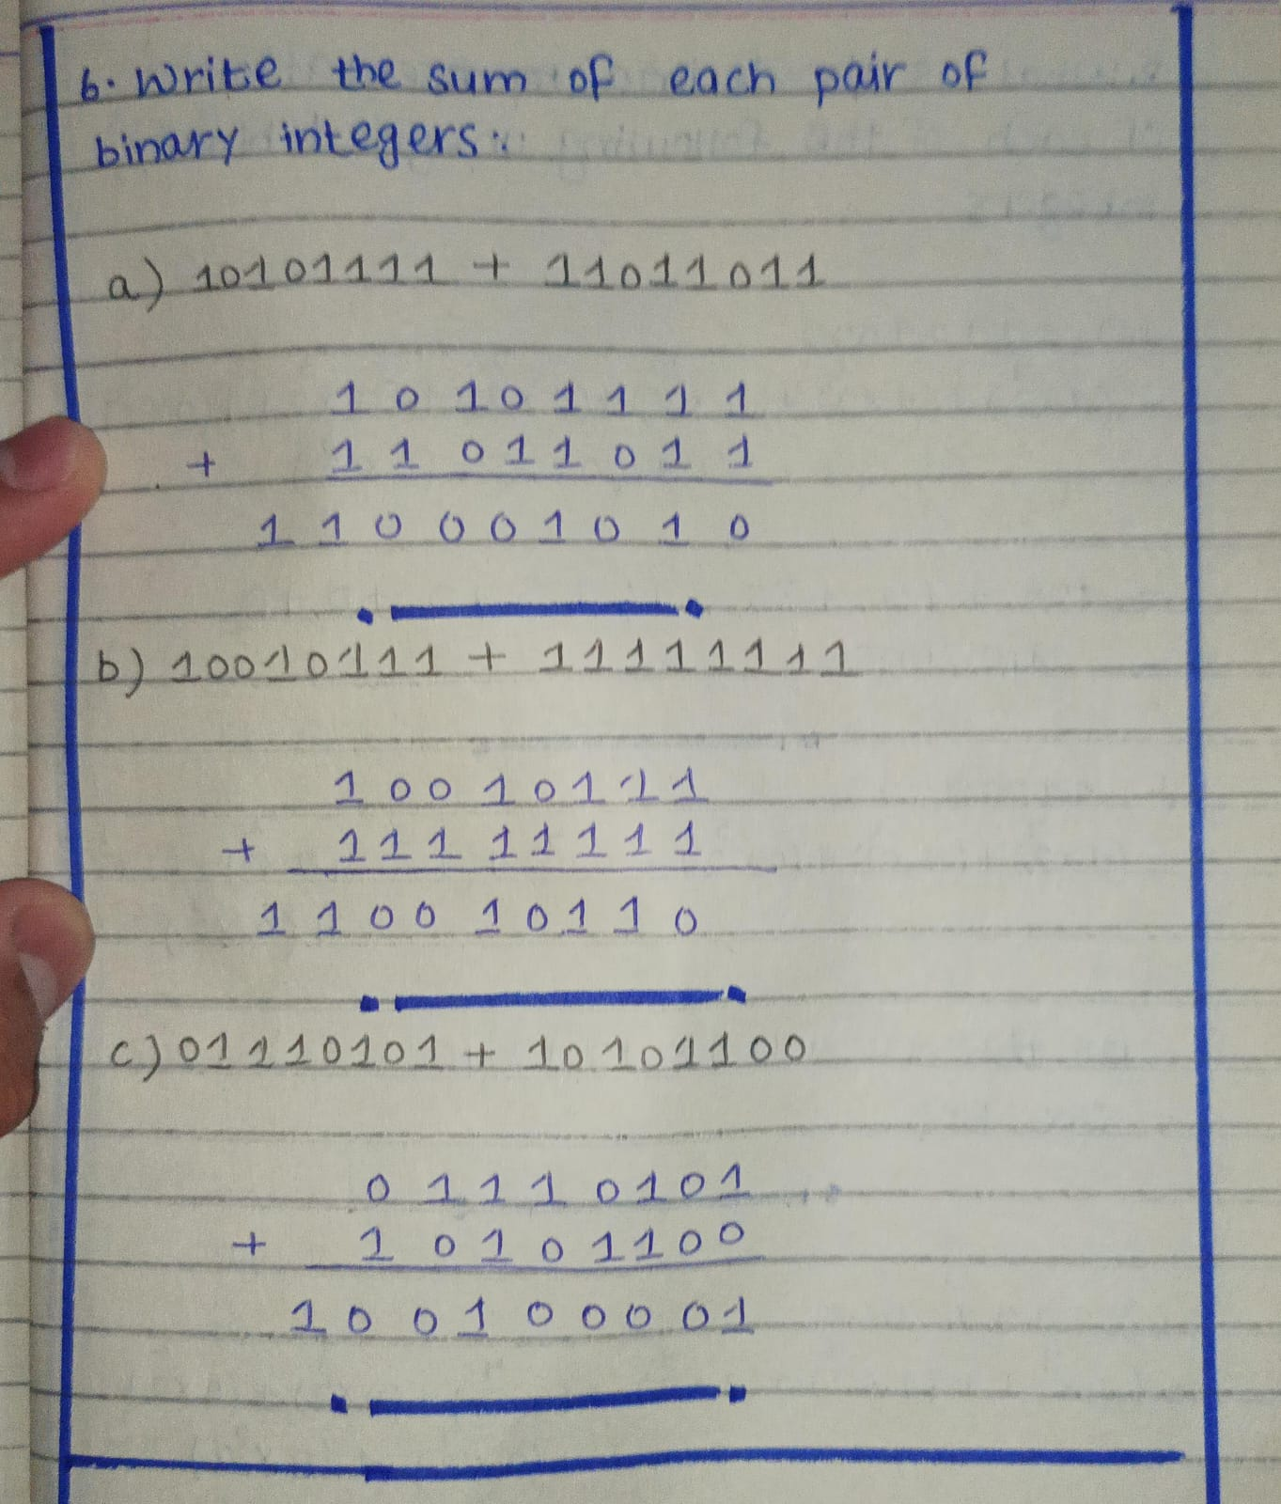

Question 12
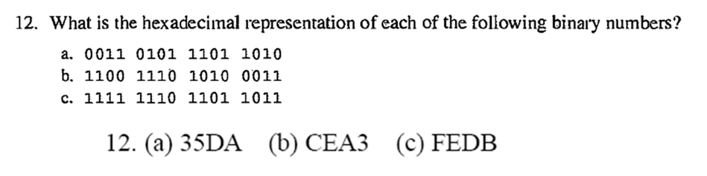
Solution
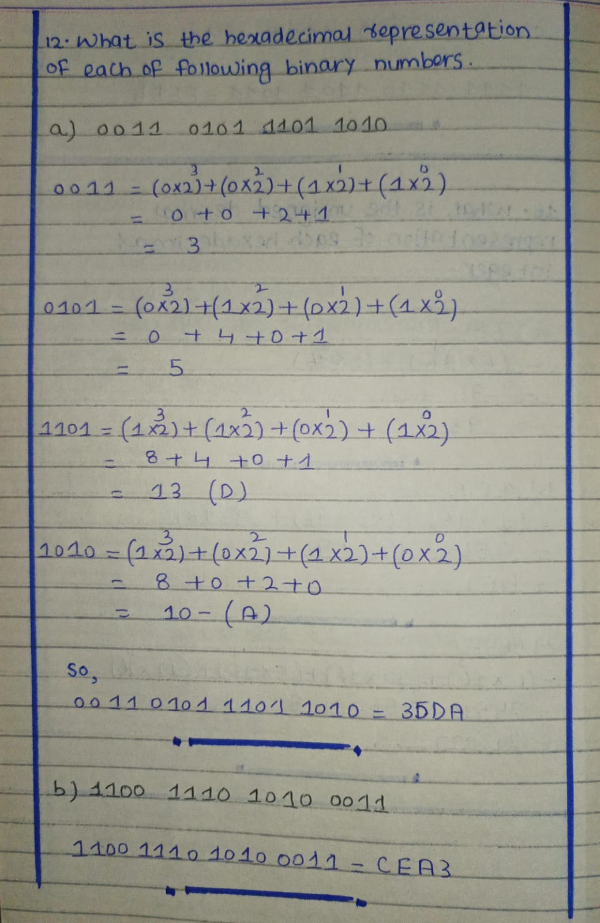
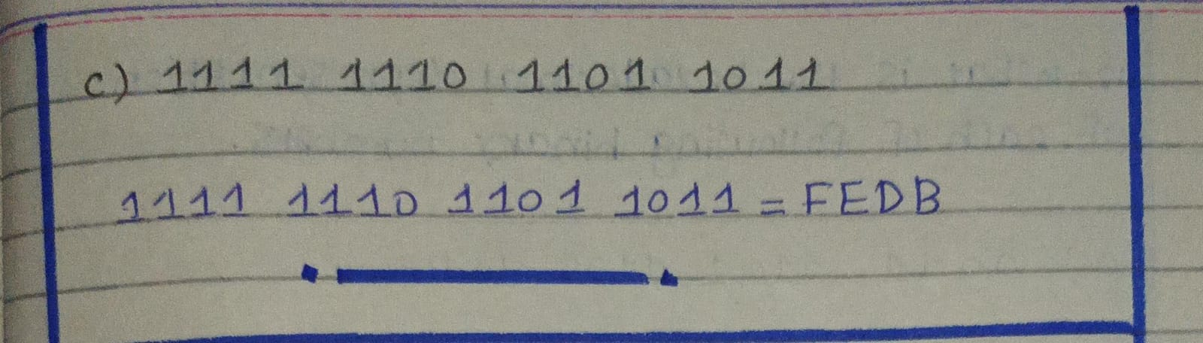
Question 16
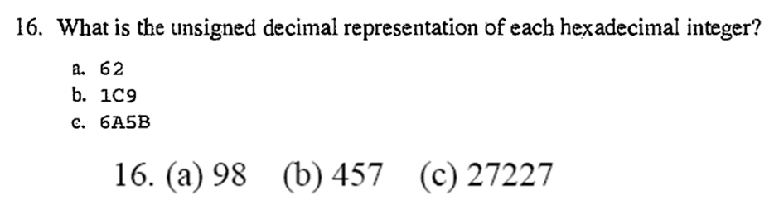
Solution
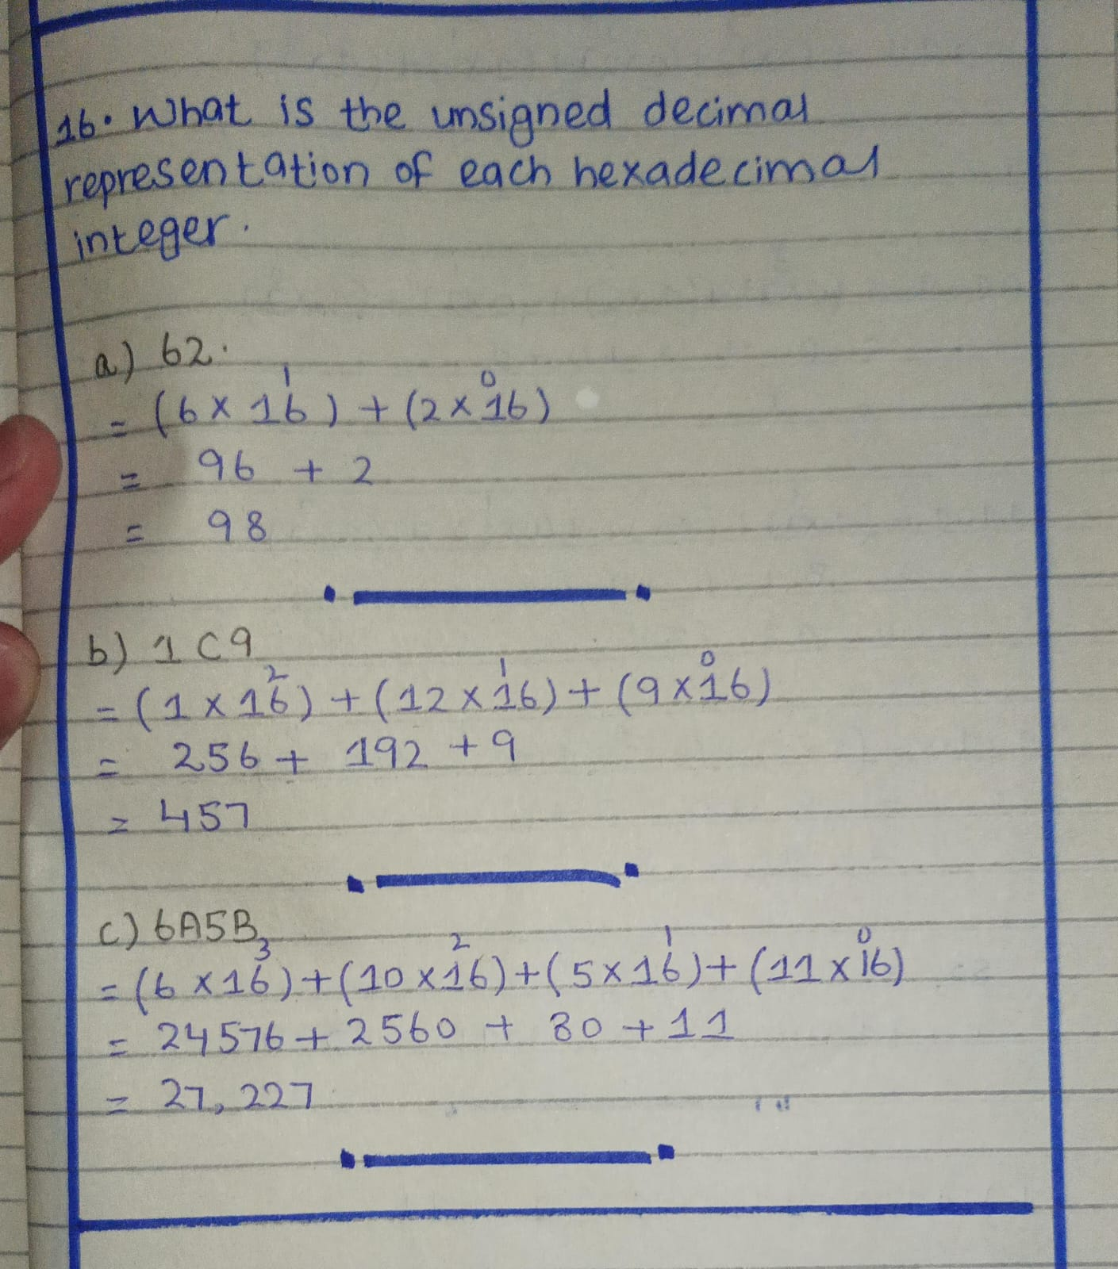
Question 18
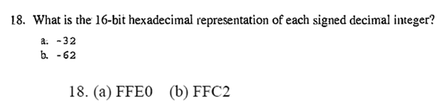
Solution
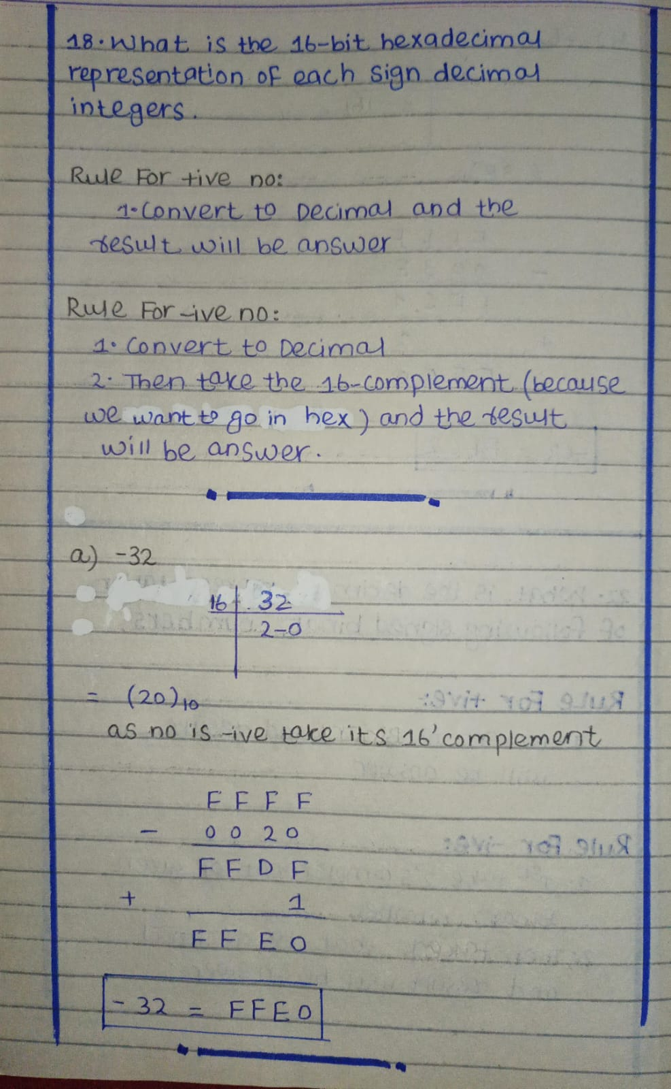
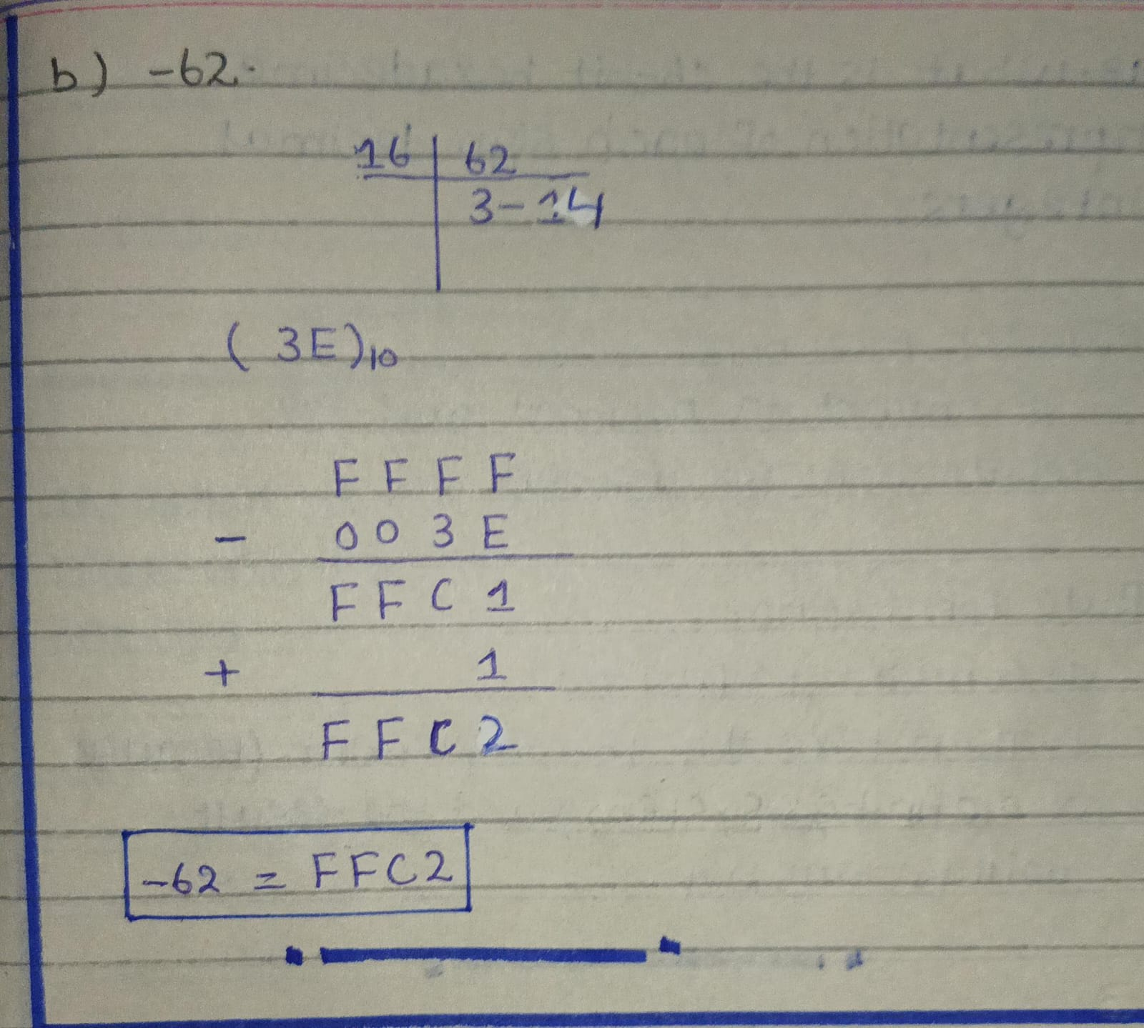
Question 22
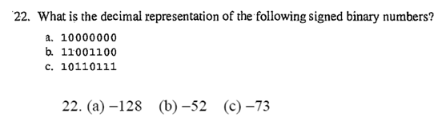

Solution
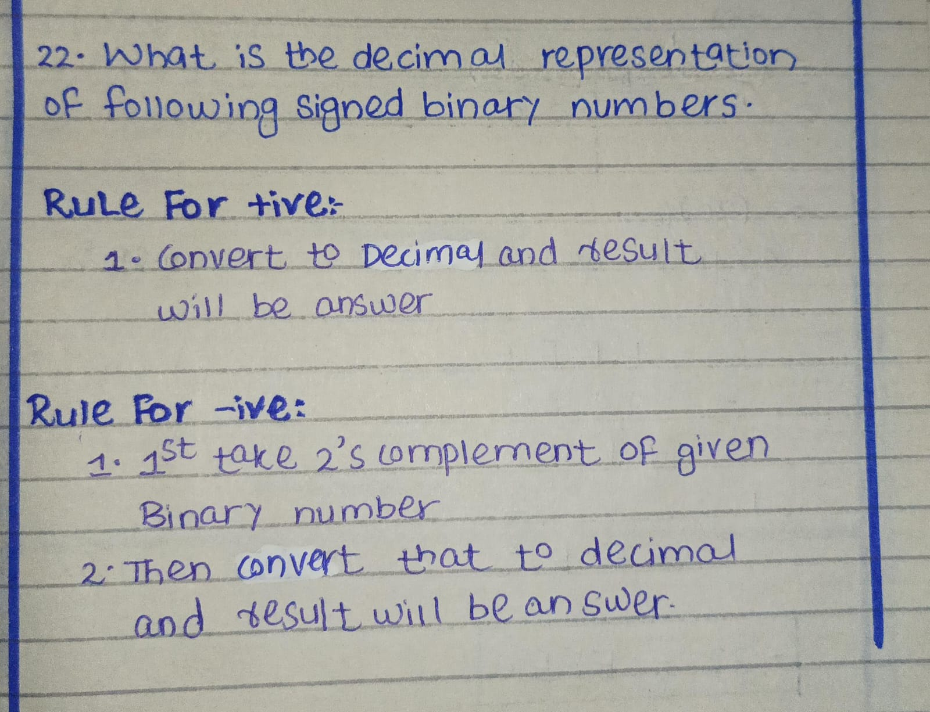
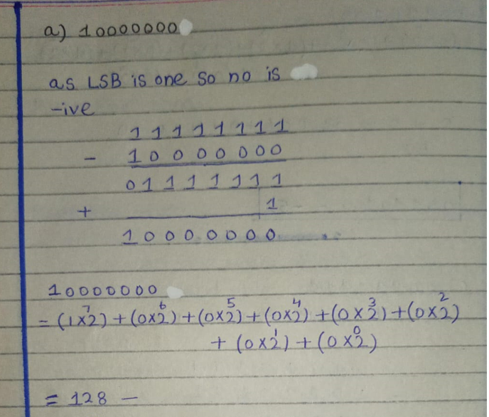
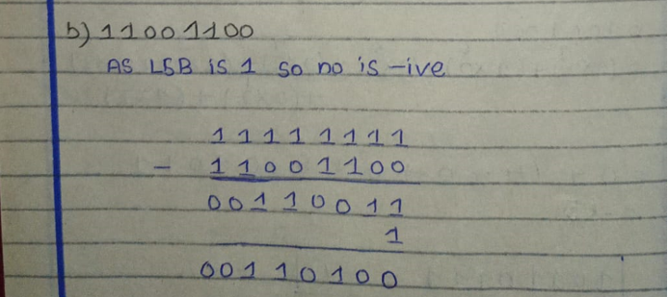
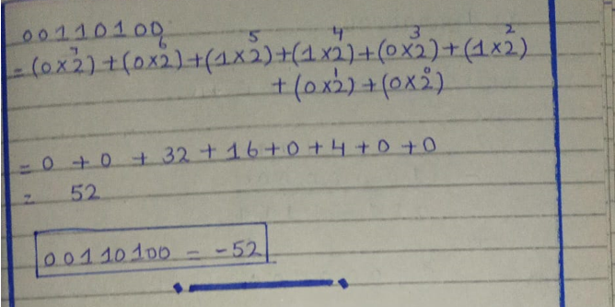
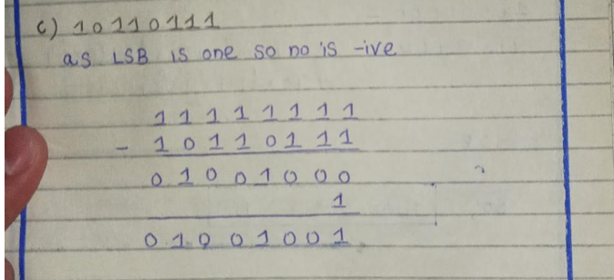
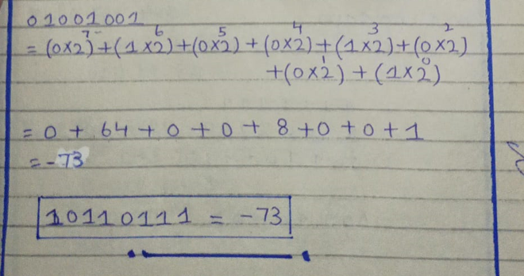
Question 20
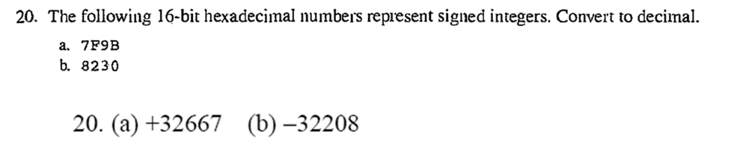
Solution
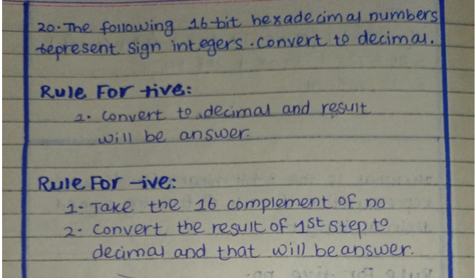
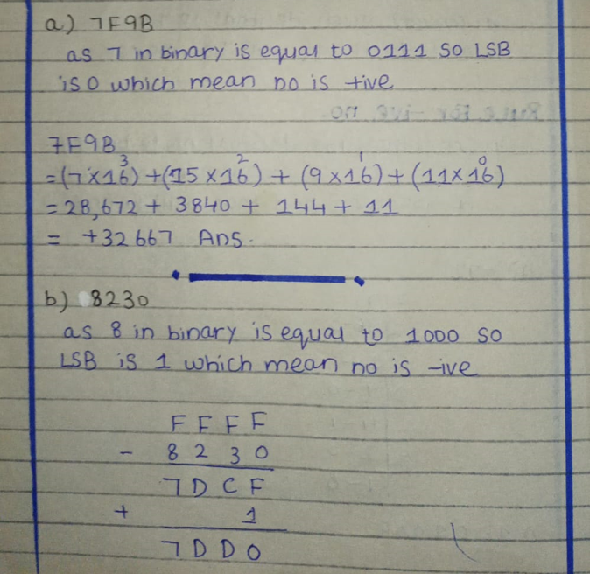
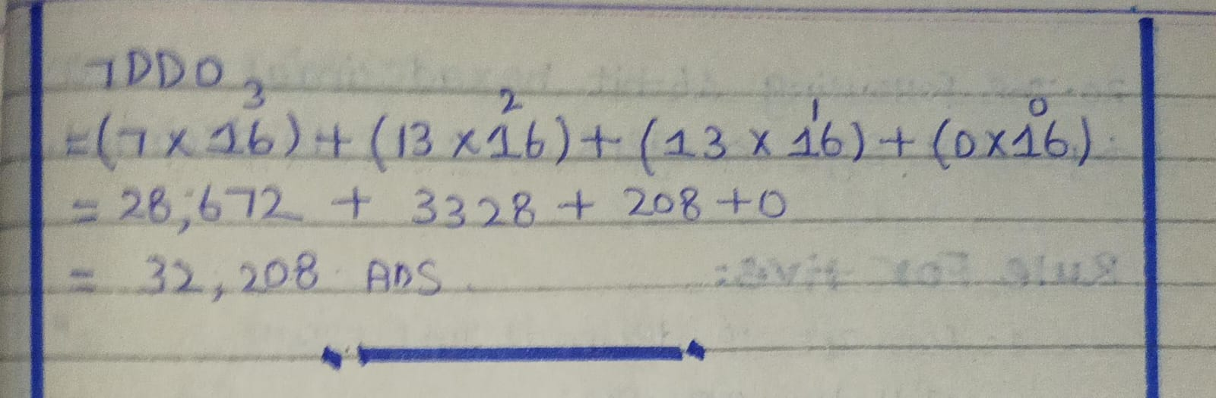

Question 24
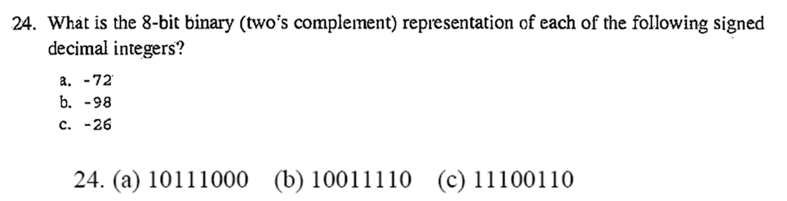
Solution
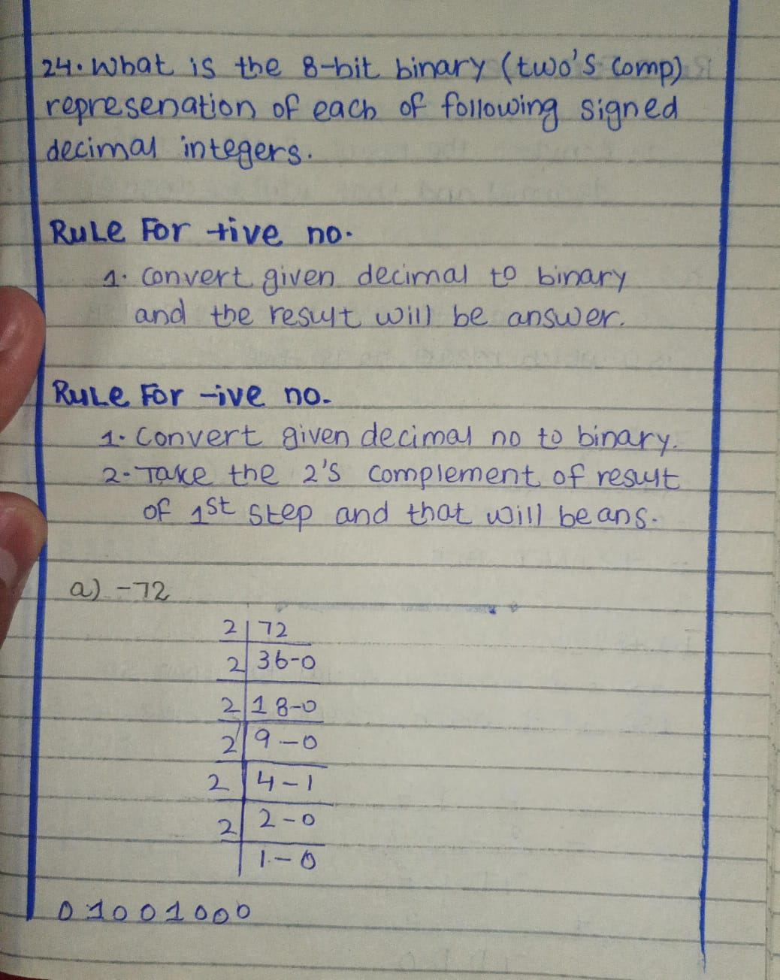
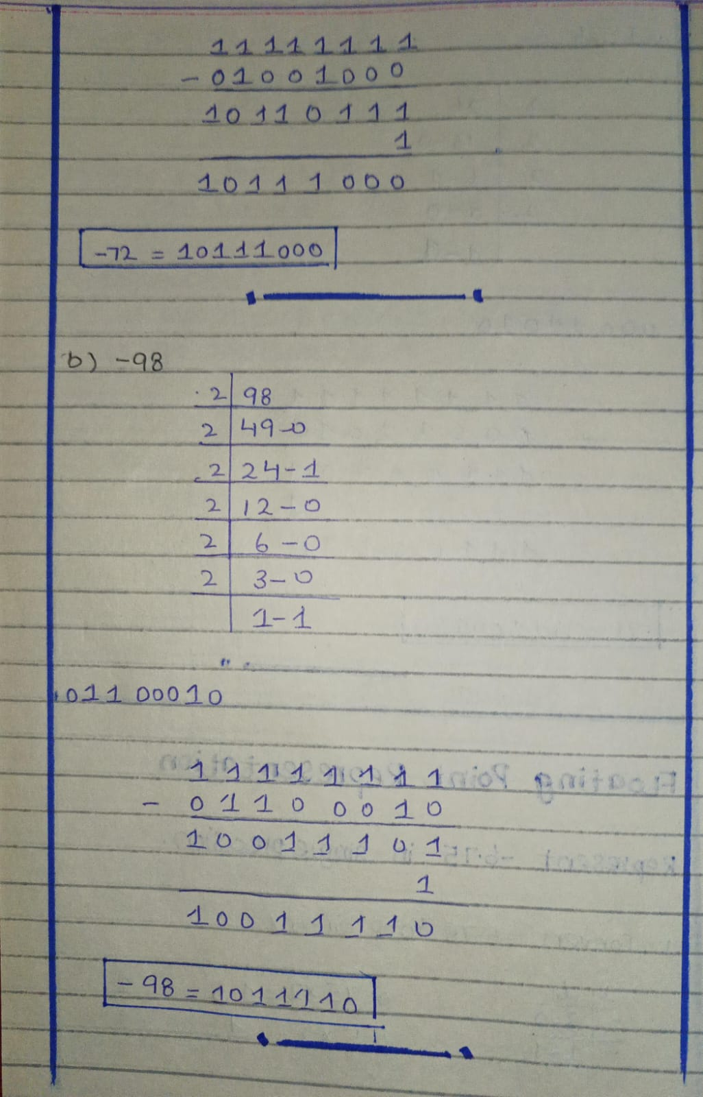
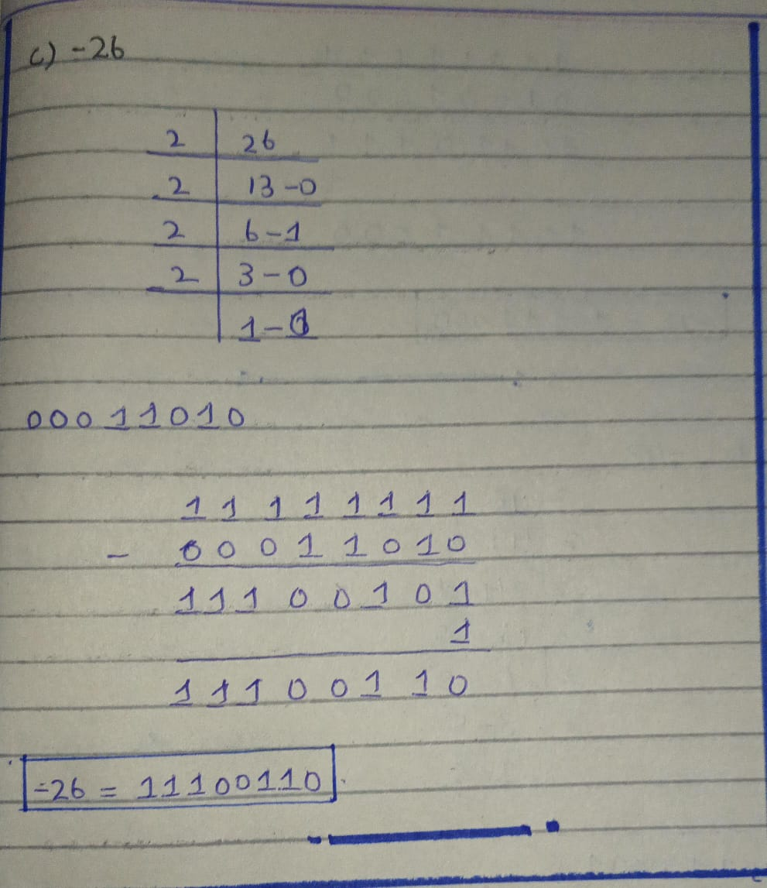

Floating Point Data Representation
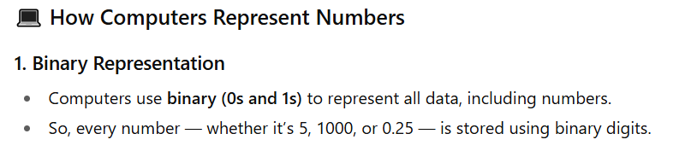
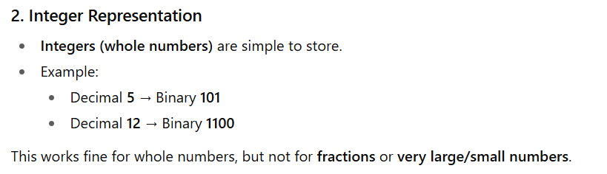
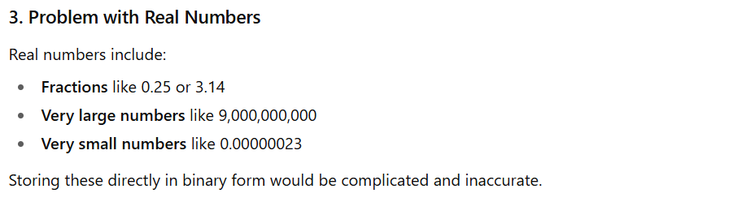
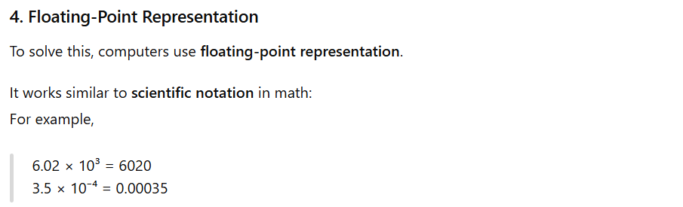

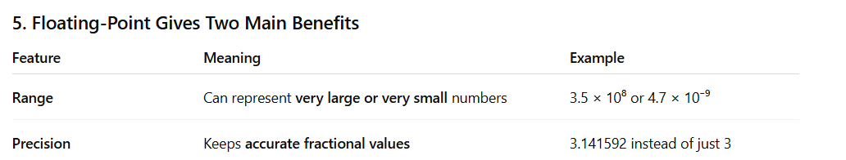
Floating Point Data Representation
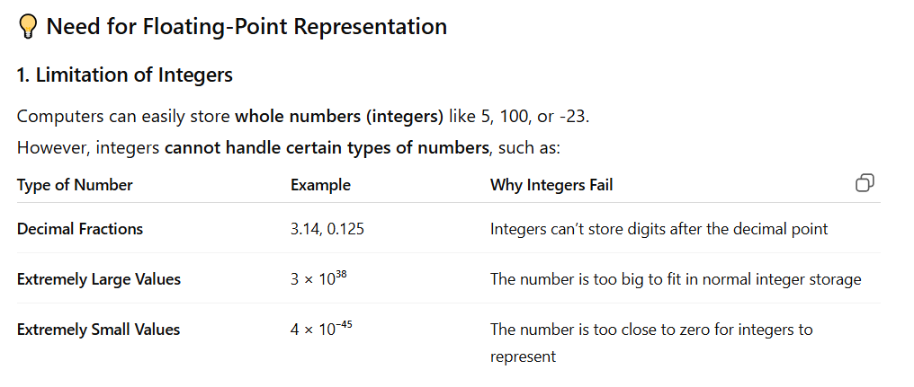
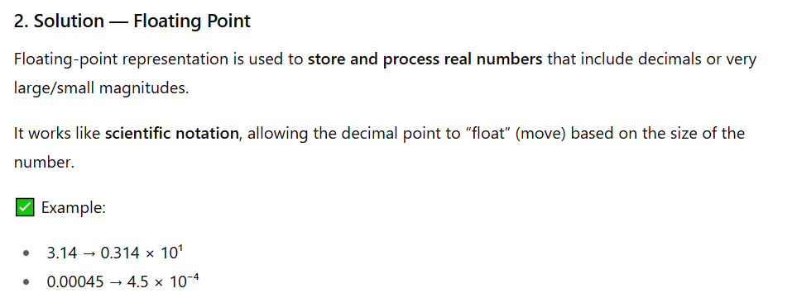
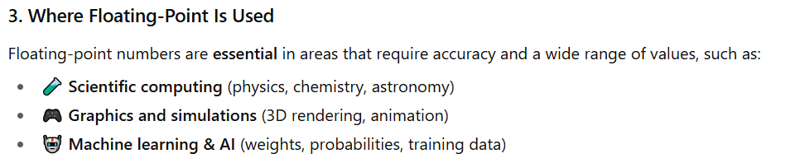
Floating Point Data Representation
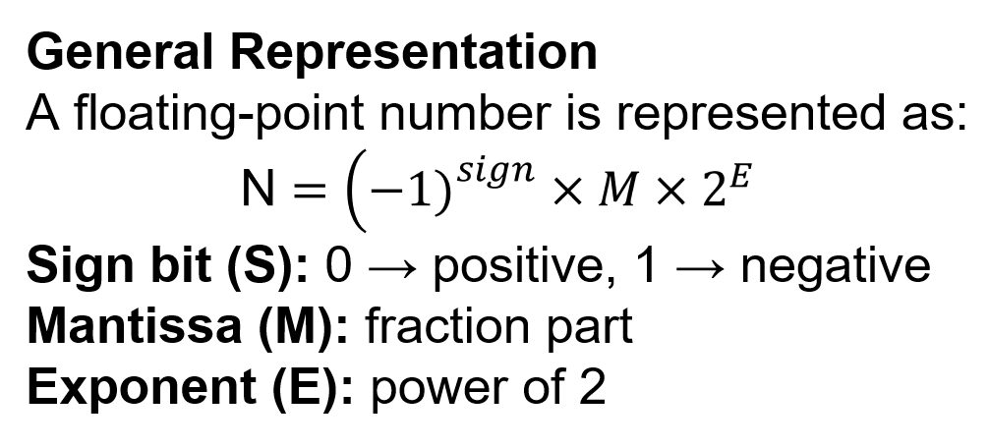
Floating Point Data Representation
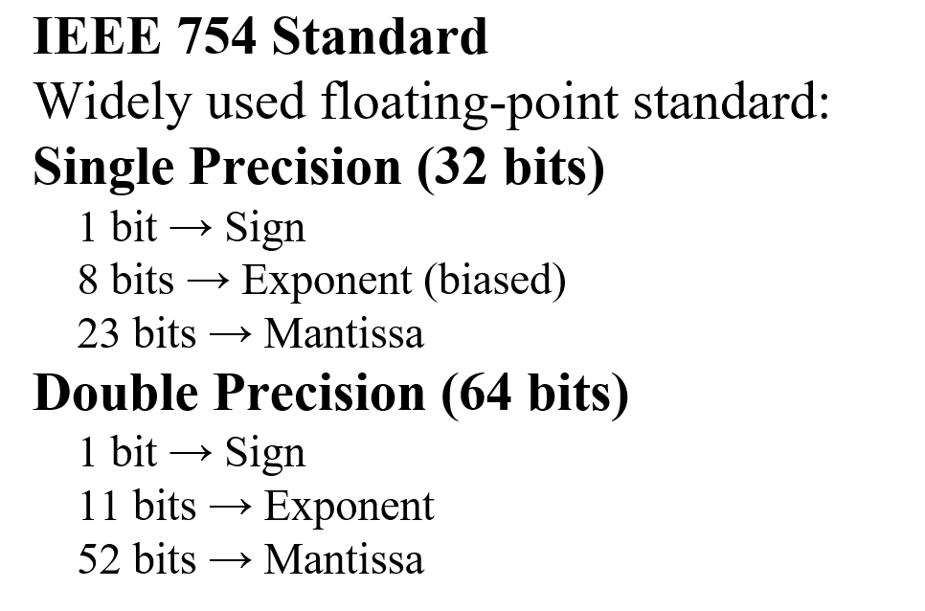

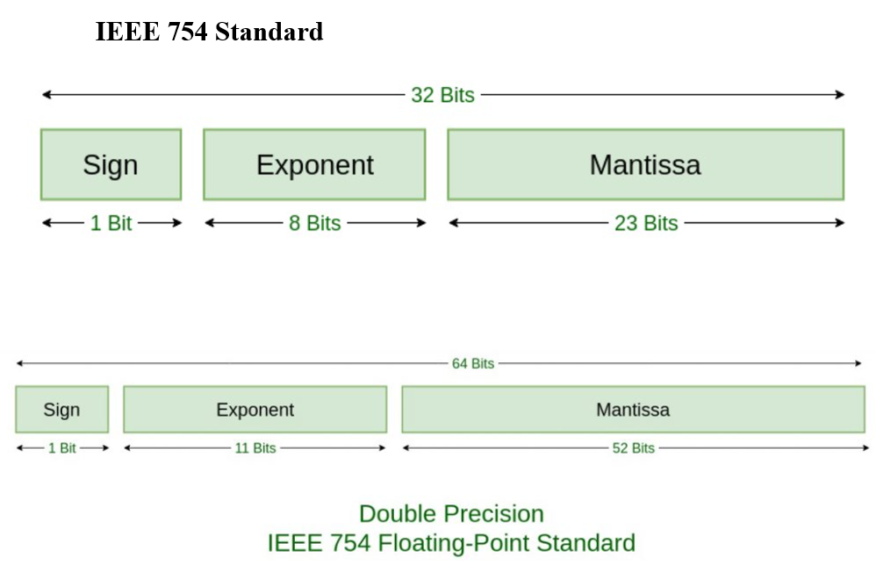
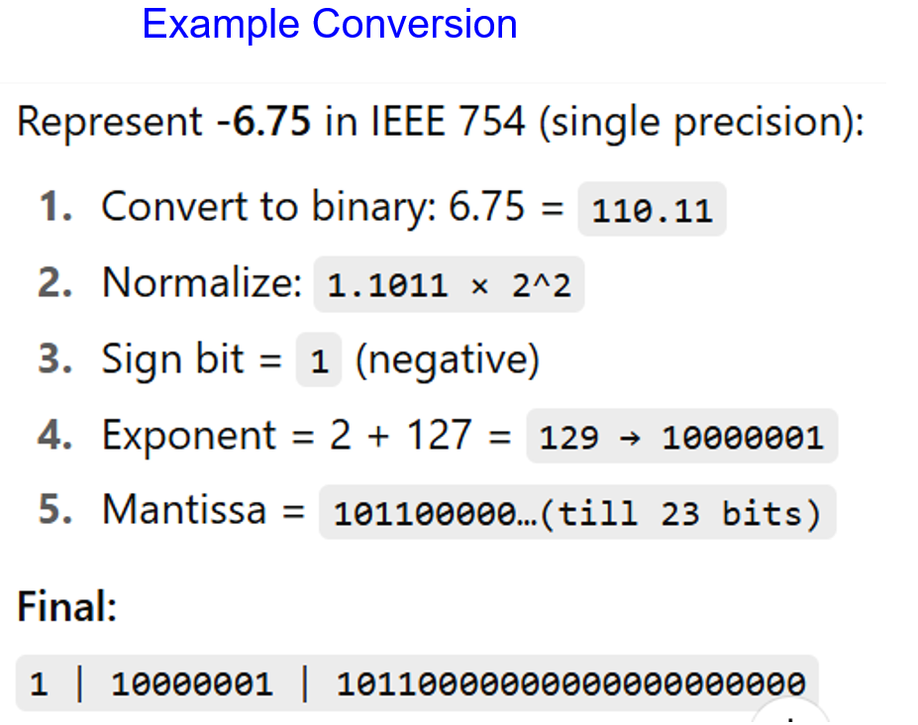
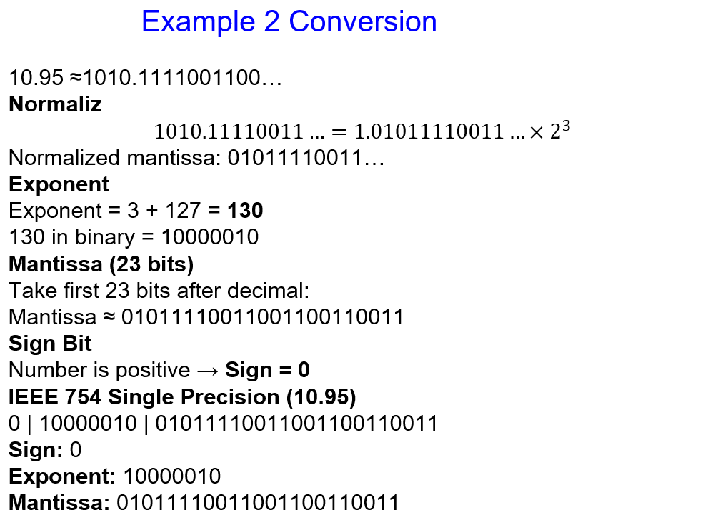
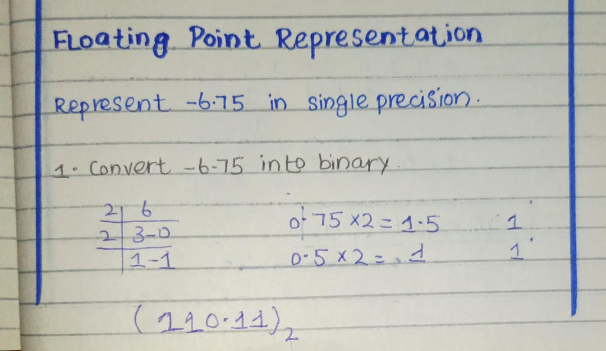
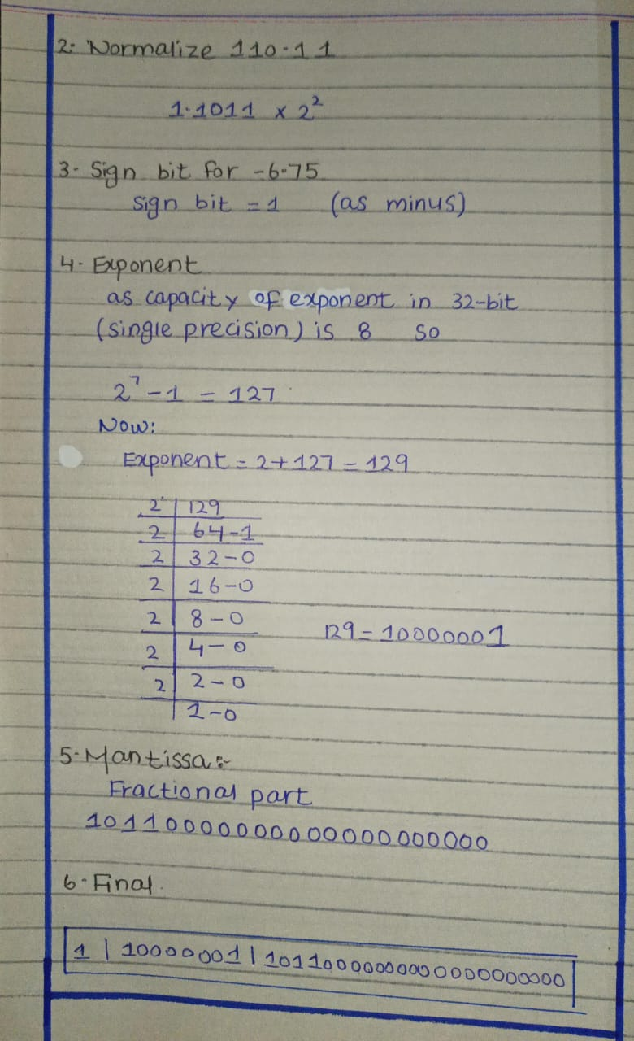
Lecture 1
Von Neuman Architecture
The Von Neumann Model
John W. Mauchly and J. Presper Eckert were the main inventors of ENIAC (Electronic Numerical Integrator and Computer), which was the first all-electronic, general-purpose digital computer.
Later, they got the idea that a computer should be able to store both data and program instructions inside its memory.
A mathematician named John von Neumann read their proposal for another computer called EDVAC (Electronic Discrete Variable Automatic Computer). He liked the idea and helped to publish and explain it clearly so everyone could understand.
Because of this, all computers that store programs in memory are now called Von Neumann systems, and this design is known as the Von Neumann architecture.
Additional Concepts
Stored program
Store programs mean the instructions (program) are kept in the computer’s memory along with the data, so the computer can read and execute them automatically without manual setup.
Stored-Program Concept (Before Von Neuman)
Before Von Neuman Architecture computers could not store programs in memory — they were manually programmed using switches, plugs, or punched cards for each new task.
So, to run a different program, the machine had to be rewired or reconfigured completely.
ENIAC
ENIAC was the first fully electronic general-purpose computer (means it can be used to perform many different types of tasks or calculations, not just one specific job).
It was designed to perform fast and complex mathematical calculations, especially for the U.S. Army, such as computing artillery firing tables (used to aim weapons accurately).
EDVAC
EDVAC (Electronic Discrete Variable Automatic Computer) was one of the earliest stored-program computers, designed to store both data and instructions in memory, making it faster and more flexible than earlier machines like ENIAC.
The Von Neuman Model
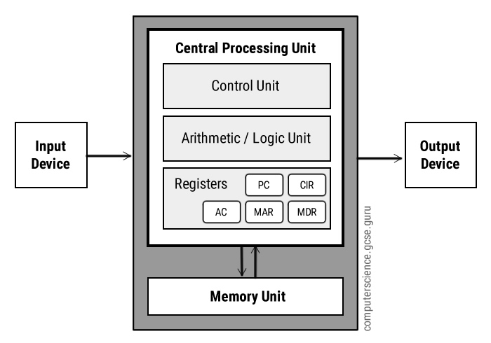
The Von Neumann Model
Today’s computers that use the stored-program idea have these main features:
1. Three main hardware parts:
- CPU (Central Processing Unit): It includes the Control Unit, ALU (Arithmetic Logic Unit), Registers (small memory areas), and a Program Counter (keeps track of the next instruction).
- Main Memory: Stores both data and program instructions.
- Input/Output System (I/O): Lets the computer communicate with the outside world (like keyboard, mouse, monitor, etc.).
2. Step-by-step instruction processing
The computer follows one instruction at a time in order.
3. Single communication path
There is only one path between the CPU and main memory, so the computer must alternate between fetching instructions and executing them.
This delay is called the Von Neumann Bottleneck.
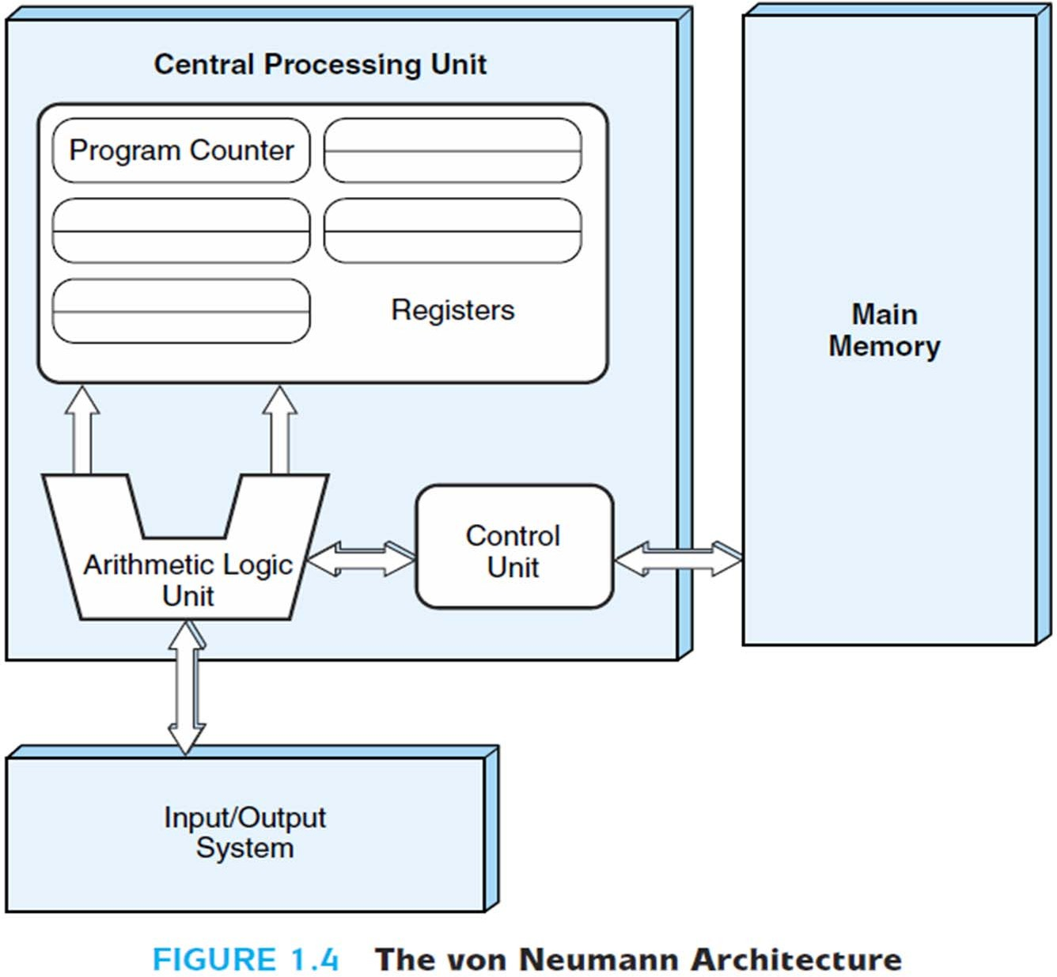
Von Neumann Bottleneck
The Von Neumann Bottleneck is a major limitation in the Von Neumann computer architecture. It occurs because both program instructions and data share the same communication path between the CPU and main memory, which slows down processing.
1. One communication path
In this architecture, there is only one path (bus) that connects the CPU and memory.
Both data and instructions use this same path, which creates a traffic jam when both are needed at the same time.
2. Sequential Execution
Because of the single path, the CPU can process only one instruction at a time.
It must first fetch an instruction, then execute it, and only then move to the next one — leading to slower performance.
3. Data and Instruction Conflict
Since data and instructions travel through the same path, they can interfere or compete for access.
This conflict prevents the CPU from fetching data and instructions simultaneously.
4. Result — Slow Processing Speed
These limitations cause the CPU to wait frequently, reducing the overall speed and efficiency of the system.
It is called a bottleneck because, like the narrow neck of a bottle, it limits the flow of data between memory and the processor.

The Von Neumann Instruction Execution Cycle
In the Von Neumann architecture, the CPU follows a specific step-by-step process to fetch and execute instructions stored in memory.
This process is called the Instruction Execution Cycle or Fetch–Decode–Execute Cycle.
1. Fetch
The Control Unit gets (fetches) the next instruction from the main memory.
The Program Counter (PC) keeps track of the memory address of that instruction.
After fetching, the PC is updated to point to the next instruction.
Example: The CPU reads the next command (like “add two numbers”) from memory.
2. Decode
The fetched instruction is then interpreted (decoded) by the Control Unit.
The CPU figures out what action needs to be performed and which data or registers are involved.
Example: The CPU understands that the command means “add the numbers in Register A and Register B.”
3. Execute
The Arithmetic Logic Unit (ALU) or other CPU parts perform the actual operation.
This could be a calculation, data transfer, or logical comparison.
Example: The CPU adds the two numbers and stores the result in a register or memory.
4. Write Back
Once the instruction is executed, the CPU repeats the cycle — fetching the next instruction, decoding it, and executing it — repeatedly, very quickly.
Von Neumann Buses
In the Von Neumann architecture, buses are the communication pathways that connect the CPU, memory, and input/output (I/O) devices.
They carry data, instructions, and control signals between different parts of the computer.
There are three main types of buses:
1. Data Bus
- Carries actual data between the CPU, memory, and I/O devices.
- It is bidirectional — data can move to and from the CPU.
Example: Sending numbers to the CPU for calculation or storing results back in memory.
2. Address Bus
- Carries the address (location) of data or instructions in memory.
- It is unidirectional — only the CPU sends addresses to memory or I/O devices.
Example: The CPU tells memory where to find or store data.
3. Control Bus
- Carries control signals that manage and coordinate all computer activities.
- These signals tell other components what to do, such as read, write, or stop.
Example: The CPU sends a signal to memory saying “read data from this address.”
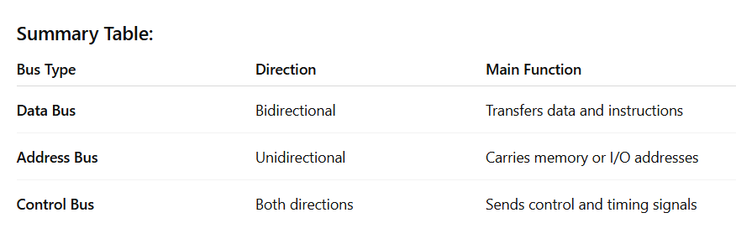
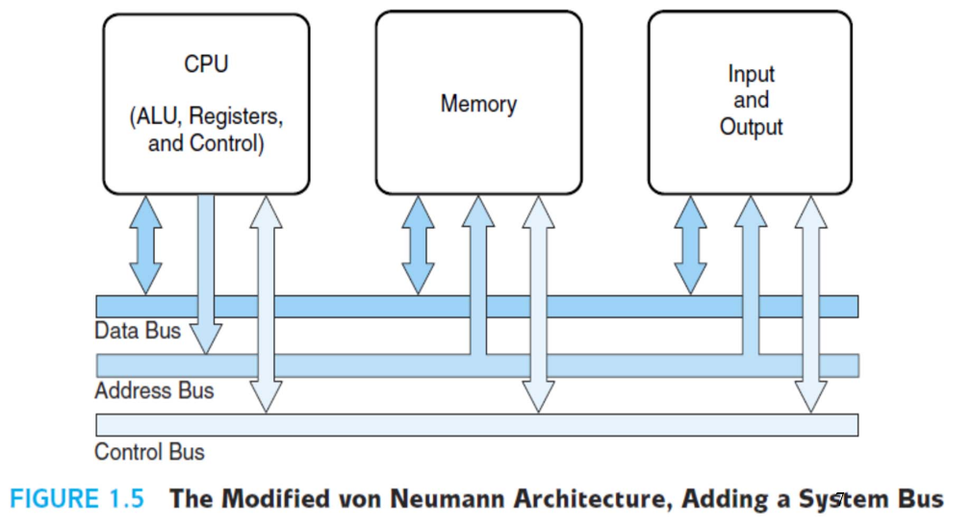
Extension of von Neumann Architecture
The von Neumann architecture has been improved so that programs and data stored on slow devices (like hard drives) can be copied to faster memory (like RAM) before the program runs. This makes execution quicker because RAM can be accessed much faster.

System Bus Model
This updated version of the architecture is known as the system bus model.
In this model:
- The data bus transfers data between the main memory and the CPU registers (both ways).
- The address bus carries the address of the specific data that is being accessed.
- The control bus sends control signals that manage how and when the data transfer happens.
Enhancements to von Neumann Architecture
Some improvements made to the von Neumann design include:
- Using index registers for addressing data efficiently.
- Supporting floating-point data (decimal numbers).
- Introducing interrupts and asynchronous I/O to handle multiple tasks smoothly.
- Adding virtual memory to increase usable memory.
- Using more general-purpose registers to speed up processing.
Welcome to Assembly Language
Assembly language is a low-level programming language that is closer to the computer’s hardware.
It uses short words or symbols (called mnemonics) instead of 0s and 1s (machine code).
Example: Instead of writing 10110000 01100001, you write MOV AL, 61h.

1. How does Assembly Language (AL) relate to Machine Language?
One-to-one relationship
Each instruction in assembly language corresponds directly to one specific machine code instruction.
Example:
ADD AX, BX in AL → becomes one machine code instruction that adds the two registers.
2. How do C++ and Java relate to Assembly Language?
One-to-many relationship
A single line of code in C++ or Java often becomes many assembly (and machine) instructions when compiled.
Example:
sum = a + b; in C++ → compiler generates multiple AL instructions for loading, adding, and storing values.
3. Is Assembly Language portable?
No
Assembly language is not portable because it depends on the processor type (CPU architecture).
Example:
Code written for an Intel processor will not run on an ARM processor
4. Why learn Assembly Language?
- To understand how computers really work at the hardware level.
- To write highly efficient programs (e.g., in performance-critical systems).
- To debug or optimize low-level code.
- To work with embedded systems, device drivers, or operating systems.

Assembly Language Applications
Some representative types of applications:
- Business application for single platform –
Used to create programs that run on one specific operating system or computer type only.
Example: Payroll or inventory software for Windows only.
- Hardware device driver –
Written in assembly to directly control or communicate with hardware devices.
Example: Printer or keyboard driver.
- Business application for multiple platforms –
Some parts may use assembly for performance, even though the main program runs on different systems.
Example: Banking or accounting software optimized for speed.
- Embedded systems & computer games –
Assembly is often used where speed and efficiency are critical.
Example: Software in washing machines, robots, or fast computer games.

Comparing ASM to High-Level Languages
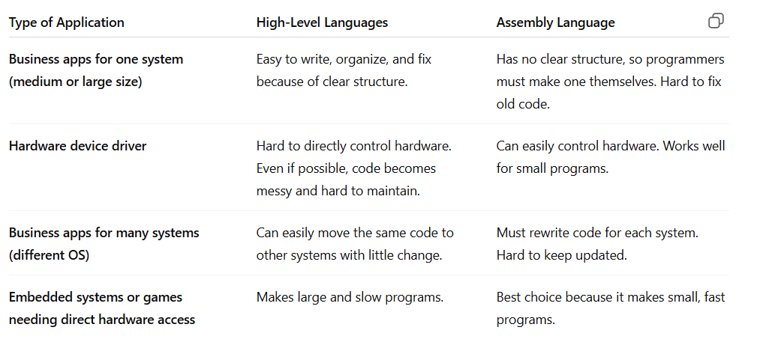
Questions
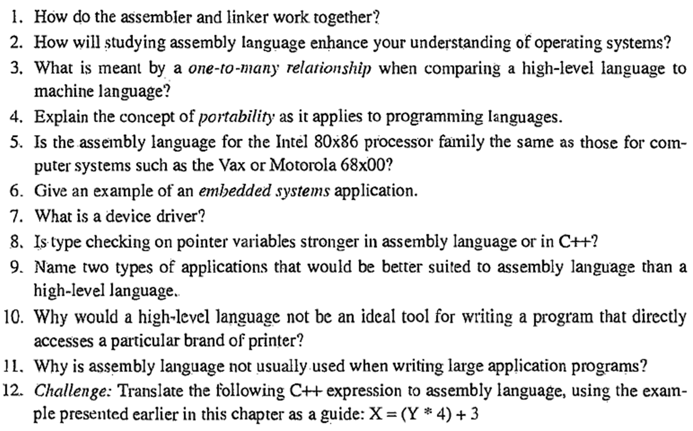
Answers
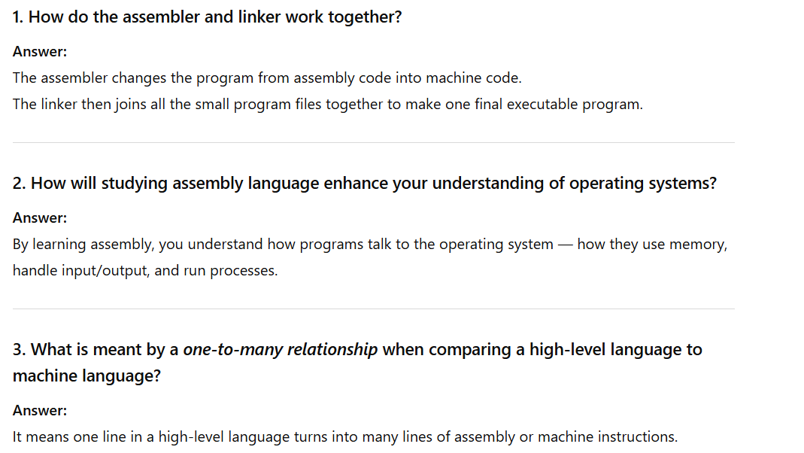
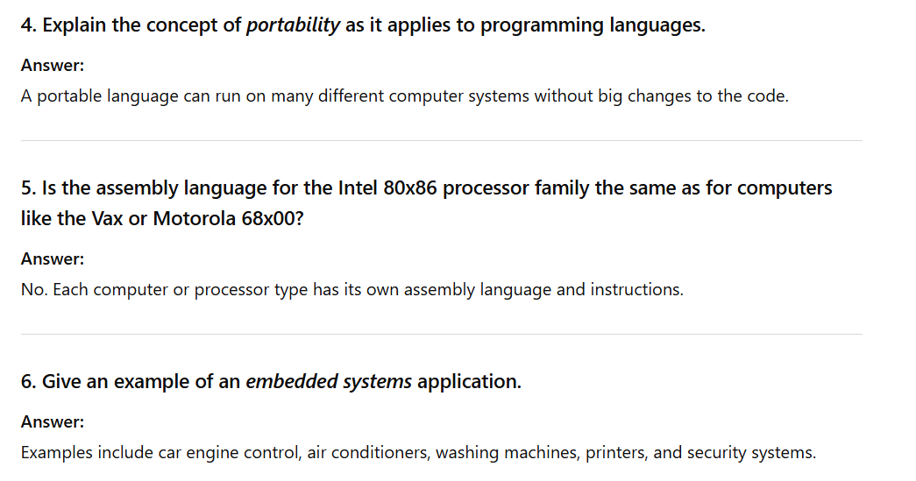
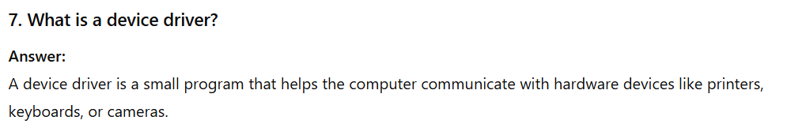
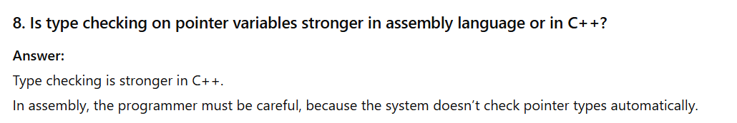
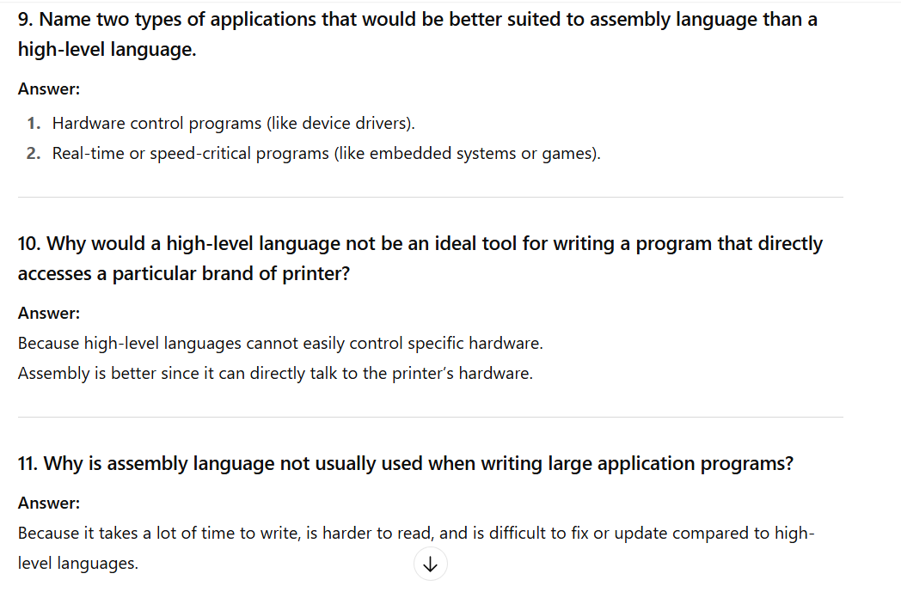
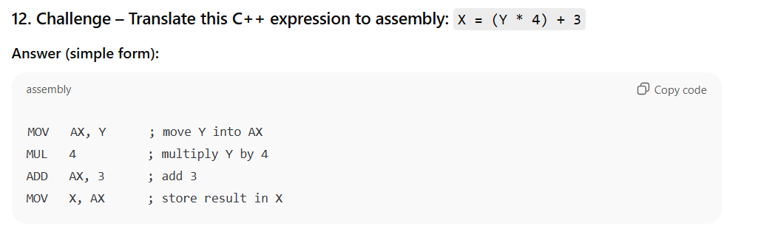

Virtual Machine?
A Virtual Machine (VM) is a software-based computer that runs inside a real computer.
It allows one physical computer to act like many separate computers, each with its own operating system and programs.
Every VM works independently, even though they share the same hardware.
This helps in testing, running different OS (like Windows and Linux together), and improving security.
Based on Tanenbaum
- Every real computer has its own basic language called machine language (L0) — it talks directly to the hardware.
- Above that, we can create a simpler or more human-friendly language (L1) to make programming easier.
- Programs written in L1 can run in two ways:
  - Interpretation: The computer runs an L0 program that reads and executes each L1 instruction one at a time.
  - Translation (Compilation): The L1 program is fully converted into an L0 program, which then runs directly on the hardware.
In simple words:
A virtual machine is like a layer between you and the real computer.
It lets you write and run programs as if you’re using another machine — even though you’re actually using the same hardware underneath.

Translating Languages
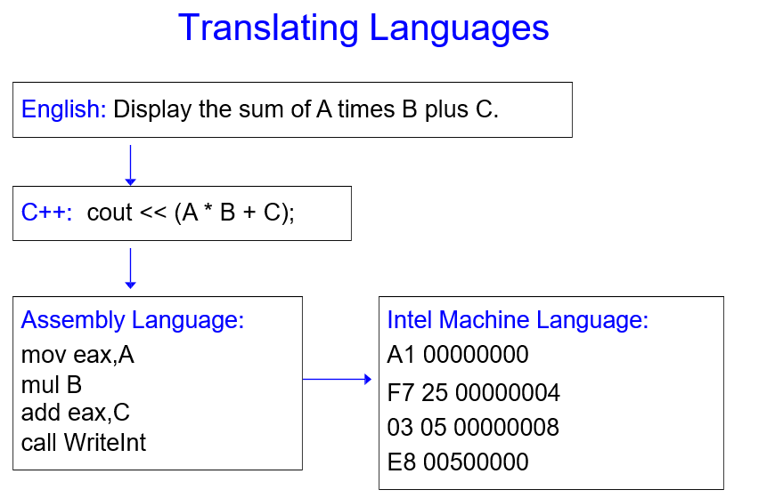
Specific Machine Levels
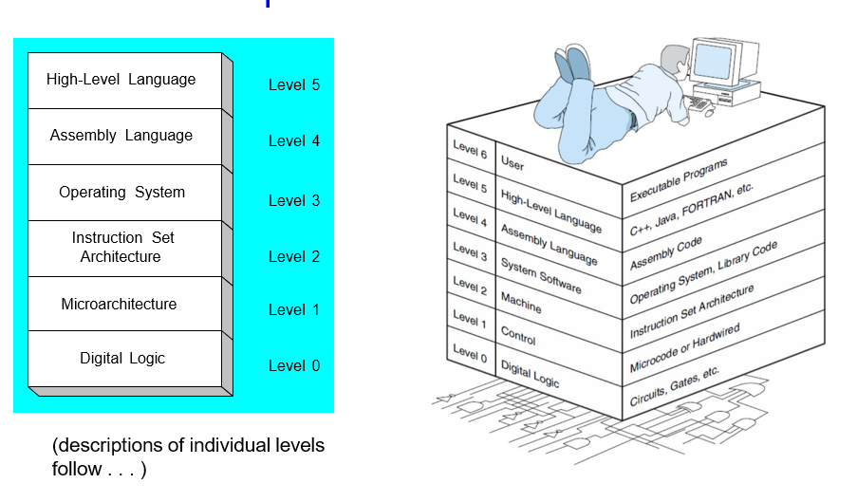
High-Level Language
High-level languages are programming languages that are easy for humans to read, write, and understand.
They use simple English-like words instead of complex machine code.
Level 5 – Application-Oriented Languages
- These are the languages that people use to make real-world applications.
- Examples: C++, Java, Pascal, Visual Basic, and others.
- Programs written in these languages are translated (compiled) into assembly language (Level 4) so the computer can understand and run them.
Assembly Language
Assembly language is a low-level programming language that is closer to the computer’s hardware.
It uses short words or symbols (called mnemonics) instead of 0s and 1s (machine code).
Example: Instead of writing 10110000 01100001, you write MOV AL, 61h.
Level 4 – Assembly Language
- Uses short words called mnemonics (like ADD, MOV, SUB) that match machine instructions one by one.
- Can use functions or services from the operating system (Level 3).
- Programs written in assembly are translated (assembled) into machine language (Level 2) so the computer can run them.

Operating System
A program that acts as an intermediary between a user of a computer and the computer hardware
Level 3 – Operating System Level
- This level provides services and helps to programs written in Level 4 (assembly language).
- Examples of services: reading files, printing, or handling input/output.
- Programs at this level are translated and run using the machine language (Level 2) instructions.
Level 2 – Instruction Set Architecture (ISA)
- This level is also called machine language — it’s made of binary instructions (0s and 1s) that the computer can directly run.
- These instructions are actually executed by the microarchitecture (Level 1), which is the hardware inside the CPU.
- It defines what the computer’s processor can do — like adding numbers, moving data, or jumping to another instruction.
Level 1 – Microarchitecture Level
- This level reads and carries out the machine instructions (Level 2).
- It is run by the computer’s digital hardware (Level 0) like circuits, logic gates, and processors.
- It decides how each machine instruction will actually be done inside the CPU.
Level 0 – Digital Logic Level
- This is the lowest level of the computer.
- It includes the CPU, memory, and system bus — all made using digital logic gates (like AND, OR, NOT).
- These parts are built using electronic components such as transistors.
- This level runs everything by sending and receiving electrical signals (0s and 1s).
What is Java Virtual Machine (JVM)?
The Java Virtual Machine (JVM) is a special program that runs Java programs.
It acts like a bridge between your Java code and the actual computer hardware.
How it works (in simple steps):
- You write Java code → MyProgram.java
- The Java compiler changes it into bytecode → MyProgram.class
- The JVM reads and runs this bytecode on any computer.
Key Points:
- JVM lets Java programs run on any computer (Windows, Mac, Linux, etc.) without changing the code.
- This is why Java is called “write once, run anywhere.”
- JVM also helps with memory management and program security.
What is a Compiler?
A compiler is a special program that translates code written in a high-level language (like C++, Java, or Python) into machine language (0s and 1s) that the computer can understand and run.

How it works
- You write code → program.cpp
- The compiler checks it for errors.
- If no errors, it changes (compiles) the code into machine language or an executable file.
- The computer then runs that file.
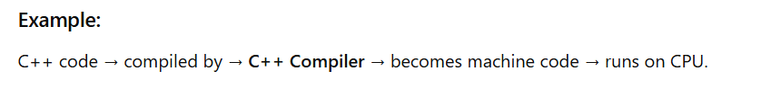
Questions and Answers
1. In your own words, describe the virtual machine concept.
A Virtual Machine (VM) is a software-based computer that runs inside a real computer.
It allows one physical computer to act like many separate computers, each with its own operating system and programs.
Every VM works independently, even though they share the same hardware.
This helps in testing, running different OS (like Windows and Linux together), and improving security.
In short, a VM lets you use multiple computers in one machine through virtualization software like VirtualBox or VMware.
2. What does it mean to use the native language of a computer to write application programs?
Programmers don’t use the native language of the computer (machine language) because it is very hard to read, write, and understand.
Machine language uses only 0s and 1s, which makes programs long, confusing, and easy to make mistakes in.
It also takes a lot of time to write and fix errors.
That’s why programmers use high-level languages (like C++, Java, or Python) — they are easier, faster, and more human-readable, and the computer can later translate them into machine language.
3. (True/False): When an interpreted program written in language L1 runs, each of its instructions is decoded and executed by a program written in language L0.
When an interpreted program written in language L1 runs, each of its instructions is read (decoded) and executed by another program written in language L0 — the lower-level language that runs directly on the hardware.
4. Explain the technique of translation when dealing with languages at different virtual machine levels.
Translation means changing a program written in a higher-level language into a lower-level language so the computer can understand and run it.
For example, a program written in Level 5 (high-level language like C++) is translated (compiled) into Level 4 (assembly language), which is then translated again into machine language (Level 2).
Each lower level gets closer to the hardware.
After translation, the program can be run directly by the computer without needing to be interpreted line by line.
5. How does the Intel IA-32 processor architecture demonstrate an example of a virtual machine?
The Intel IA-32 processor architecture is an example of a virtual machine because it allows many different operating systems and programs to run as if they all have their own separate computer.
It does this by creating different levels (layers) between the hardware and the software.
Programs written in higher-level languages (like C++ or Java) don’t need to know how the actual hardware works — the IA-32 architecture provides a virtual environment that makes them think they are using their own processor.
6. What software permits compiled Java programs to run on almost any computer?
The Java Virtual Machine (JVM) is the software that allows compiled Java programs to run on almost any computer.
Explanation:
When you write a Java program, it is first compiled into bytecode (not machine code).
The JVM reads and runs this bytecode on any computer — Windows, Mac, or Linux — as long as that computer has a JVM installed.
7. Name the six virtual machine levels named in this section, from lowest to highest.
8. Why don’t programmers write applications in microcode?
Programmers don’t write applications in microcode because it is:
- It is very low-level — it directly controls the hardware and is hard to understand.
- Difficult to write and debug — even small programs would take a lot of time.
- Machine-dependent — microcode only works on one specific type of CPU.
- Not needed — high-level languages (like C++ or Java) are easier, faster, and automatically get converted into machine instructions.
9. Conventional machine language is used at which level of the virtual machine shown in Figure 1-1?
Conventional machine language is used at Level 2 of the virtual machine.
Explanation
Level 2 is called the Instruction Set Architecture (ISA) level.
It’s the level where programs are written in machine language — the binary instructions that the computer hardware (Level 1 and Level 0) can understand and execute.
10. Statements at the assembly language level of a virtual machine are translated into statements at which other level(s)?
Statements at the assembly language level (Level 4) are translated into statements at the machine language level (Level 2).
Explanation
Assembly language instructions are first converted into machine language so the computer’s hardware can understand and execute them.
Each assembly instruction matches one machine instruction, just written in a more readable form for humans.

Lecture
Modes of Operation
Operating Modes of 80386 Microprocessors
The Intel 80386 microprocessor, also called i386, was a very popular computer chip.
Its main feature was that it could work in different modes, which allowed:
- better memory control,
- stronger system protection,
- and compatibility with older processors (it could run old programs too).
The 80386 Modes of Operation
- Real Mode
- Protected Mode
- Virtual 8086 Modes
- System Management Mode
Each mode of 80386 had its own special features and was made for different purposes —
like running old programs, handling advanced memory tasks, or doing system control work.
Understanding these modes helps us know what the 80386 microprocessors could do, what its limits were, and how it was used in early computers and servers.

Real Mode
When the 80386 microprocessor is first powered on, it starts in Real Mode — this is its default mode.
Backward Compatibility
Real Mode is fully compatible with older processors like 8086 and 8088. This means that any old programs made for those processors can run on 80386 without any changes.
Memory Access
In Real Mode, the processor can access up to 1 MB of memory because it has a 20-bit address space.
The memory is divided into segments of 64 KB each, and a 16-bit segment register is used to access these sections.
Memory Handling
80386 uses a segment-based memory addressing system in this mode.
However, it does not have advanced memory management or security features — programs can freely access any part of memory.
Limitations
Real Mode has a limited set of instructions and cannot use protected or virtual memory.
It’s mainly used for starting the system or running very old software.
Protected Mode
Protected Mode is an advanced operating mode of the Intel 80386 processor.
It allows the processor to use 32-bit addressing, which means it can access up to 4 GB of memory — much more than Real Mode.

Memory Management and Protection
Protected Mode includes advanced memory control features to keep programs safe (80386 gives each program its own memory area) from each other and to manage memory better.
Segmentation
Memory is divided into segments, which are logical blocks or sections.
Each program gets its own segments, and access to other programs’ segments can be restricted — this prevents one program from interfering with another.
Paging
Paging helps the computer use memory more efficiently by swapping data between RAM and the hard disk — so you can run more programs even if your RAM is small.
Memory is also divided into small fixed-size parts called pages.
Paging allows the system to move pages in and out of physical memory when needed, helping to manage memory efficiently.
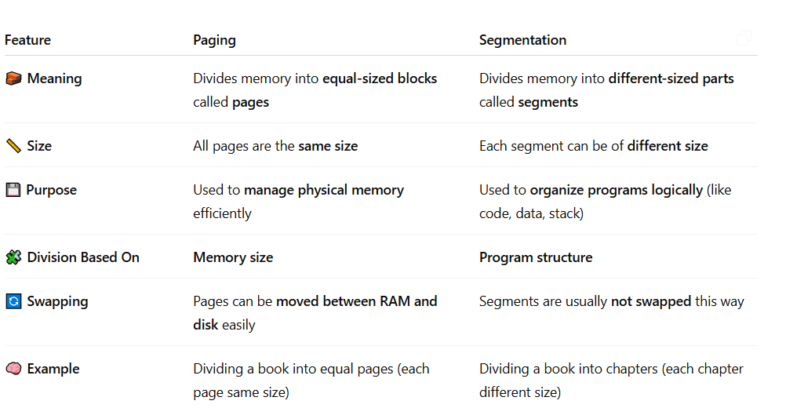
Virtual Memory
Protected Mode supports virtual memory, which lets the computer use more memory than is physically installed.
It does this by temporarily storing data on the hard disk and swapping it with the main memory (RAM) when needed.
Privileged Instructions
In Protected Mode, the processor can use some special (privileged) instructions and registers that are not available in Real Mode.
These are used by the operating system to control hardware and manage system resources securely.
Virtual 8086 Mode
Virtual 8086 Mode (V86 Mode) is a special mode of the 80386 processor that lets it run old 8086 programs (like old DOS software) inside a modern protected environment.
How It Works
- 80386 can create many small virtual computers that each act like a real 8086 processor.
- Each virtual machine has its own memory space and registers, even though they all share the same physical memory.
- This means many old programs can run at the same time without disturbing each other.
Features
- It imitates the behavior of the 8086 processor.
- The processor can switch between these virtual environments whenever needed.
- The system handles interrupts and errors (exceptions) safely so that each virtual machine runs smoothly.
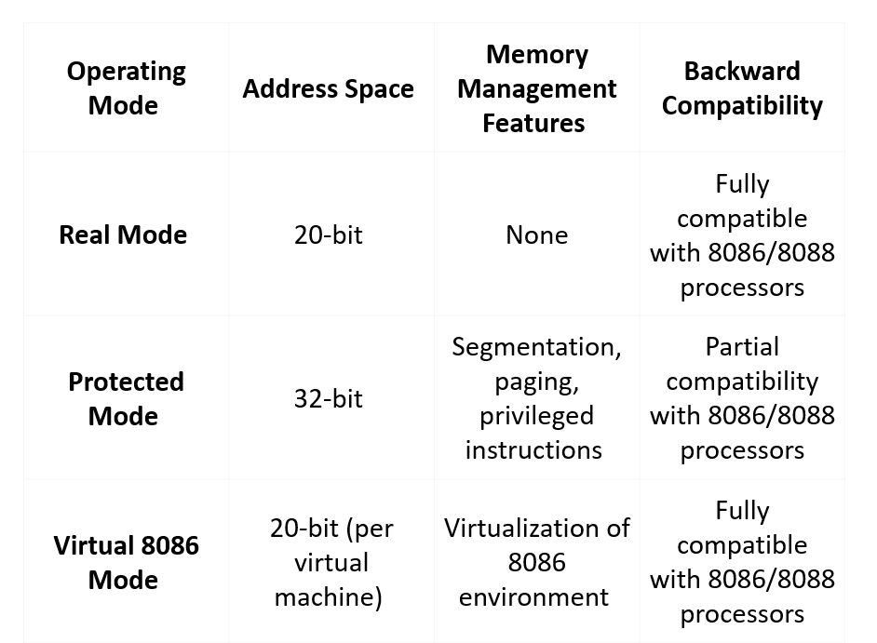
1. Protected Mode
- This is the main (native) mode of the 80386 processor.
- The processor can use all its powerful features here.
- Each program has its own safe memory area (segment).
- If a program tries to use memory that doesn’t belong to it, the processor stops it — this protects other programs.
In short: Every program works in its own space safely — one crash won’t affect others.
2. Virtual-8086 Mode
- Runs old MS-DOS or 8086 programs safely while in Protected Mode.
- Each program acts like it has its own computer, with separate memory and registers.
- If one program crashes, it doesn’t affect others.
In short: Lets old programs run safely alongside modern programs.
3. Real-address Mode
- Works like the old Intel 8086 processor.
- It can run old software that takes full control of the computer hardware.
- All Intel processors start in this mode when turned on.
In short: Used to run very old programs or start the system.
4. System Management Mode (SMM)
- Special mode used for tasks like power management and system security.
- Often customized by computer manufacturers for their specific systems.
In short: Handles special system functions safely and efficiently.
What are Registers?
Registers are the fastest type of memory located inside the CPU. They store very small amounts of data (like instructions, addresses, or temporary values) that the CPU is currently working on. Since they are part of the processor, accessing registers takes almost no time (one CPU clock cycle). But registers are very limited in number and expensive.

General Purpose Registers
General purpose registers are registers inside the CPU that are used to store data, intermediate results, or addresses during program execution. They can be used for many different tasks, such as holding numbers for calculations or temporarily storing values while instructions are being executed.
Extended Accumulator Register (EAX): Used for arithmetic operations and to store function return values.
Extended Base Register (EBX): Used as a base pointer to access data in memory.
Extended Counter Register (ECX): Used as a loop counter.
Extended Data Register (EDX): Used for input/output operations and as extra support in arithmetic.
Extended Source Index (ESI): Points to the source in string and array operations.
Extended Base Pointer (EBP): Points to the base of the current stack frame and helps access function arguments and local variables.
Extended Destination Index (EDI): Points to the destination in string and array operations.
Extended Stack Pointer (ESP): Points to the top of the stack and manages push and pop operations.
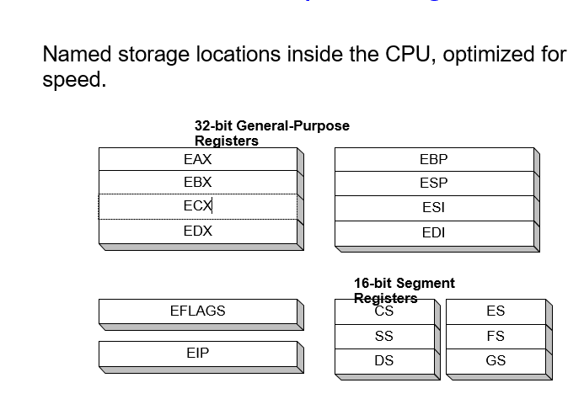
What are special purpose registers
Special purpose registers are CPU registers used for specific tasks like controlling program flow, managing memory, and storing status information. Examples include the Program Counter (PC), Stack Pointer (SP), Flags Register, and Segment Registers.
- Program Counter (PC) / Instruction Pointer (IP): Holds the address of the next instruction.
- Stack Pointer (SP): Points to the top of the stack.
- Flags / Status Register: Shows the results of operations (e.g., zero, carry, overflow).
- Segment Registers (CS, DS, SS, ES, FS, GS): Point to different memory segments.
- Memory Address Register (MAR): Holds the address for memory access.
- Memory Data Register (MDR): Holds data read from or written to memory.
What are segment Registers
Segment registers are special CPU registers that store the starting address of different memory segments. They help the processor divide memory into parts like code, data, and stack so programs can run safely and efficiently.
1. Code Segment (CS)
Points to the memory segment containing the program’s instructions. The CPU uses CS with the instruction pointer to fetch and execute instructions.
2. Data Segment (DS)
Points to the memory segment where a program’s variables and constants are stored. The CPU uses DS to read from or write to variables
3. Stack Segment (SS)
Points to the memory segment used for the program stack, which stores temporary data, function calls, and local variables. The stack pointer works with SS to manage the stack.
4. Extra Segments (ES, FS, GS)
Additional data segment registers that allow programs to access multiple memory segments at the same time, useful for tasks like moving or copying data between memory locations.
What are control registers
Control registers are special CPU registers used to control and manage the operation of the processor and the system. Control registers tell the CPU how to behave—for example, which mode it is running in (real or protected), whether interrupts are enabled, or which memory pages are active.

Common examples in x86:
- CR0: Controls CPU operating modes (e.g., enabling protected mode).
- CR2: Stores the address that caused a page fault.
- CR3: Points to the page directory base for memory management.
- CR4: Enables or controls advanced CPU features (e.g., virtual memory extensions).
Pointer Registers
These registers hold memory addresses pointing to data or locations in memory.
They are mainly used for accessing stacks, arrays, or buffers.
Examples:
- Stack Pointer (SP / ESP): Points to the top of the stack.
- Base Pointer (BP / EBP): Points to the base of the current stack frame.
Index Registers
These registers are used to point to or traverse elements in arrays or strings.
They can be combined with offsets for efficient data access.
Examples:
- Source Index (SI / ESI): Points to the source location in string operations.
- Destination Index (DI / EDI): Points to the destination location in string operations.

Debug Registers
These registers are used by the CPU to help find and fix bugs in programs.
They can monitor memory locations and trigger an alert when a certain condition occurs (like reading or writing to a specific address).
Examples (x86): DR0 – DR7, each used to store addresses or control debugging functions.
Test Registers
These registers are used to test and control the CPU’s internal operations, especially the cache and TLB (Translation Lookaside Buffer).
They help ensure that the processor and memory systems are working correctly.
Example (older x86 processors): TR6, TR7 (for cache testing).

Lecture 9 (a)
Direct Memory Access
What is DMA?
Direct Memory Access (DMA) is a technique that allows devices to transfer data directly to and from memory without involving the CPU.
Purpose
The purpose of DMA is to make data transfer faster and to free the CPU, so the CPU can do other important work instead of wasting time moving data.
What is DMA Controller?
A DMA Controller is a small helper chip in the computer that moves data between memory and devices without bothering the CPU.
Very simple:
It is like a special worker whose job is to transfer data fast, so the CPU can focus on other important tasks

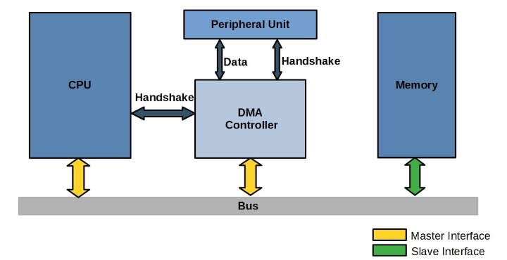
Figure Explanation
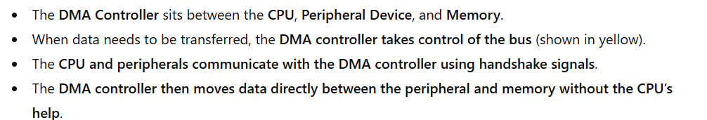
Block Diagram of DMA
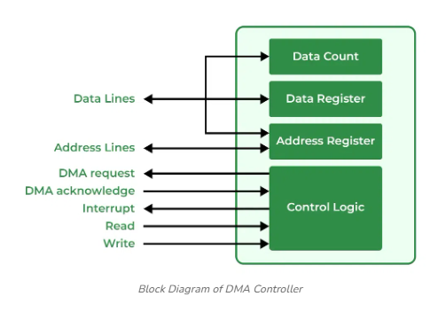
Figure Explanation
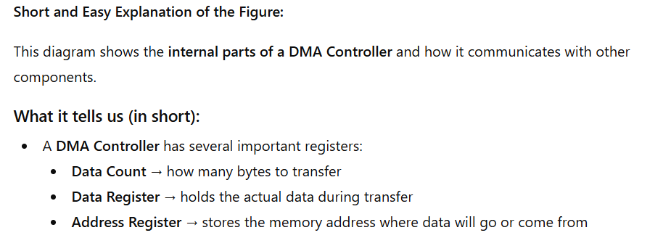
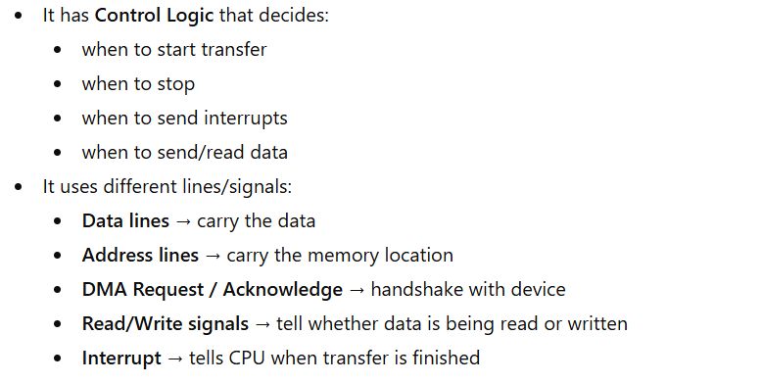
Interface of the DMA
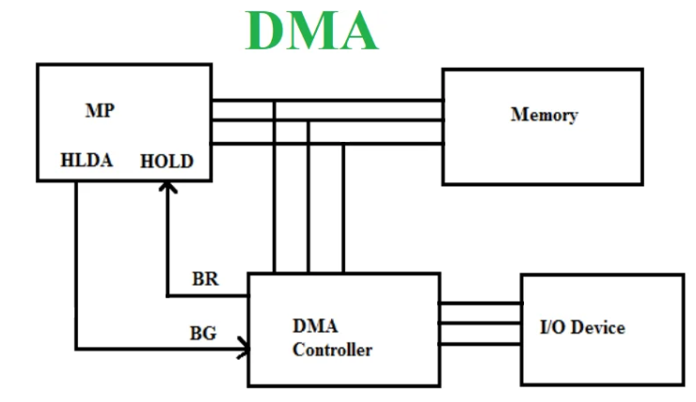

Figure Explanation
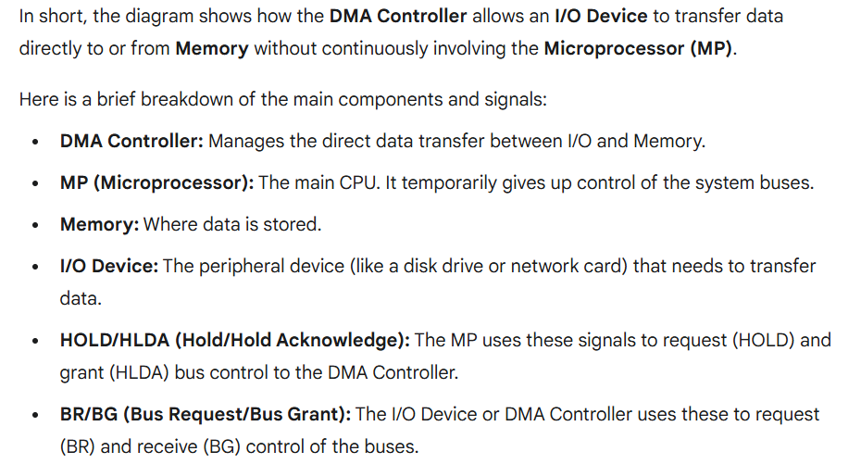
Types of Direct Memory Access (DMA)
There are four popular types of DMA.
- Single-Ended DMA
- Dual-Ended DMA
- Arbitrated-Ended DMA
- Interleaved DMA
Types of Direct Memory Access (DMA)
1. Single-Ended DMA
Single-Ended DMA can read or write using only one memory address.
It is the simplest and most basic type of DMA.
Example: Imagine you have a photo in memory address 1000. The CPU wants to display it on the screen. The DMA controller reads from memory address 1000 → sends it to the screen. Once that is done, then it can move to the next address (1001) for the next photo.
Key Point
- It handles only one memory location at a time.
- If there’s more data, it processes them one by one, not simultaneously.
2. Dual-Ended DMA
Dual-Ended DMA can use two different memory addresses for reading and writing.
It is more advanced than single-ended DMA.
Example: Imagine you have a song file in Folder A on your computer. You want to copy or move it to Folder B. Dual-Ended DMA works like this: it reads the song from Folder A (source) and writes it to Folder B (destination) at the same time.
Key point:
- Two memory addresses are involved — one for reading, one for writing.
- This is faster than Single-Ended DMA, which can only handle one memory address at a time.
3. Arbitrated-Ended DMA:
Arbitrated-Ended DMA can work with many memory addresses at the same time.
It is more advanced than dual-ended DMA.
Example: Imagine a printer in an office. Several computers send print jobs at the same time. The printer can handle all the jobs by deciding which job to print first, second, third, etc. Similarly, Arbitrated-Ended DMA handles multiple memory read/write requests at the same time.

Key point:
It’s more advanced than Single-Ended or Dual-Ended DMA because it can manage many memory transfers at once.
4. Interleaved DMA:
Interleaved DMA reads from one memory address and writes to a different memory address at the same time.
It is used for faster and smoother data transfer.
Example: Imagine a video playing on your screen. The computer reads frames from storage (like pouring juice from the bottle). At the same time, it sends those frames to the screen (like someone drinking from the glass). Because reading and writing happen simultaneously, the video plays smoothly without stopping.
Working of DMA Controller
The DMA controller has three registers as follows:
Address Register –
It stores the memory address of the data to be transferred.
Example: If you want to copy a file from memory location 1000, the address register holds 1000.
Word Count Register –
It stores the number of words (data units) to transfer.
Example: If a file has 5 words, the word count register is set to 5, and decreases as each word is transferred.
Control Register –
It specifies the transfer mode (like read, write, burst, or single).
Example: You can set it to read from memory A and write to memory B.
Note: All registers in DMA appear to the CPU as I/O registers.
Therefore, the CPU can read or write these registers via the data bus to control the DMA.
Example: The CPU sets the address, word count, and control mode, then the DMA transfers data automatically.
Working
The DMA controller is connected to the CPU.
They talk to each other using the data bus (for data) and control lines (for signals).
How the CPU selects a DMA register
- The CPU uses the address bus to choose which DMA register it wants to access.
- The RS (Register Select) lines help the CPU pick the correct DMA register (address register, word count register, or control register).
Simple example:
The CPU sends an address like “0001”, and RS selects the word count register.
What RD and WR mean
- RD (Read): CPU wants to read from a DMA register.
- WR (Write): CPU wants to write into a DMA register.
These signals work in both directions, which is why they are called two-way inputs.
What BG (Bus Grant) means
BG = 0 → CPU is using the buses.
- CPU can talk to the DMA registers.
- DMA cannot use memory directly.
BG = 1 → CPU gives control to DMA.
- CPU steps aside and stops using the buses.
- DMA now directly transfers data between memory and I/O without disturbing the CPU.
Simple Real-Life Analogy
- Think of the CPU and DMA sharing one road (bus).
- BG = 0: The CPU is using the road; DMA must wait.
- BG = 1: CPU moves aside and lets DMA use the road to move data freely.
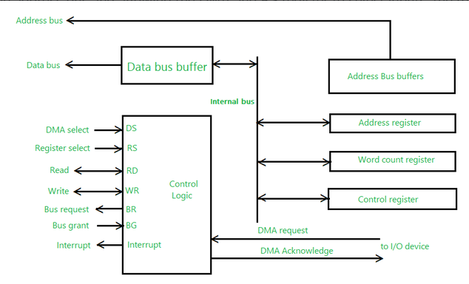

How DMA Works
What is DMA Controller?
A DMA Controller is a small helper chip in the computer that moves data between memory and devices without bothering the CPU.
Memory Transfer Paths:
Data can go directly between a device and memory, without the CPU doing the work.
Process:
- CPU starts the transfer
The CPU tells the DMA controller what to transfer and where.
- DMA controller moves the data
It copies the data between the device and memory on its own.
- DMA controller informs the CPU
When the transfer is finished, it sends a signal to the CPU saying “I’m done.”
Why DMA is Important
Reduces CPU Load:
DMA takes the data-transfer work away from the CPU.
This means the CPU is free to do other tasks.
Increases Data Transfer Speed:
DMA allows data to move while the CPU is working on something else.
So, overall data moves faster.
Improves System Performance:
DMA is very helpful in systems that need fast and continuous data flow,
like audio, video, or real-time processing.

Types of DMA Transfer Modes
Burst Mode:
DMA transfers a big chunk of data in one single go.
Example: Sending 1000 bytes of audio data at once without stopping.
Cycle Stealing Mode:
DMA takes the bus for a very short time, then returns it to the CPU.
Example: DMA grabs the bus for a moment to transfer a few bytes, then CPU continues working.
Transparent Mode:
DMA works only when the CPU is not using the bus, so the CPU never gets disturbed.
Example: DMA transfers data only when the CPU is idle or free.
DMA Transfer Process
Initialization:
The CPU tells the DMA controller where the data is coming from, where it should go, and how much data needs to be moved.
Data Transfer:
The DMA controller starts moving the data on its own. The CPU does not need to help.
Completion:
After the transfer finishes, the DMA controller sends a signal (interrupt) to the CPU to inform it that the job is done.
Advantages of DMA
Reduces CPU Load:
DMA takes the data-transfer work away from the CPU.
This means the CPU is free to do other tasks.
Increases Data Transfer Speed:
DMA allows data to move while the CPU is working on something else.
So, overall data moves faster.
Improves Multitasking:
While DMA is transferring data, the CPU can continue doing other tasks at the same time.
Improves System Performance:
DMA is very helpful in systems that need fast and continuous data flow,
like audio, video, or real-time processing.
Applications of DMA
Graphics Processing:
DMA quickly sends image or video data to the screen without waiting for the CPU, making graphics smooth.
Audio/Video Streaming:
DMA transfers sound or video data in real time so playback doesn’t lag or pause.
Networking:
Network cards use DMA to move incoming/outgoing data fast, helping the internet or network work smoothly.
Limitations of DMA
1. Hardware Complexity
DMA needs extra hardware (DMA controller).
This makes the computer slightly more complex and expensive.
Example:
Like adding an extra helper in a shop — helpful, but you must pay them and manage them.
2. Bus Contention (Fighting for the Bus)
Sometimes many devices want to use the system bus at the same time.
DMA also uses the bus, so they may have to wait.
Example:
Like many people trying to use one single road — traffic can happen.
3. Not Good for Small Data
DMA setup takes some time.
For very small data, this setup time is longer than the actual transfer.
So it becomes slower instead of faster.
Example:
You don’t call a delivery truck to move one small pencil.
You just pick it up yourself because it is faster.
DMA in Modern Computing
DMA in CPUs:
Almost all modern CPUs and microcontrollers have DMA built-in.
It helps move data quickly without bothering the CPU.
DMA for Peripheral Devices:
DMA is very important for devices like hard drives, network cards, and GPUs.
It lets them transfer data fast to memory or other devices.
Example:
In gaming consoles, DMA helps move graphics data quickly from memory to the screen, so games run smoothly without lag.

DMA vs. Other Data Transfer Techniques
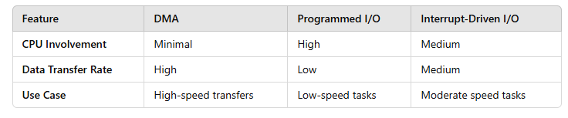
Standalone DMA Controllers
Intel 8237A:
One of the first DMA controllers, used in early PCs to move data without using the CPU much.
Texas Instruments TMS320C550x Series:
Used in low-power digital signal processors (DSPs), with built-in DMA for fast data transfers.
AMD Am9517A:
Works like the Intel 8237, used in different computers to handle data transfers efficiently.
Motorola MC68450:
Used in Motorola computers and some embedded systems to manage memory and device data transfers.
Processors with DMA Controllers
Intel x86/x64 Processors:
Modern Intel CPUs have built-in DMA controllers to move data fast, especially useful in servers.
AMD Ryzen and EPYC Processors:
AMD CPUs include DMA to transfer data quickly for gaming and server applications.
Texas Instruments OMAP Processors:
High-performance processors for mobile devices with DMA to handle fast data transfer.
Broadcom BCM2837 (Raspberry Pi 3):
Has DMA channels to manage peripherals and video data efficiently.
Lecture 9 (b)
Interfacing
IA-32 I/O Interfacing
What it is:
IA-32 I/O interfacing is how a 32-bit Intel CPU talks to external devices like keyboards, hard drives, or network cards.
It lets the CPU send or receive data from these devices efficiently.
How it works:
- The CPU uses special I/O ports (like addresses for devices).
- It also uses special instructions to read or write data to these ports.
- This ensures smooth communication between software and hardware.
Simple Example:
Pressing a key on the keyboard:
- The keyboard sends the key press to a specific I/O port.
- The CPU reads this data from the port using I/O instructions and knows which key was pressed.

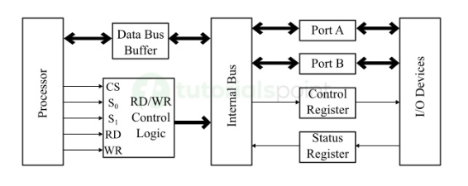
IA-32 I/o Interfacing
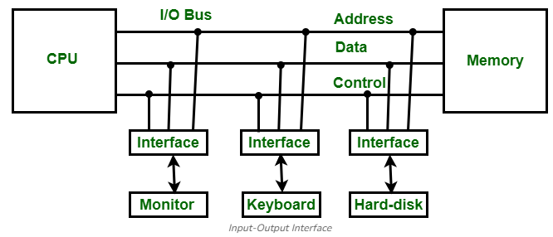
Overview of IA-32 I/O Interfacing
I/O interfacing in IA-32 is done using I/O ports to send and receive data from devices. This communication has two main types:
Memory-Mapped I/O:
Uses a part of the computer’s memory addresses to talk to devices.
Example: A device appears like a memory location, and the CPU can read/write to it just like normal memory.
Port-Mapped I/O:
Uses special I/O instructions and a separate address space (different from memory).
Example: The CPU uses instructions like IN and OUT to communicate with the device directly.
Note:
- IA-32 supports both types.
- Port-mapped I/O is more common for simple devices because it is direct and easy to use.
I/O Addressing Modes
I/O Address Space:
IA-32 uses a 16-bit address space for I/O, which means it can have up to 65,536 unique I/O ports.
Each device or port has its own unique number.
Direct I/O Addressing:
The CPU directly specifies the port number in the instruction.
Example: IN AL, 0x60 reads data directly from port 0x60.
Indirect I/O Addressing:
The CPU gets the port address indirectly, usually through a register.
Example: The port number is stored in a register like DX, and the instruction uses that register to access the port.
I/O Instructions in IA-32
The IA-32 CPU has special instructions to talk to I/O ports:
IN:
- Reads data from an I/O port into a CPU register.
- Example: IN AL, DX → Reads 8-bit data from the port in DX and stores it in AL.
OUT:
- Writes data from a CPU register to an I/O port.
- Example: OUT DX, AL → Sends 8-bit data from AL to the port in DX.
Sizes:
- Both IN and OUT can handle 8-bit, 16-bit, or 32-bit data.
Purpose:
These instructions let the CPU send and receive data to/from devices like keyboards, printers, or network cards.
I/O Port Access and Protection
Privilege Levels:
- IA-32 has four privilege levels (rings 0–3).
- Ring 0 = most powerful, Ring 3 = least powerful.
- Only programs running in privileged mode (like the OS) can use I/O instructions.
- This prevents untrusted programs from directly controlling hardware, keeping the system safe.
I/O Permission Bit Map (IOPM):
- Stored in the Task State Segment (TSS).
- It tells the CPU which I/O ports each task is allowed to use.
- This ensures that tasks can only access the devices they are allowed to, controlling device interaction securely.

Example: Interfacing with a Keyboard
A common example of IA-32 I/O interfacing is reading key presses from a keyboard.
The keyboard is connected to specific I/O ports:
- 0x60 → for reading data (the key pressed)
- 0x64 → for control
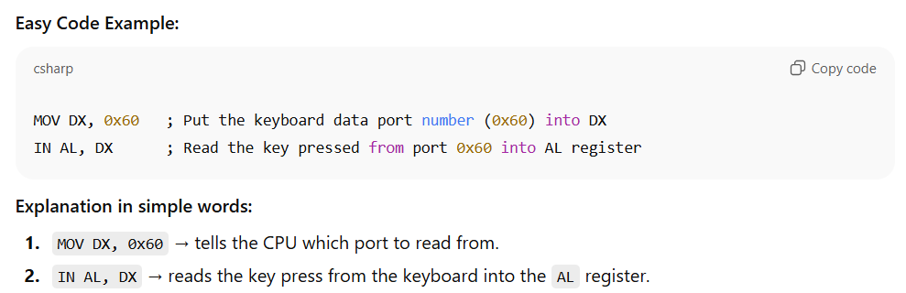
Interrupt-Driven I/O
What it is:
Instead of the CPU constantly checking devices (polling), devices send a signal (interrupt) to the CPU when they need attention. This is more efficient because the CPU only works on I/O when necessary, saving time.
Interrupt Service Routine (ISR):
- A special piece of code that runs when an interrupt occurs.
- It tells the CPU what to do for that I/O request.
Programmable Interrupt Controller (PIC):
- Manages multiple interrupts from different devices.
- Decides the priority of each interrupt before sending it to the CPU.
Additional Question
Difference between interrupt and polling 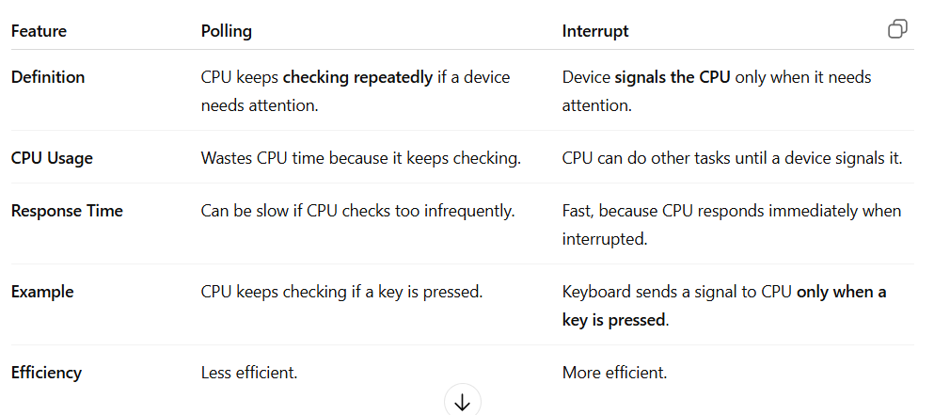
Lecture
CPU Performance-1
CPU Performance Calculation
CPU performance means how fast and how well the computer’s main brain (CPU) can run programs.
When we measure CPU performance, we can compare different computers and see which one works faster.
It also helps us improve software and hardware so everything runs more smoothly.

Key Measures of Performance
Instruction Count (IC)
Instruction Count means how many instructions (steps) a program needs to finish its work.
It depends on:
- The algorithm:
A better or smarter method needs fewer steps.
- Programming language and compiler:
Some languages or compilers create code that runs using more or fewer instructions.
- Instruction Set Architecture (ISA):
The CPU’s design decides what types of instructions it can run, which can change how many steps are needed.
1. Instruction Count (IC)
Example 1
A sorting program written in C becomes 10 million small CPU steps after compiling.
Instruction Count = 10,000,000
(Meaning: the CPU needs to perform 10 million steps to finish the program.)
Example 2
A loop has 5 instructions, and it repeats 1,000 times.
So total steps = 5 × 1,000 = 5,000
Instruction Count = 5,000
(Meaning: the CPU performs 5,000 total steps when the loop runs.)
Clock Cycle Time / Clock Rate
Clock Cycle Time (T)
This is the time taken for one CPU cycle.
(How long one tiny step of the CPU takes.)
Clock Rate (R)
This is how many cycles the CPU can do in one second.
Measured in Hz (cycles per second).
Example
2 GHz means the CPU can do:
2 × 10⁹ cycles per second
(That is 2 billion cycles every second!)
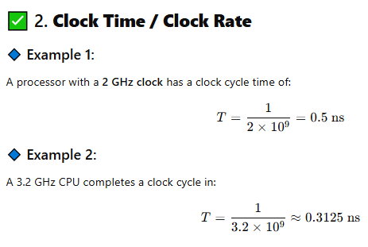

Cycles Per Instruction (CPI)
CPI means how many clock cycles (CPU steps) are needed to complete one instruction on average.
What affects CPI?
- Instruction mix (simple vs complex):
Simple instructions need fewer cycles.
Complex instructions need more cycles.
- Pipeline efficiency:
If the CPU pipeline works smoothly, CPI becomes lower (better).
If there are delays or stalls, CPI becomes higher (slower).
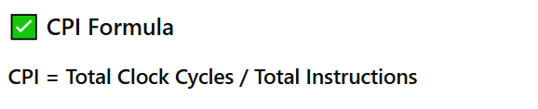
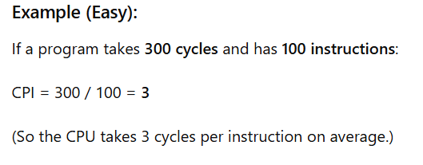
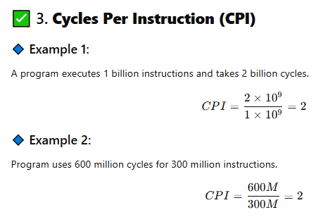
Performance Equations
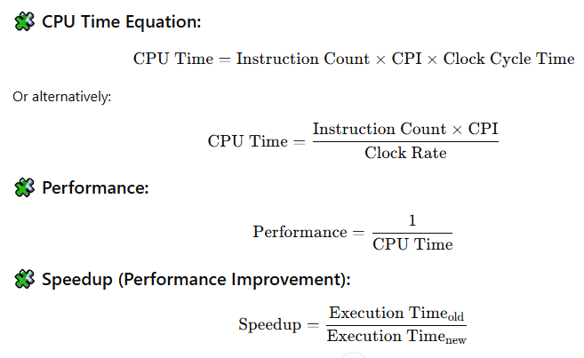
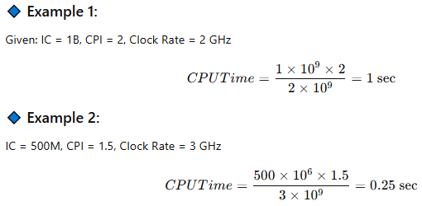
MIPS (Millions of Instructions Per Second)
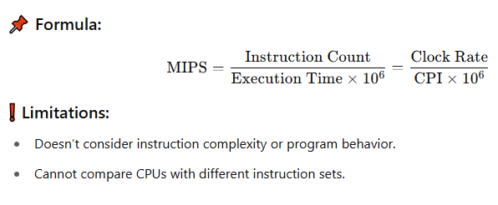
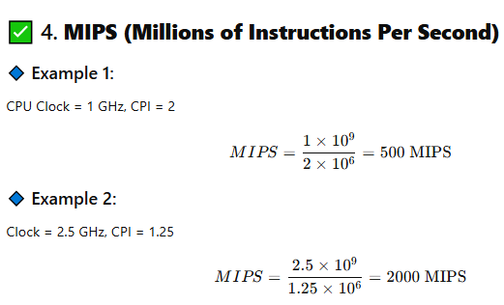
MFLOPS
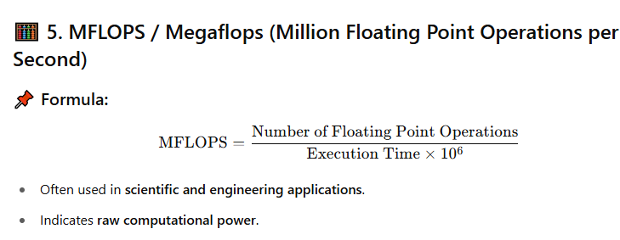
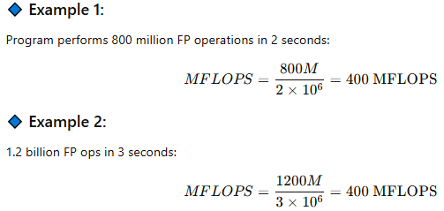
SPEC Benchmark
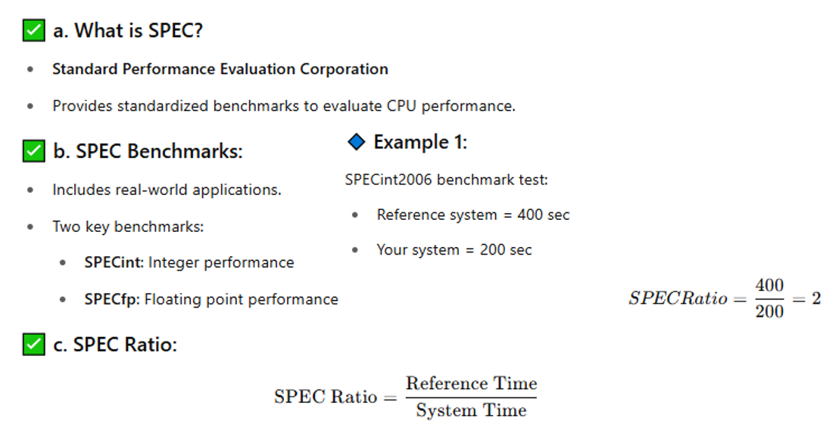
Benchmark
A benchmark is a test used to check how fast or how well a computer, CPU, or software works. It runs certain programs or tasks and gives numbers or scores. These scores help us compare different computers or components to see which one is better.
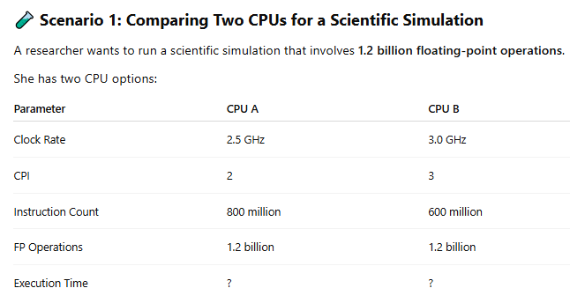
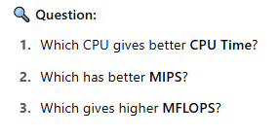
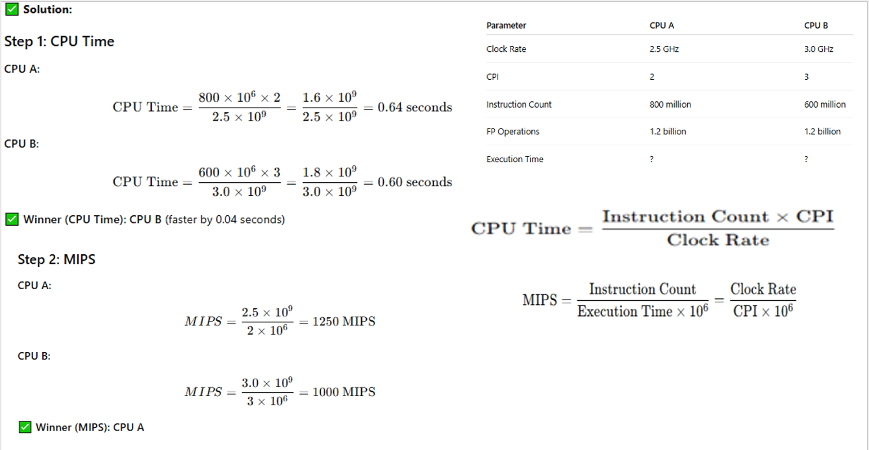
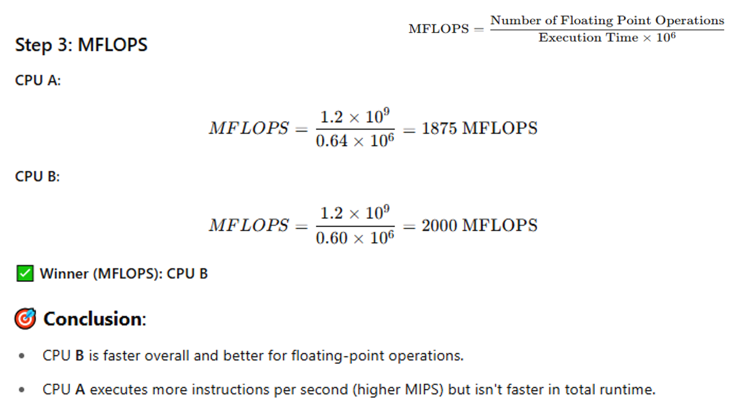
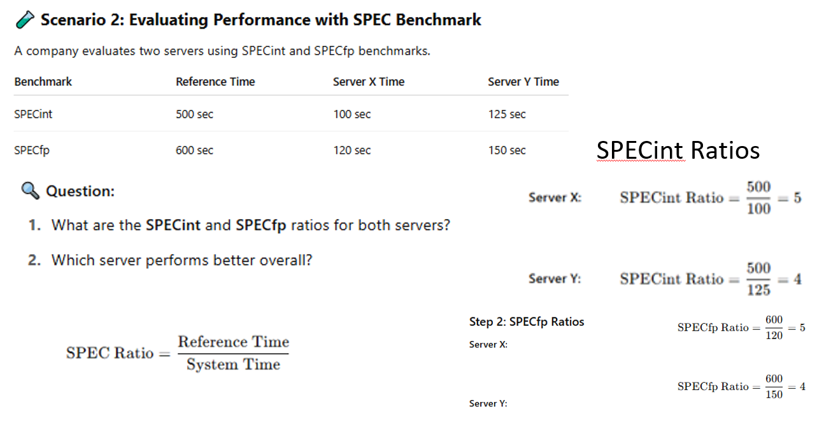

Lecture
Superscalar vs Vector Processor
Superscalar Processor
- A superscalar processor is a type of CPU architecture that is capable of executing more than one instruction per clock cycle.
- This is achieved by employing multiple execution units (also called functional units), which allow the processor to handle multiple instructions in parallel.
- The key idea behind a superscalar processor is to increase the throughput (number of instructions executed per unit of time) without increasing the clock speed of the processor.
Key Features of Superscalar Processors
Multiple Execution Units:
A superscalar processor has many execution units like ALU, FPU, and load/store units. Because of this, the processor can perform different types of operations at the same time instead of one by one.
Instruction-Level Parallelism (ILP):
The processor finds instructions that are independent of each other and executes them together in the same clock cycle, which increases speed.
Out-of-Order Execution:
Instructions do not always run in the order written in the program. If an instruction is waiting for data, another ready instruction is executed first. This helps in better use of the CPU and saves time.
Instruction Fetch and Decode:
The processor can fetch and decode multiple instructions at once. After decoding, it decides which instructions can be executed together in parallel.
Superscalar
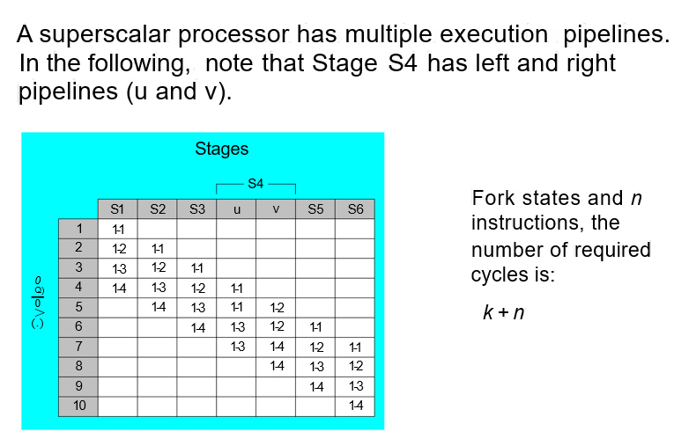
- Instruction Fetch
- Instruction Decode
- Operand Fetch
- Instruction Execute
- Memory Access
- Write back
Reading from Memory
Multiple machine cycles are required when reading from memory, because it responds much more slowly than the CPU. The steps are:
- Address placement: The address is placed on the address bus.
- RD Signal activation: The Read Line (RD) is set low.
- Wait state: The CPU waits one cycle for memory to respond.
- Data retrieval: The Read Line (RD) goes to 1, indicating that the data is on the data bus.
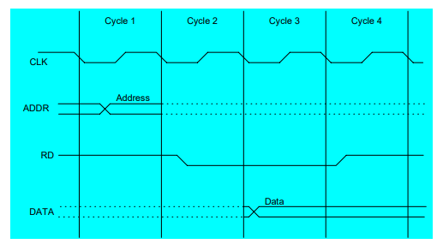
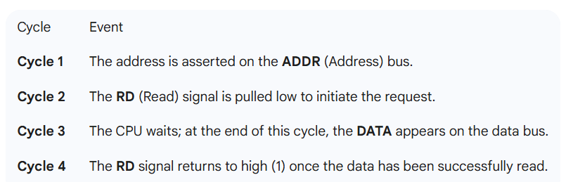
Cache Memory
Cache memory is a very fast, small-sized memory placed between the CPU and main memory (RAM). The CPU often needs the same data or instructions again and again. If this frequently used data is kept in cache, the CPU can quickly access it without waiting for slower RAM.
Cache Types
L1 Cache (Level 1)
- Inside the CPU.
- Very fast but very small.
- Stores data and instructions the CPU needs right now.
L2 Cache (Level 2)
- Near or inside the CPU.
- Bigger than L1 but a little slower.
- Stores data that is used often but not immediately.
L3 Cache (Level 3)
- Shared between CPU cores or on the motherboard.
- Bigger than L2 but slower than L2.
- Helps the CPU reduce going to slow RAM.
Cache Hits
A cache hit happens when the CPU looks for some data and finds it already stored in the cache. This is the best case because the CPU gets the data very quickly without going to slower RAM. More cache hits mean faster performance.
Cache Misses
A cache miss happens when the CPU does not find the required data in cache. In that case, the data has to be fetched from RAM (or sometimes even slower storage), which takes more time. Too many cache misses slow down the CPU because it has to wait.
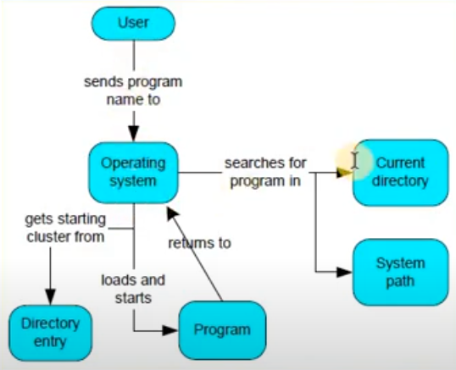
Multitasking
An operating system (OS) can run many programs at the same time. Even within a single program, there can be multiple threads running simultaneously. To manage this, the OS uses a scheduler, which gives each program a certain amount of CPU time to run.
The Illusion of Multitasking
A single CPU can only run one instruction at a time, but the OS makes it look like multiple programs run simultaneously. This is done using time slicing, where the CPU’s time is divided into small segments called time slices. Each program gets a short turn to use the CPU, and the CPU switches rapidly between programs. This happens so fast that it appears all programs are running at once, even though the CPU handles them one by one.
Task Switching and the TSS
When a task is paused, the processor automatically saves important information about the task in a special area called the Task State Segment (TSS). This includes the EFLAGS register, which keeps track of the CPU’s current state. When the processor switches to a new task, it loads the EFLAGS register from the new task’s TSS so that the task can resume properly.
Memory Models in Multitasking
When multitasking is used, each task can use a different memory model, meaning they can manage memory in their own way without interfering with other tasks.
Introduction to Vector Processors
A vector processor is a special type of computer that can work on whole sets of data (vectors) at once, instead of handling one value at a time.
Uses of Vector Processors
Vector processors are very good for tasks that repeat the same operation on lots of data. They are often used in:
- Scientific computing (like physics or chemistry calculations)
- Simulations (like weather or engineering models)
- Some AI algorithms that process large datasets
Vector Processor
A vector processor is a type of CPU or processing unit that can do the same operation on many pieces of data at the same time using vector instructions.

Difference from Scalar Processor
A scalar processor works on one piece of data at a time, while a vector processor can handle multiple data points together, making it much faster for large datasets.
Characteristics of Vector Processors
1. Vector Registers
Vector processors have special registers that can store many data elements at once, unlike scalar processors which store only one.
2. Vector Instructions
They have special instructions to perform operations like addition or multiplication on whole arrays of data at the same time.
3. Pipelining
Vector processors use pipelining, which means different steps of a calculation can happen at the same time, making processing faster.
4. High Bandwidth
They can move large amounts of data quickly between memory and the processor, which is needed for handling big vectors efficiently.
Examples of Vector Processors
Cray-1: One of the earliest and most famous supercomputers, it was a vector processor that revolutionized high-performance computing in the 1970s.
NEC SX-Series: High-performance vector processors used in scientific applications.
Modern SIMD (Single Instruction, Multiple Data) Extensions: Found in modern CPUs, these vector extensions (e.g., Intel AVX, ARM NEON) are designed for parallel data processing.
Architecture of Vector Processors
Vectorization
Vectorization is the process of changing normal operations on single data items (scalar operations) into operations on whole sets of data (vector operations).
Key Components of Vectorization
1. Vector Length
This is the number of data elements that a vector processor can handle at the same time.
2. Stride
- When a vector processor works on a vector, the elements of the vector are usually stored in memory one after another.
- Stride tells the processor how far apart the elements are in memory.
- If elements are stored continuously, the stride is 1.
- If elements are not stored next to each other, the stride is more than 1, meaning the processor skips some memory locations to get to the next element.

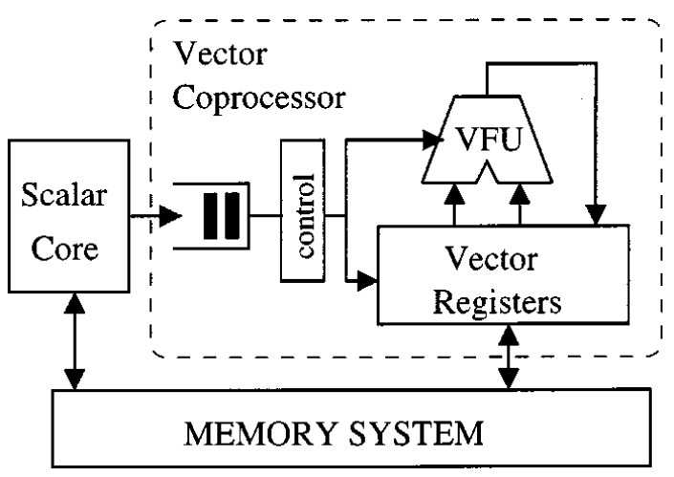
Vector Functional Units
Vector processors contain specialized functional units for various operations:
- Adders: Perform vector addition.
- Multipliers: Perform vector multiplication.
- Logical Units: Handle logical operations on vectors.
Memory Access Patterns
- Vector processors need to access lots of data quickly.
- The memory system is designed to deliver data in large blocks (chunks) at a time, instead of one piece at a time.
- This makes vector operations faster and more efficient.

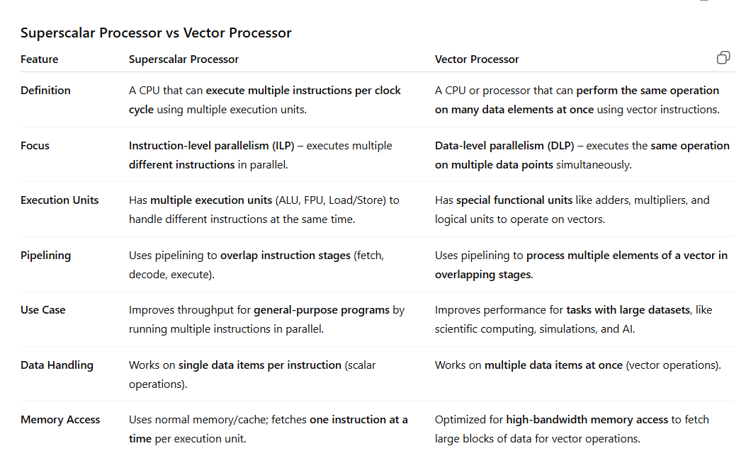
Introduction to Parallel Processing
Parallel processing is a way of computing where multiple processors work at the same time to solve problems faster.
- Instead of doing tasks one after another (sequential processing), the main task is divided into smaller subtasks.
- These subtasks are then executed at the same time by different processors.
- This approach improves performance, especially for big and complex problems in high-performance computing.
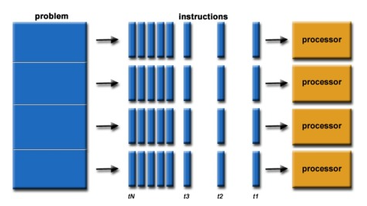
Types of Parallelism
1. Data Parallelism:
In this type, the same work is done on different parts of the data at the same time.
The data is divided into pieces, and each core handles a part of it.
Example
Suppose you have 1,000 students’ test scores, and you want to add 5 bonus marks to everyone’s score.
Instead of one core updating all 1,000 scores one by one,
you can split the list into 4 parts —
each core adds 5 marks to 250 scores at the same time.
2. Task Parallelism:
Here, different threads do different kinds of work at the same time.
Each thread performs its own unique task on possibly the same or different data.
Example:
In a video player:
- One thread plays the video,
- Another plays the audio,
- Another handles user controls.
All run together on different cores.
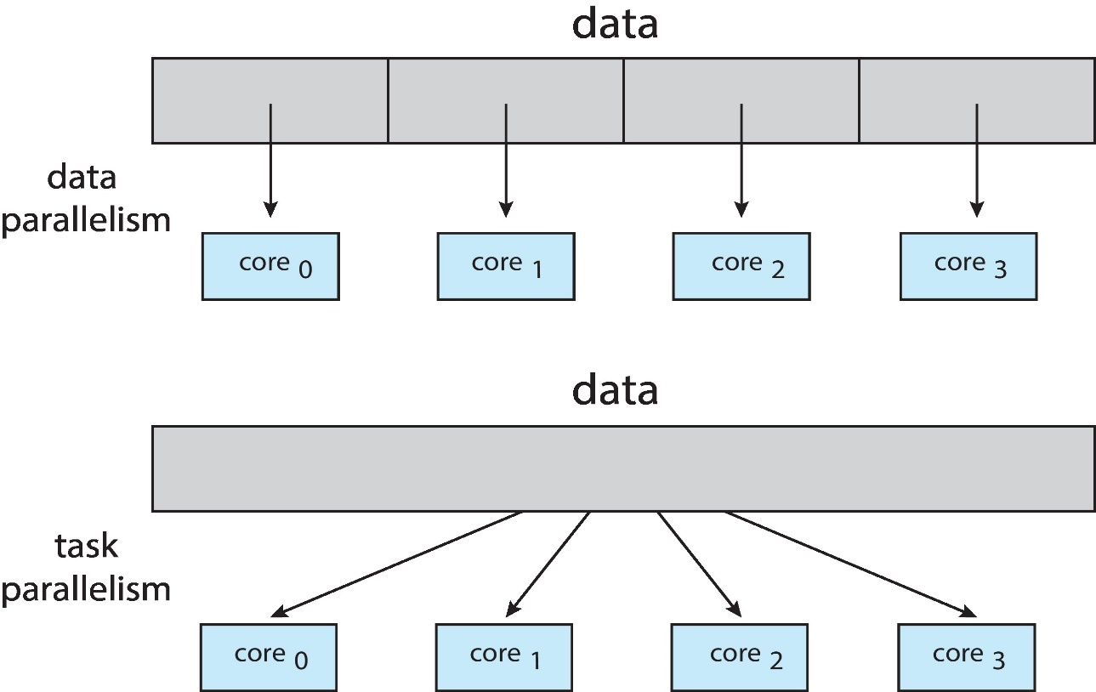
Flynn’s Taxonomy of Parallel Processing
- SISD (Single Instruction, Single Data): Traditional sequential computing.
- SIMD (Single Instruction, Multiple Data): A single instruction operates on multiple data points simultaneously (e.g., vector processors).
- MISD (Multiple Instruction, Single Data): Rarely used in practical computing, this model involves multiple instructions operating on the same data stream.
- MIMD (Multiple Instruction, Multiple Data): Multiple processors execute different instructions on different data simultaneously (e.g., multicore processors, distributed systems).
Architectures for Parallel Processing
Shared Memory Architecture
In shared memory systems, multiple processors share a common memory space. These systems are easier to program but require complex synchronization mechanisms to avoid data corruption (e.g., race conditions).
Examples: Multicore CPUs, some supercomputers.
Distributed Memory Architecture
In distributed memory systems, each processor has its own private memory, and processors communicate by passing messages. This architecture scales well but is more complex to program.
Examples: Clusters, grid computing systems.
Hybrid Architecture
Many modern parallel computing systems use a hybrid model that combines shared and distributed memory to optimize performance.
These architectures are commonly used in supercomputers and cloud computing platforms.
Parallel Processing Techniques
1. Pipelining
- Pipelining is a technique where different stages of instructions overlap.
- While one instruction is being processed in one stage, the next instruction starts in another stage.
- This helps the CPU work on multiple instructions at the same time, making it faster.
2. Multithreading
- Multithreading lets multiple threads (small parts of a program) run in parallel on a single processor or core.
- It improves CPU usage and reduces waiting time for tasks that are slow, like memory access.
Parallel Programming Models
- Message Passing Interface (MPI): Used in distributed memory systems where processors communicate via message passing.
- OpenMP: A programming model for shared memory systems, enabling the creation of parallel code with minimal effort.
- CUDA: A parallel computing platform for GPUs (Graphics Processing Units) that allows for high-speed data processing.

